y: M. S. KumarSwamy, TGT(Maths) Page - 1 -
Prepared b
MATHEMATICS
QUESTION BANK
For

CLASS – VI

CHAPTER WISE COVERAGE IN THE FORM MCQ WORKSHEETS AND PRACTICE QUESTIONS

- Identify the greatest and the smallest in 2853, 7691 , 9999 , 12002 , 124

(a) 12002,124 (b) 9999,124 (c) 7691,124 (d) 2853,124

- Which pair has same digits at hundreds place
(a) 4232,4331 (b) 2334,2340 (c) 6524,7823 (d) 5432,6922

- Using digits 4,5,6&0 without repetition make the greatest four digit number
(a) 4560 (b) 5640 (c) 6540 (d) 6504

- Using digits 0,1,2,3 without repetition make the smallest four digit number
(a) 0123 (b) 1023 (c) 1230 (d) 1032

- Make the greatest four digit number by using any one digit twice by 3,8,7

(a) 3387 (b) 8378 (c) 8873 (d) 8773

- Make the smallest four digit number by using any one digit twice by 0,4,9
(a) 0049 (b) 4009 (c) 0449 (d) 4049

- Make the greatest and the smallest four digit number using any four-digits number with digit 5 always at thousand place
(a) 5986 , 5012 (b) 5987,5012 (c) 5999, 5000 (d) 5789,5120

8 Correct ascending order of 847,9754,8320, 571
(a) 571,8320,847,9754 (b) 571,847,8320,9754
(c) 9754,847,8320,571 (d) 9754,8320,847,571

- Correct descending order of 5000,7500,85400,7861is
(a) 5000,7500,85400,7861 (b)85400,7500,7861,5000
(c) 85400,7861,7500,5000 (d) 7861,7500,7861,5000

- (i)Ascending order means arrangement from the smallest to the greatest
  - Ascending order means arrangement from the greatest to the smallest
  - Descending order means arrangement from the greatest to the smallest
  - Descending order means arrangement from the smallest to the greatest
    - All statements are true (b) All statements are false
(c) Only statements (i) & (iii) are true (d) Only statements (ii) & (iv) are true

- When one is added to the greatest four digit number what is the result?
(a) Greatest 5 digit number (b) Smallest 5 digit number
(c) Greatest 4 digit number (d) Smallest 4 digit number

- Which is greatest and smallest 4 digit number.
(a) 10000,9999 (b) 1000,99999 (c) 9999,1000 (d) 9999,10000

- When 1 is subtracted from smallest 5 digit number what is the result?
  - Smallest 4 digit number (b) Greatest 4 digit number
(c) Greatest 5 digit number (d) Smallest 5 digit number
- Expand the number 500428
  - Five crore four hundred thirty eight (b)fifty lakh four hundred twenty eight
(c) five lakh four hundred twenty eight (d) five lakh four hundred eight.
- If we add 1 more to the greatest 6 digit number we get
  - ten lakh (b) one lakh (c) ten lakh one (d) one lakh one
- The smallest 8 digit number is called .
  - one lakh (b) one crore (c) ten lakh (d) ten crore
- One crore is similar to .
  - hundred thousand (b)100 lakhs (c)10 hundreds (d) 1000 hundreds
- Write the numeral for the number Nine crore five lakh fourty one.
(a) 9,50,00,041 (b) 9,05,00,041 (c) 9,05,041 (d) 9,500,041
- 1 million is equal to how many lakhs
(a) 1 (b)10 (c) 100 (d) 1000
- Insert, commas suitably according to Indian system of numeration in 98432701.
(a) 9,84,32,701 (b) 98432701 (c) 98432701 (d) 98432701.
- Insert, commas suitably according to International system of numeration in 99985102 (a) 99985102 (b) 99985102 (c) 99985102 (d) 99985102

10. How many centimeters | make a meter.
(a) 1 | (b) 10 | (c) 100 | (d) 1000
- How many millimeter make one kilometer.
(a) 1000 (b) 10,000 (c) 100,000 (d) 10,00,000
- A box contains 500000 medicine tablets each winging 10 mg. what is the total weight of all the tablets in the box in kilograms
(a) 5,00,000 (b) 50,000 (c) 5kg (d) 500kg
- What is the difference between the greatest and the least number that can be written using the digits 6, 2,7,4,3, each only once
(a) 50000 (b) 52965 (c) 52865 (d) 51965
- Population of sundernagar was 235471 in the year 1991. In the year 2001 it was found to be increased by 72598. What was the population of the city 2001
(a) 308429 (b) 309429 (c) 30428 (d) 30328
- The town news paper is published everyday . One copy has 12 pages . Every day 11980 copies are printed. How many total pages are printed everyday
(a) 153760 (b) 143760 (c) 163760 (d) 143660

- In a basket there are two thousand kg apples , 340 kg oranges, and 20 kg grapes, what is the total weight of fruits?
(a) 2840 (b) 2850 (c)2870 (d)2860

- What must be subtracted from 11010101 to get 2635967.
(a) 934134 (b) 7383414 (c) 8374134 (d) 937414

- The difference between the face value and place value of 4 in 2416 is .
(a) 404 (b) 396 (c) 3000 (d)2996

- The symbol M in roman numeral stands for:
(a) 100 (b) 500 (c) 1000 (d) 50

- Which of the following is meaning less.
  - XIII (b) XIX (c) XVV (d) XL

- For 500 which symbol is used in Roman system
  - L (b) C (c) M (d) D

- In the international system of numeration we write one billion for
  - 1 crore (b) 10 crore (c)100 crore (d) 1000 crore

- Estimation of the quotient 86÷ 9 to nearest 10
  - 90 (b)10 (c)80 (d) none of these

- When 1787 is rounded off to nearest tens , we get
(a) 1790 (b) 1780 (c) 1700 (d)1800

- The sum of the number 765432 and the number obtained by reversing its digit is
(a) 930865 (b) 980356 (c) 999999 (d) 9999998

- The corresponding numeral for
5x 100000 + 8x10000 + 1x1000 + 6x100 + 2x10 + 3x1 is
(a) 581623 (b) 5081623 (c) 5810623 (d) 5816023

- The expanded form for 308927 is
(a) 3000000 + 8000 + 900 + 20 + 7 (b) 300000 + 800 + 90 + 2 + 7
(c) 30000 + 80000 + 9000 + 20 + 7 (d) 300000 + 8000 + 900 + 20 + 7
- Estimate 734+998 by rounding off the nearest tens
(a) 1730 (b) 1740 (c) 1750 (d) 1760
- Estimate 636 +988 by rounding off the nearest tens
(a) 1630 (b) 1640 (c) 1650 (d) 1660
- Estimate 574+676 by rounding off the nearest tens
(a) 1230 (b) 1240 (c) 1250 (d) 1260

PRACTICE QUESTIONS

CLASS - VI: CHAPTER - 1
KNOWING OUR NUMBERS

- Find the greatest and the smallest numbers. (a) 4536, 4892, 4370, 4452.
(b) 15623, 15073, 15189, 15800.
(c) 25286, 25245, 25270, 25210.
(d) 6895, 23787, 24569, 24659.

- Use the given digits without repetition and make the greatest and smallest 4-digit numbers. (a) 2, 8, 7, 4 (b) 9, 7, 4, 1 (c) 4, 7, 5, 0 (d) 1, 7, 6, 2 (e) 5, 4, 0, 3
- Arrange the following numbers in ascending order :
(a) 847, 9754, 8320, 571 (b) 9801, 25751, 36501, 38802

- Arrange the following numbers in descending order :
(a) 5000, 7500, 85400, 7861 (b) 1971, 45321, 88715, 92547

- Place commas correctly and write the numerals:
  - Seventy three lakh seventy five thousand three hundred seven.
  - Nine crore five lakh forty one.
  - Seven crore fifty two lakh twenty one thousand three hundred two.
  - Fifty eight million four hundred twenty three thousand two hundred two.
  - Twenty three lakh thirty thousand ten.

- Insert commas suitably and write the names according to Indian System of Numeration : (a) 87595762 (b) 8546283 (c) 99900046 (d) 98432701

- Insert commas suitably and write the names according to International System of Numeration : (a) 78921092 (b) 7452283 (c) 99985102 (d) 48049831

- A box contains 2,00,000 medicine tablets each weighing 20 mg. What is the total weight of all the tablets in the box in grams and in kilograms?

- Population of Sundarnagar was 2,35,471 in the year 1991. In the year 2001 it was found to be increased by 72,958. What was the population of the city in 2001?

- In one state, the number of bicycles sold in the year 2002-2003 was 7,43,000. In the year 2003- 2004, the number of bicycles sold was 8,00,100. In which year were more bicycles sold? and how many more?

- The town newspaper is published every day. One copy has 12 pages. Everyday 11,980 copies are printed. How many total pages are printed everyday?

- The number of sheets of paper available for making notebooks is 75,000. Each sheet makes 8 pages of a notebook. Each notebook contains 200 pages. How many notebooks can be made from the paper available?

- A machine, on an average, manufactures 2,825 screws a day. How many screws did it produce in the month of January 2006?

- A merchant had Rs 78,592 with her. She placed an order for purchasing 40 radio sets at Rs 1200 each. How much money will remain with her after the purchase?

- A student multiplied 7236 by 65 instead of multiplying by 56. By how much was his answer greater than the correct answer? (Hint: Do you need to do both the multiplications?)

- To stitch a shirt, 2 m 15 cm cloth is needed. Out of 40 m cloth, how many shirts can be stitched and how much cloth will remain?

- In an election, the successful candidate registered 5,77,500 votes and his nearest rival secured 3,48,700 votes. By what margin did the successful candidate win the election?

- Kirti bookstore sold books worth Rs 2,85,891 in the first week of June and books worth Rs 4,00,768 in the second week of the month. How much was the sale for the two weeks together? In which week was the sale greater and by how much?

19. Estimate: 5,290 + 17,986.
20. Estimate: 5,673 – 436.

- Estimate the following products :
(a) 87 × 313 (b) 9 × 795 (c) 898 × 785 (d) 958 × 387

- Estimate each of the following using general rule:
(a) 730 + 998 (b) 796 – 314 (c) 12,904 +2,888 (d) 28,292 – 21,496

- Estimate the following products using general rule:
(a) 578 × 161 (b) 5281 × 3491 (c) 1291 × 592 (d) 9250 × 29

- Write in Roman numerals.

(a). 98 | (b). 88 | (c). 79 | (d).69 | (e). 59 | (f). 49 | (g).39
(h).55 | (i). 65 | (j). 75 | (k).85 | (l). 95 | (m). | 92 (n).71
(o).45 | (p).25 | (q).15 | (r). 36 | (s). 29 | (t). 99 | (u).78

- Write the Roman numerals in number:

(a). XXX | (b). XL | (c). XC | (d). XCVIII | (e). LXXXVI | (f). LXIII
(g). XXVIII | (h). XIX | (i). XLVIII | (j). XXIX | (k). LXVIII | (l). LXXXVIII

ASSIGNMENT QUESTIONS

CLASS - VI: CHAPTER - 1
KNOWING OUR NUMBERS

- Write the numerals for each of the following:
  - Sixteen crore forty lakh ten thousand two hundred forty-nine
  - Seven crore two lakh eighty-seven

2. Write number names for (a) 7,23,56,708 (b) 27,57,002

3. Write each in expanded form: (a) 5,35,23,981 (b) 34,49,28,876

- Find the difference between the place values of two 7s in 78,65,49,756.

- Arrange the following numbers in ascending as well as descending order: 4,75,63,892; 56,45,389; 3,27,896; 5,64,585 and 45,87,692.

- Express each of the following as a Hindu-Arabic numeral:
  - XXXII (b) XCV (c) DCCLXIV (d) CCXX (e) MVI (f) LXXXIV

- Round off each of the following numbers to nearest tens: (i) 84 (ii) 98 (iii) 984 (iv) 808 (v) 998

- Round off each of the following numbers to nearest hundred: (i) 3985 (ii) 7289 (iii) 8074 (iv) 14627 (v) 28826

- Round off each of the following numbers to nearest thousand: (i) 2401 (ii) 7278 (iii) 7832 (iv) 9567 (v) 26019

- Write the following in Roman numerals:
(i) 49 (ii) 69 (iii) 72 (iv) 89 (v) 98 (v) 92 (vi) 175 (vii) 197

- Write the following in Hindu-Arabic numerals:
- XXIX (ii) XLV (iii) LXXXIX (iv) XCIX (v) CLXV

- Population of Agra and Aligarh districts in the year 2001 was 36,20, 436 and 29,92,286, respectively. What was the total population of the two districts in that year?

- Estimate the product 5981 × 4428 by rounding off each number to the nearest (i) tens (ii) hundreds

Fill in the blank
  - 10 million = crore.
  - 10 lakh = million.
  - 1 metre = millimetres.
  - 1 centimetre = millimetres.
  - 1 kilometre = millimetres.
  - 1 gram = milligrams.
  - 1 litre = millilitres.

  - 1 kilogram = miligrams.
  - 100 thousands = lakh.
  - Height of a person is 1m 65cm. His height in millimetres is .

  - Length of river ‘Narmada’ is about 1290km. Its length in metres is .

  - The distance between Srinagar and Leh is 422km. The same distance in metres is .
  - Writing of numbers from the greatest to the smallest is called an arrangement in order.
  - By reversing the order of digits of the greatest number made by five different non-zero digits, the new number is the number of five digits.
  - By adding 1 to the greatest digit number, we get ten lakh.
  - The number five crore twenty three lakh seventy eight thousand four hundred one can be written, using commas, in the Indian System of Numeration as .
  - In Roman Numeration, the symbol X can be subtracted from , M and C only.
  - The number 66 in Roman numerals is .
  - The population of Pune was 2,538,473 in 2001. Rounded off to nearest thousands, the population was .

- Estimate each of the following by rounding off each number to nearest hundreds: (a) 874 + 478 (b) 793 + 397
(c) 11244 + 3507 (d) 17677 + 13589

- Estimate each of the follwoing by rounding off each number to nearest tens: (a) 11963 – 9369 (b) 76877 – 7783
(c) 10732 – 4354 (d) 78203 – 16407

- Estimate each of the following products by rounding off each number to nearest tens: (a) 87 × 32 (b) 311×113
(c) 3239 × 28 (d) 1385 × 789

- The population of a town was 78787 in the year 1991 and 95833 in the year 2001. Estimate the increase in population by rounding off each population to nearest hundreds.

- Which of the following numbers in Roman Numerals is incorrect?
(A) LXII (B) XCI (C) LC (D) XLIV

- Fill in the blank:
  - In Indian System of Numeration, the number 61711682 is written, using commas, as
.
  - The smallest 4 digit number with different digits is .

- What is the predecessor of 17
(a) 16 (b) 18 (c) 0 (d) 17
- Write the successor of 1997
(a) 1996 (b) 1997 (c) 1998 (d) none of these 3.Which is the smallest whole number
(a) 1 | (b) 0 | (c) 2 | (d) -1
- Divide 7÷0  - 7 | (b) 0 | (c) not defined | (d) 1

- Find value of 297x17 + 297x3
(a) 5940 (b) 5980 (c) 5942 (d) 5970
- Which of the following will not represent 0
(a) 1+0 (b) 0x0 (c) 0/2 (d) (10-10)/2
- If the product of two whole numbers is one if
  - one number is 1 (b) two numbers are 1 (c) not defined (d) none of these
- Smallest natural number is
(a) -1 (b) 1 (c) 0 (d) 2
9. Simplify 126x55+126x45
(a)12000 (b) 12400 (c) 12600 (d) 12500

- (i)If the product of two whole numbers is zero then one number will be zero
- If the product of two whole numbers is zero then both number will be zero
  - Only I can be true (b) only ii can be true (c) Both can be true (d)both are false
- Study the pattern 1x8+1=9
12x8+2=98
Next step is-
(a)123x8+3=987 (b)1234x8+4=9876 (c) 120x8+3=963 (d) 13x8+3=987
- Fill in the blanks to make the statement true 6245+(631+751)=631+ )+751
(a) 6245 | (b) 751 | (c) 200 | (d) 231
- 5 divided by 0 is  - 5 | (b) 0 | (c) 1 | (d) not defined
- 0 divided by 6 is  - 6 | (b) 0 | (c) 1 | (d) 60
15.Write the correct number to complete: 13x100x = 1300000
(a)10 (b) 1000 (c) 10000 (d)100

- State the property used statement (29x36)x18=29x(36x18)
  - Associative property in multiplication (b) Commutative property in multiplication (c)Distributive property in multiplication (d) Closure property in multiplication

- The school canteen charges Rs 20 for lunch Rs 4 for milk for each day How much money do you spend in 5 days on these things
(a) 100 (b)20 (c) 120 (d) 5

- Largest number formed by digits 2,4,0,3,6,9 is
(a) 432900 (b) 392460 (c) 964320 (d) 903642

- If 36 flats cost Rs 68251500 What is the cost of each flat
(a) Rs 198670 (b)Rs 135649 (c) Rs 203456 (d)Rs 1895875

- State the property in statement:256x24=24x256
  - Associative property in multiplication (b) commutative property in multiplication (c)Distributive property in multiplication (d)Closure property in multiplication

- Find product 12x35
(a) 12600 (b) 34840 (c) 420 (d) 400

- Find the value of 1507 – (625/25)
(a) 1482 (b) 1580 (c) 1370 (d) 1234

8. Find the sum 837+ 208 + 603
(a) 1548 (b) 1148 (c) 1648 (d) 1148

- Find the whole number if n +4 =9
(a) 5 (b) 3 (c) 4 (d) 6

- Find a whole number n such that n=2n
(a) 20 (b) 100 (c) 0 (d) 1

- The difference of largest number of three digit and smallest natural number is (a) 998 (b) 997 (c) 996 (d) 995

- The largest whole number is:
  - 99 (b) 9979 (c) 9999 (d)can not be found

- The sum of a natural number with a whole number is always:
  - 0 (b) 100 (c) even number (d) a natural number

- The sum of two whole numbers is always:
  - zero (b) 100 (c) a whole number (d) odd number

- How many natural numbers are there
  - 100 (b) 1000 (c) infinitly many (d) 10

- The product multiplication of a number with zero is always
  - zero (b)one (c) the number itself (d)none of these

- The line on which we represent the natural number is known as
(a)counting line  6. Smallest natural number is | (b) number line | (c) digit line | (d) zero line
(a) 0 | (b) 1 | (c) 2 | (d) -1

- (I) All natural numbers are also whole numbers
  - One is the smallest natural number
    - only I is true (b) only II is true (c) both are true (d) both are false

- The natural numbers along with zero form the collection of
(a) Whole numbers (b) Integers (c) Rational numbers (d) Real numbers

- Predecessor of which two digit number has a single digit
(a) 9 (b) 10 (c) 0 (d) 11

- Which natural number has no predecessor
(a) 0 (b) 1 (c) 10 (d) 100

- Whole numbers are closed under which operation
(a) Addition (b) Subtraction (c) Division (d) None of these

- Which number is identity for Addition of whole number
(a) 0 (b) 1 (c) 10 (d) 100

- Which number is identity for multiplication of whole numbers:
(a) 0 (b) 1 (c)10 (d) 100

- Smallest whole number is
(a) 0 (b) 1 (c) 2 (d) -1

- Predecessor of which two digit number has a two digit
(a) 99 (b) 100 (c) 101 (d) 111

- Find 4 + 5; 2 + 6; 3 + 5 and 1+6 using the number line.
- Find 8 – 3; 6 – 2; 9 – 6 using the number line.
3. Write the successor of : (a) 2440701 (b) 100199 (c) 1099999 (d) 2345670
4. Write the predecessor of : (a) 94 (b) 10000 (c) 208090 (d) 7654321
5. Find : 7 + 18 + 13; 16 + 12 + 4
6. Find : 25 × 8358 × 4 ; 625 × 3759 × 8
7. Find 15 × 68; 17 × 23; 69 × 78 + 22 × 69 using distributive property.
8. Simplify: 126 × 55 + 126 × 45
- A taxidriver filled his car petrol tank with 40 litres of petrol on Monday. The next day, he filled the tank with 50 litres of petrol. If the petrol costs Rs 44 per litre, how much did he spend in all on petrol?
- A vendor supplies 32 litres of milk to a hotel in the morning and 68 litres of milk in the evening. If the milk costs Rs 15 per litre, how much money is due to the vendor per day?
- Find the value of the following:
(a) 297 × 17 + 297 × 3 (b) 54279 × 92 + 8 × 54279
(c) 81265 × 169 – 81265 × 69 (d) 3845 × 5 × 782 + 769 × 25 × 218
- Find the product using suitable properties.
(a) 738 × 103 (b) 854 × 102 (c) 258 × 1008 (d) 1005 × 168
- Find using distributive property :
(a) 728 × 101 (b) 5437 × 1001 (c) 824 × 25 (d) 4275 × 125 (e) 504 × 35
- Find the sum by suitable rearrangement:
(a) 837 + 208 + 363 (b) 1962 + 453 + 1538 + 647

- Find the product by suitable rearrangement:
(a) 2 × 1768 × 50 (b) 4 × 166 × 25 (c) 8 × 291 × 125
(d) 625 × 279 × 16 (e) 285 × 5 × 60 (f) 125 × 40 × 8 × 25
- A dealer purchased 139 VCRs. If the cost of each set is Rs 14350, find the cost of all the sets together.
- A housing society constructed 397 houses. If the cost of construction for each house is Rs. 325000, what is the total cost for all the houses?
- Using distributive property, find the following product?
(a) 937 x 105 (b) 346 x 1007 (c) 947 x 96 (d) 996x 267
- 50 chairs and 30 blackboards were purchased for a school. If each chair casts Rs. 165 and a blackboard costs Rs. 445, find the total amount of the bill.
- The product of two whole numbers is zero. What do you conclude.

- Calculate using suitable rearrangements:
(i) 31 + 32 + 33 + 34 + 35 + 65 + 66 + 67 + 68 + 69
(ii) 1 + 2 + 3 + 4 + 996 + 997 + 998 + 999
(iii) 12 + 14 + 16 + 18 + 20 + 80 + 82 + 84 + 86 + 88

- What is the difference between the largest number of 5 digits and the smallest 6 digits?

- The digits of 6 and 9 of the number 36490 are interchanged. Find the difference between the original number and the new number.

- Determine the products by suitable rearrangement:
(i) 8 x 125 x 40 x 25 (ii) 250 x 60 x 50 x 8 (iii) 37256 x 25 x 9 x 40

- Determine the product of: (i) the greatest number of 4-digits and the smallest number of 3-digits
- smallest number of 2-digits and the greatest number of 5-digits.

- A dealer purchased 120 LCD television sets. If the cost of each set is Rs. 20000, determine the cost of all sets together.

- Find the value of each of the following using properties: (i) 493 x 9 + 493 x 2 (ii) 24579 x 93 + 7 x 24579
(ii) 1568 x 184 – 1568 x 84 (iv) 5625 x 1625 – 5625 x 625

- The product of two whole numbers is zero. What do you conclude?

- Determine the products by suitable rearrangement:
(i) 2 x 1497 x 50 (ii) 4 x 358 x 25 (iii) 625 x 20 x 8 x 50

- Find the product 8739 × 102 using distributive property.

- Write in expanded form : (a) 74836
(b) 574021
(c) 8907010

- A person had Rs 1000000 with him. He purchased a colour T.V. for Rs 16580, a motor cycle for Rs 45890 and a flat for Rs 870000. How much money was left with him?

- Out of 180000 tablets of Vitamin A, 18734 are distributed among the students in a district. Find the number of the remaining vitamin tablets.

- Chinmay had Rs 610000. He gave Rs 87500 to Jyoti, Rs 126380 to Javed and Rs 350000 to John. How much money was left with him?

- Find the difference between the largest number of seven digits and the smallest number of eight digits.

- A mobile number consists of ten digits. The first four digits of the number are 9, 9, 8 and 7. The last three digits are 3, 5 and 5. The remaining digits are distinct and make the mobile number, the greatest possible number. What are these digits?

- A mobile number consists of ten digits. First four digits are 9,9,7 and 9. Make the smallest mobile number by using only one digit twice from 8, 3, 5, 6, 0.

- In a five digit number, digit at ten’s place is 4, digit at unit’s place is one fourth of ten’s place digit, digit at hunderd’s place is 0, digit at thousand’s place is 5 times of the digit at unit’s place and ten thousand’s place digit is double the digit at ten’s place. Write the number.

- Find the sum of the greatest and the least six digit numbers formed by the digits 2, 0, 4, 7, 6, 5 using each digit only once.

- A factory has a container filled with 35874 litres of cold drink. In how many bottles of 200 ml capacity each can it be filled?

- The population of a town is 450772. In a survey, it was reported that one out of every 14 persons is illiterate. In all how many illiterate persons are there in the town?

- Determine the sum of the four numbers as given below:
  - successor of 32
  - predecessor of 49
  - predecessor of the predecessor of 56
  - successor of the successor of 67

- A loading tempo can carry 482 boxes of biscuits weighing 15kg each, whereas a van can carry 518 boxes each of the same weight. Find the total weight that can be carried by both the vehicles.

- In the marriage of her daughter, Leela spent Rs 216766 on food and decoration,Rs 122322 on jewellery, Rs 88234 on furniture and Rs 26780 on kitchen items. Find the total amount spent by her on the above items.

- A box contains 5 strips having 12 capsules of 500mg medicine in each capsule. Find the total weight in grams of medicine in 32 such boxes.

- Which of the following is smallest prime number:
(a) 1 (b) 2 (c) 3 (d) 4

- The only prime number which is also even
(a) 1 (b) 2 (c) 4 (d) 6
- The sum of two odd and one even numbers is
  - Even (b) Odd (c) Prime (d) Composite
- The smallest composite number is
(a) 1 (b) 2 (c) 3 (d) 4
- Tell the maximum consecutive numbers less then 100 so that there is no prime number between them
(a) 5 (b) 6 (c) 7 (d) 8
- If a number is divisible by 2 and 3 both then is divisible by
(a) 5 (b) 6 (c) 8 (d) 10
- Which of the following number is divisible by 3
(a) 121 (b) 123 (c) 124 (d) 122
- A number is divisible by 4 if its
  - Last digit is 4 (b) last digit is 0
(c) last two digits are divisible by 4 (d) last digit is 8
- Two numbers having only 1 as common factor are called
  - Prime numbers (b) Co- prime numbers
(c) Composite numbers (d) Odd numbers
- Which of the following pair is co-prime
(a) 6 and 8 (b) 18 and 35 (c) 7 and 35 (d) 30 and 415
- Common factors of 15 and 25 are
(a) 15 (b) 25 (c) 5 (d) 75
- If a number is divisible two co-prime numbers than it is divisible by their
  - Sum also (b) Difference also (c) Product also (d) Quotient also

- The exact divisor of number 9 is
(a) 2 (b) 3 (c) 4 (d) 5
- Which number is factor of every number
(a) 1 (b) 2 (c) 10 (d) 100
- Numbers of factors of given number are:
  - 1 (b) 2 (c) finite (d) infinite
- The numbers of multiples of given number are
  - 1 (b) 2 (c) finite (d) infinite
- Every number is multiple of
  - 1 (b) 2 (c) 10 (d) itself
- A number for which sum of all its factors is equal to twice number is called
  - Perfect number (b) even number (c) Odd number (d) Prime number
- How many factors does 36 has
(a) 7 (b) 9 (c) 10 (d) 8
- Which of following number is multiple of 8
(a) 2 (b) 4 (c) 10 (d) 16
- The numbers having two factors are called
  - Even (b) Odd (c) Prime (d) Composite
- The numbers having more than two factors are called
  - Prime numbers (b) Composite numbers (c) Even numbers (d) Odd numbers
- Which number is neither prime nor composite
(a) 0 (b) 1 (c) 2 (d) 3
- The multiple of 2 are also called
  - Even numbers (b) Odd numbers (c) Prime numbers (d) Composite numbers

- The product of L.C.M and H.C.F. of two numbers is equal to
  - Sum of numbers (b) Difference of numbers
(c) Product of numbers (d) Quotients of numbers
- The missing number is:

60
6
?
10
3 2 5

(a) 1 (b) 2 (c) 3 (d) 4
- What are the prime factors of greatest 4 –digit number
(a) 3x3x11x101 (b) 9x11x101 (c) 3x33x101 (d) 3 x3 x 11 x11
- Which of the following expression has prime factors
(a) 24=2x3x4 (b) 56=7x2x2x2 (c) 70= 2x5x7 (d)54=2x3x9
- Which of the following numbers has 4 different prime factors
(a) 24 (b) 120 (c) 210 (d)100
- The product of three consecutive numbers is always divisible by
(a) 2 (b) 4 (c) 6 (d) 8
- The sum of two consecutive odd number is always divisible by
(a) 2 (b) 4 (c) 6 (d)8
- What is the H.C.F. of 18 and 48
(a) 2 (b) 4 (c) 6 (d)8
- What is the H.C.F. two consecutive even numbers
(a) 1 (b)2 (c) 4 (d) 8
- What is the H.C.F. two consecutive odd numbers
(a) 1 (b) 2 (c) 4 (d) 8

- Find the L.C.M. of 12 and 18
(a) 6 (b) 36 (c) 12 (d) 18
- L.C.M. of two co-prime numbers is always
  - product of numbers (b) sum of numbers
(c) difference of numbers (d)none
- Find the least number which when divided by 6,15 and 18 leave remainder 5 in each case (a) 90 (b) 180 (c) 95 (d)185
- Divisibility by 2,5,10 can be checked by
  - sum of digits (b) last digit (c) last two digits (d) last three digits
- Which is greatest 3-digit number exactly divisible by 8,10,12
(a) 120 (b) 360 (c) 960 (d) 980
6. 4= 2x2 , 15= 3x5, so H.C.F. of 4 and 15 is
(a) 0 (b) 1 (c) 2 (d) 3
- Find the least number which when divided by 12, 16, 24 and 36 leaves a remainder 7 in each case.
  - 150 (b) 151 (c)144 (d) none of these
- Renu purchases two bags of fertiliser of weights 75 kg and 69 kg. Find the maximum value of weight which can measure the weight of the fertiliser exact number of times.
  - 150 (b) 138 (c)144 (d) none of these
- Which of the following is divisible by 3?
(a)15287 (b) 15267 (c) 15286 (d) 152638

- Which of the following is divisible by 9?
(a)15287 (b) 15267 (c) 15286 (d) 152638

- If a number is divisible by 9, it must be divisible by .
(a) 6 (b) 3 (c) 2 (d) 12
- Numbers having more than two factors are called Composite numbers.
  - Prime numbers (b) Co- prime numbers
(c) Composite numbers (d) Odd numbers

- Write all the factors of 68.
- Write first five multiples of 6.
- Write all the factors of the following numbers : (a) 24 (b) 15 (c) 21
(d) 27 (e) 12 (f) 20
(g) 18 (h) 23 (i) 36
- Write first five multiples of : (a) 5 (b) 8 (c) 9
- Find all the multiples of 9 upto 100.
- Write all the prime numbers less than 15.
- The numbers 13 and 31 are prime numbers. Both these numbers have same digits 1 and 3. Find such pairs of prime numbers upto 100.
- Express the following as the sum of two odd primes. (a) 44 (b) 36 (c) 24 (d) 18
- Express each of the following numbers as the sum of three odd primes: (a) 21 (b) 31 (c) 53 (d) 61
- Write five pairs of prime numbers less than 20 whose sum is divisible by 5.
- Give three pairs of prime numbers whose difference is 2.
- Using divisibility tests, determine which of the following numbers are divisible by 4; by 8: (a) 572 (b) 726352 (c) 5500 (d) 6000 (e) 12159
(f) 14560 (g) 21084 (h) 31795072 (i) 1700 (j) 2150
- Using divisibility tests, determine which of following numbers are divisible by 6: (a) 297144 (b) 1258 (c) 4335 (d) 61233 (e) 901352
(f) 438750 (g) 1790184 (h) 12583 (i) 639210 (j) 17852
- Using divisibility tests, determine which of the following numbers are divisible by 11: (a) 5445 (b) 10824 (c) 7138965 (d) 70169308 (e) 10000001
(f) 901153
- Find the common factors of 75, 60 and 210.
- Find the common multiples of 3, 4 and 9.
- Write all the numbers less than 100 which are common multiples of 3 and 4.
- A number is divisible by both 5 and 12. By which other number will that number be always divisible?
- A number is divisible by 12. By what other numbers will that number be divisible?
- Find the prime factorisation of 980.
- Write the greatest 4-digit number and express it in terms of its prime factors.
- Write the smallest 5-digit number and express it in the form of its prime factors.

- Find all the prime factors of 1729 and arrange them in ascending order. Now state the relation, if any; between two consecutive prime factors.
- The product of three consecutive numbers is always divisible by 6. Verify this statement with the help of some examples.

- The sum of two consecutive odd numbers is divisible by 4. Verify this statement with the help of some examples.
- Find the HCF of the following: (i) 24 and 36 (ii) 15, 25 and 30
- 8 and 12 (iv) 12, 16 and 28
- Find the LCM of 12 and 18.
- Find the LCM of 40, 48 and 45.
- Find the LCM of 20, 25 and 30.
- Two tankers contain 850 litres and 680 litres of kerosene oil respectively. Find the maximum capacity of a container which can measure the kerosene oil of both the tankers when used an exact number of times.
- In a morning walk, three persons step off together. Their steps measure 80 cm, 85 cm and 90 cm respectively. What is the minimum distance each should walk so that all can cover the same distance in complete steps?
- Find the least number which when divided by 12, 16, 24 and 36 leaves a remainder 7 in each case.
- The length, breadth and height of a room are 825 cm, 675 cm and 450 cm respectively. Find the longest tape which can measure the three dimensions of the room exactly.
- Determine the smallest 3-digit number which is exactly divisible by 6, 8 and 12.
- Determine the greatest 3-digit number exactly divisible by 8, 10 and 12.
- The traffic lights at three different road crossings change after every 48 seconds, 72 seconds and 108 seconds respectively. If they change simultaneously at 7 a.m., at what time will they change simultaneously again?
- Three tankers contain 403 litres, 434 litres and 465 litres of diesel respectively. Find the maximum capacity of a container that can measure the diesel of the three containers exact number of times.
- Find the least number which when divided by 6, 15 and 18 leave remainder 5 in each case.
- Find the smallest 4-digit number which is divisible by 18, 24 and 32.
- Renu purchases two bags of fertiliser of weights 75 kg and 69 kg. Find the maximum value of weight which can measure the weight of the fertiliser exact number of times.

ASSIGNMENT QUESTIONS

CLASS - VI: CHAPTER - 3
PLAYING WITH NUMBERS

- Write all the factors of each of the following: (i) 125 (ii) 729 (iii) 512 (iv) 75 (v) 60

- Write first five multiples of each of the follwing numbers: (i) 25 (ii) 35 (iii) 45 (iv) 40

- Find the common factors of
  - 15 and 25 (ii) 35 and 50 (iii) 20 and 28

- Find the common factors of (i) 5, 15 and 25 (ii) 2, 6 and 8

- Find first three common multiples of 6 and 8

- Find first two common multiples of 12 and 18

- Express each of the following numbers as the sum of two odd primes: (i) 36 (ii) 42 (iii) 84

- Express each of the following numbers as the sum of three odd primes: (i) 31 (ii) 35 (iii) 49

- Write the smallest 5-digit number and express it as a product of primes.

- Determine the prime factorization of each of the following numbers: (i) 216 (ii) 420 (iii) 468 (iv) 945 (v) 7325

- Find the smallest number having three different prime factors.

- Find the smallest number having four different prime factors.

- Test the divisibility of the following number by 2: (i) 6520 (ii) 1245 (iii) 1268

- Test the divisibility of the following number by 3: (i) 70335 (ii) 607439 (iii) 9082976

- Test the divisibility of the following number by 6: (i) 7020 (ii) 56423 (iii) 732510

- Test the divisibility of the following number by 4: (i) 786532 (ii) 1020530 (iii) 9801526

- Test the divisibility of the following number by 8: (i) 8364 (ii) 7314 (iii) 36712

- Test the divisibility of the following number by 9: (i) 187245 (ii) 3478 (iii) 547218

- Test the divisibility of the following number by 11: (i) 5335 (ii) 70169803 (iii) 10000001

- Using each of the digits 1, 2, 3 and 4 only once, determine the smallest 4-digit number divisible by 4.

- Fatima wants to mail three parcels to three village schools. She finds that the postal charges are Rs 20, Rs 28 and Rs 36, respectively. If she wants to buy stamps only of one denomination, what is the greatest denomination of stamps she must buy to mail the three parcels?

- Three brands A, B and C of biscuits are available in packets of 12, 15 and 21 biscuits respectively. If a shopkeepeer wants to buy an equal number of biscuits, of each brand, what is the minimum number of packets of each brand, he should buy?

- The floor of a room is 8m 96cm long and 6m 72cm broad. Find the minimum number of square tiles of the same size needed to cover the entire floor.

- In a school library, there are 780 books of English and 364 books of Science. Ms. Yakang, the librarian of the school wants to store these books in shelves such that each shelf should have the same number of books of each subject. What should be the minimum number of books in each shelf?

- In a colony of 100 blocks of flats numbering 1 to 100, a school van stops at every sixth block while a school bus stops at every tenth block. On which stops will both of them stop if they start from the entrance of the colony?

- Using divisibility tests, determine which of the following numbers are divisible by 4? (a) 4096 (b) 21084 (c) 31795012

- Using divisibility test. determine which of the following numbers are divisible by 9? (a) 672 (b) 5652

- Determine the least number which when divided by 3, 4 and 5 leaves remainder 2 in each case.

- A merchant has 120 litres of oil of one kind, 180 litres of another kind and 240 litres of a third kind. He wants to sell the oil by filling the three kinds of oil in tins of equal capacity. What should be the greatest capacity of such a tin?

- Find a 4-digit odd number using each of the digits 1, 2, 4 and 5 only once such that when the first and the last digits are interchanged, it is divisible by 4.

- 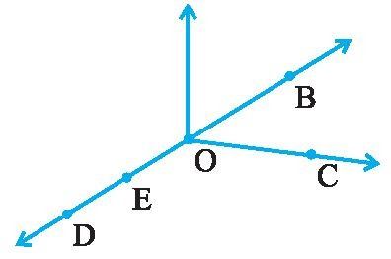How many points does the given figure has?
O
A
(d) AO

(a) 5 (b) 4 (c) 3 (d) 6

- In the given figure, the ray will be named as .

  - l (b) OA (c) OA

- How many lines pass through one given point?
  - One (b) two (c) countless (d) none
- How many lines pass through two given points?

  - One (b) two (c) many (d) none

- Which figure represents : point P lies on line segment AB.

  - A B (b) A P B (c) A P (d)
A P B

- Which of the following is an open curve?
(a) (b) (c) (d)

- The line segment forming a polygon are called .

  - Vertex (b) sides (c) angle (d) curve

- Two distinct lines meeting at a points are called .

  - Collinear lines (b) intersecting lines (c) parallel lines (d) none of these

- Name the point of intersection in the given figure. l

O

  - l (b) O (c) m (d) n

n m
- An angle is made up of two starting from common end point
  - vertex (b) lines (c) rays (d) line segments

- A flat surface which extends indefinitely in all directions is called .
  - line (b) line segment (c) plane (d) point

- Number of lines which can be drawn from one point:
  - one (b) infinite (c) two (d) zero

- Which of the following is pair of opposite sides in the given figure.
B
D

  - AB,BC (b) BC,AD (c) CD,AD (d) AB,AD C

- Which of the following is the pair of adjacent angles in the given figure. (a ) ∠ A, ∠ C (b) ∠ B, ∠ D (c) ∠ A, ∠ B (d) none of these. A
- A of a circle is a line segment joining any two points on the circle
  - radius (b) diameter (c) circumference (d) chord
- If two lines intersects each other then the common point between them is known as point of
.
  - Contact (b) vertex (c) intersection (d) concurrence

- Two lines in a plane either intersect exactly at one point or are
  - perpendicular (b) parallel (c) equal (d) equidistant
- Three or more points lying on the same line are known as points.
  - non – collinear (b) collinear (c) intersecting (d) none of these.
- Three or more points which lie on a same line are called:
  - non – collinear points (b) straight lines
(c) collinear points (d) point of concurrence
- Two lines meeting at a point are called .
  - parallel lines (b) intersecting lines (c) concurrent lines (d) intercept
- A line has length.
  - definite (b) indefinite (c) no (d) none of these.
- The edge of a ruler draws .
  - ray (b) line (c) line segment (d) curve
- A portion of a line which has two end points:
  - line segment (b) plane (c) ray (d) point
- The number of line segment in the adjoining figure: ^{A}
(a) 1 (b) 2 (c) 3 (d) 4
- The number of sides in a pentagon are
(a) 3 (b) 5 (c) 6 (d) 4
- The number of sides in a quadrilateral are ^{B} ^{C}
(a) 3 (b) 5 (c) 6 (d) 4
- The number of sides in a triangle are
(a) 3 (b) 5 (c) 6 (d) 4

- Three or more lines which pass through same point are called
  - intersecting lines (b) parallel lines
(c) perpendicular lines (d) concurrent lines.

- Geometrical figure which has no dimension is
  - line (b) plane (c) line segment (d) point.

- The lines which do not intersect and have equal distance between them are called:
  - parallel lines (b) perpendicular lines (c) intersecting lines (d) straight lines

- Number of points a line can have are :
  - infinite (b) one (c) two (d) zero.

- The point at which two lines cross each other is called:
  - point of intersection (b) point of concurrence
(c) parallel lines (d) concurrent lines.

- A line segment AB is denoted as:
  - AB (b) AB (c) AB (d) both a and c
- The length of line segment AB is denoted as:
  - AB (b) AB (c) AB (d) none of these.
- A line segment has:
  - definite length but no end points (b) infinite length but no end point
(c) definite length and have end points (d) none of these.
- If the length of a line segment AB = 3 cm then 2AB will be
  - 8 cm (b) 6 cm (c) 4 cm (d) 9 cm
- Number of line segments which can be drawn joining two points:
  - two (b) one (c) infinite (d) none
- A portion of a line is known as:
  - line segment (b) line (c) portion of a line (d) none of these
- Two line segments having the same length are said to be:
  - same (b) unequal (c) parallel (d) equal
- The number of diagonal in a triangle are:
(a) 3 (b) 2 (c) 0 (d) 1
- If two lines are perpendicular to each other then angle between them at the point of contact is (a) 80º (b) 90º (c) 85º (d) 100º
- A line segment has definite
  - breadth (b) length (c) thickness (d) area

PRACTICE QUESTIONS

CLASS - VI: CHAPTER - 4
BASIC GEOMETRICAL IDEAS

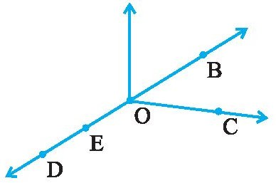
- Use the figure to name :
  - Five points
  - A line
  - Four rays
  - Five line segments

- Name the line given in all possible (twelve) ways, choosing only two letters at a time from the four given.
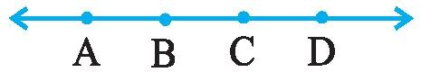
- How many lines can pass through (a) one given point? (b) two given points?

- Draw a rough figure and label suitably in each of the following cases:
  - Point P lies on AB .

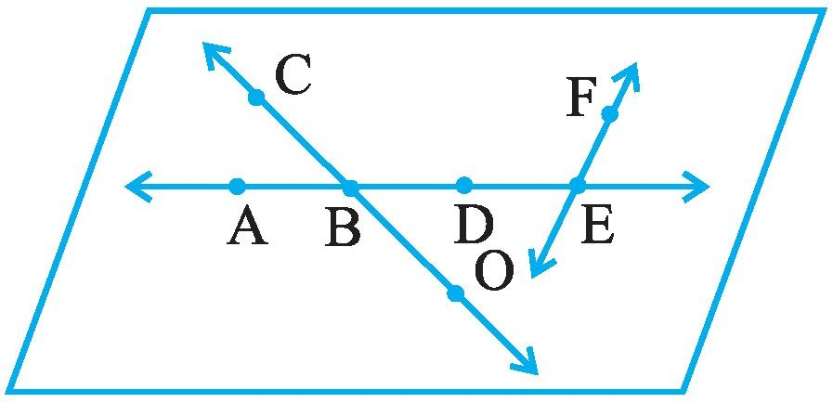
  - XY and PQ intersect at M.
  - Line l contains E and F but not D.
  - OP and OQ meet at O.

- Use the figure to name :
  - Line containing point E.
  - Line passing through A.
  - Line on which O lies
  - Two pairs of intersecting lines.

- Draw rough diagrams to illustrate the following :
  - Open curve (b) Closed curve.

- Draw any polygon and shade its interior.

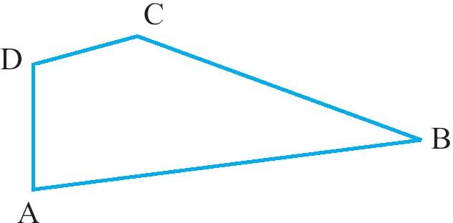
- Illustrate, if possible, each one of the following with a rough diagram:
  - A closed curve that is not a polygon.
  - An open curve made up entirely of line segments.
  - A polygon with two sides.

- Name the angles in the given figure.

- In the given diagram, name the point(s)
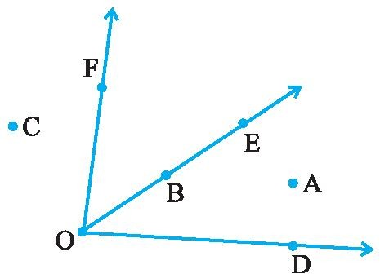
  - In the interior of ∠DOE
  - In the exterior of ∠EOF
  - On ∠EOF
- Draw rough diagrams of two angles such that they have
  - One point in common.
  - Two points in common.
  - Three points in common.
  - Four points in common.
  - One ray in common.

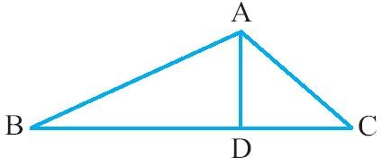
- (a) Identify three triangles in the figure.
  - Write the names of seven angles.
  - Write the names of six line segments.
  - Which two triangles have ∠B as common?

- Draw a rough sketch of a quadrilateral PQRS. Draw its diagonals. Name them. Is the meeting point of the diagonals in the interior or exterior of the quadrilateral?

- Draw a rough sketch of a quadrilateral KLMN. State,
  - two pairs of opposite sides,
  - two pairs of opposite angles,
  - two pairs of adjacent sides,
  - two pairs of adjacent angles.

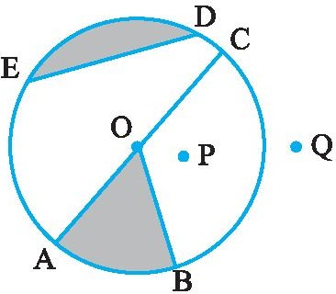
- Draw any circle and mark
  - its centre (b) a radius
(c) a diameter (d) a sector
(e) a segment (f) a point in its interior
(g) a point in its exterior (h) an arc

- From the figure, identify :
  - the centre of circle (b) three radii
(c) a diameter (d) a chord
(e) two points in the interior (f) a point in the exterior
(g) a sector (h) a segment

- Draw a rough sketch of a triangle ABC. Mark a point P in its interior and a point Q in its exterior. Is the point A in its exterior or in its interior?

- Name the rays given in below figure. Is T a starting point of each of these rays?
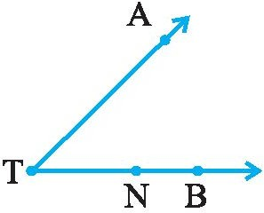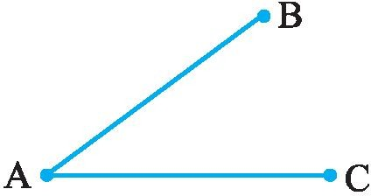
- Name the line segments in the above right figure. Is A, the end point of each line segment?

- Classify the following curves as (i) Open or (ii) Closed.
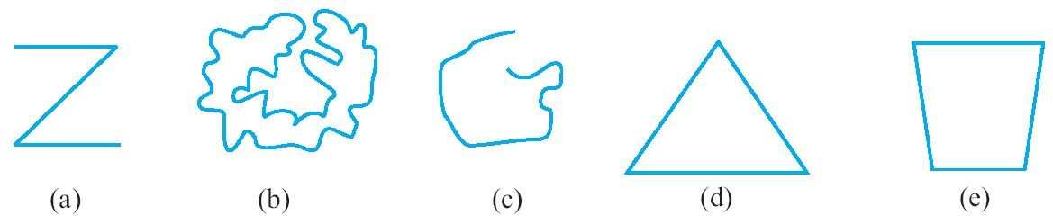

ASSIGNMENT QUESTIONS

CLASS - VI: CHAPTER - 4
BASIC GEOMETRICAL IDEAS

- Name the line segments shown in Fig
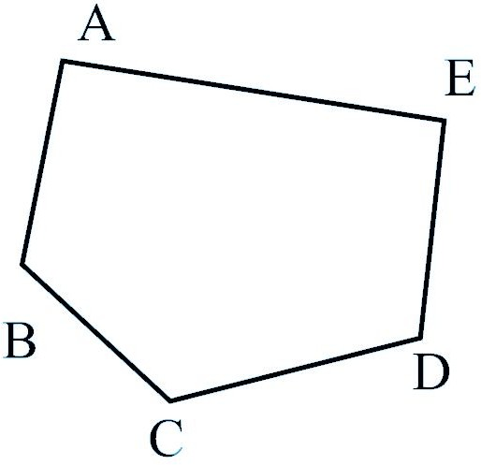
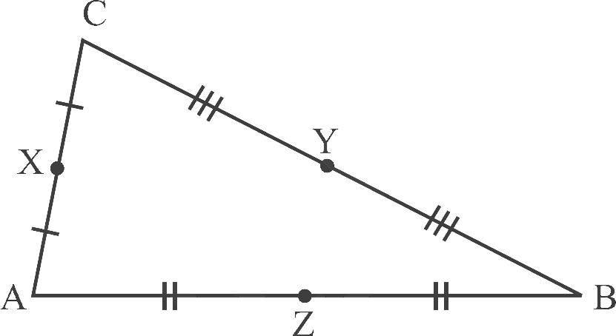
- State the mid points of all the sides of Fig.
- Name the vertices and the line segments in Fig
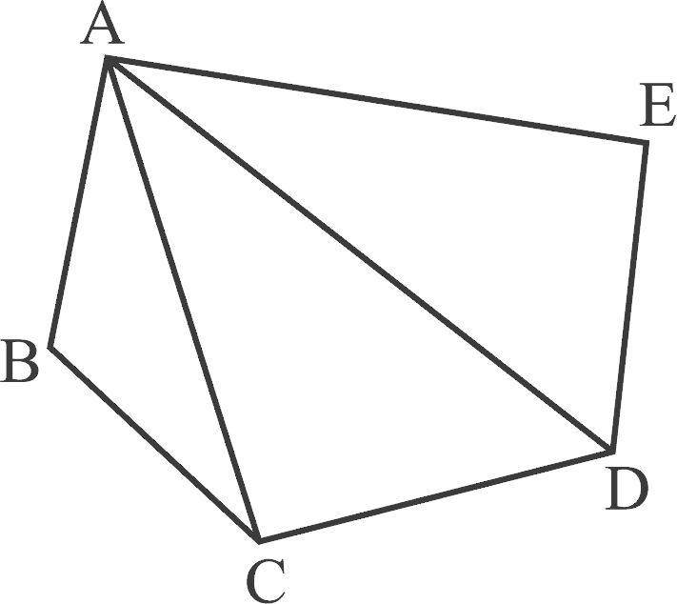
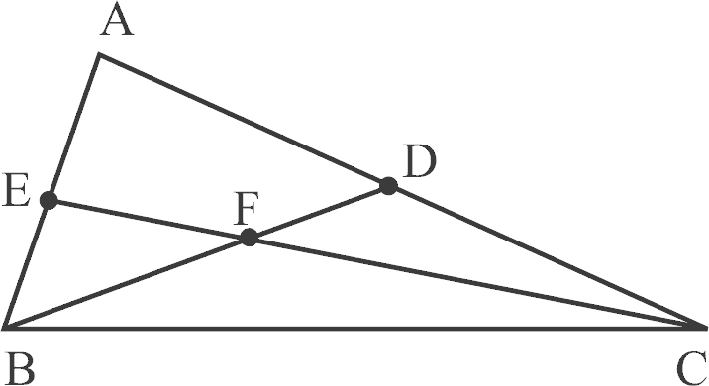
- Write down fifteen angles (less than 180° ) involved in Fig.

- In Fig., (a) name any four angles that appear to be acute angles.
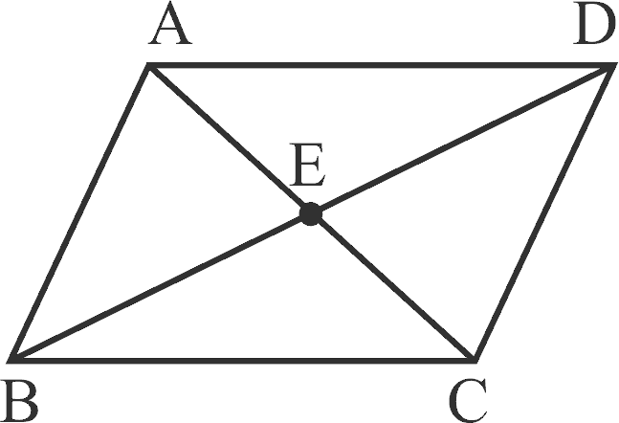
(b) name any two angles that appear to be obtuse angles.
- Name the following angles of Fig., using three letters:
(a) ∠ 1 (b) ∠ 2 (c) ∠ 3 (d) ∠ 1 + ∠ 2
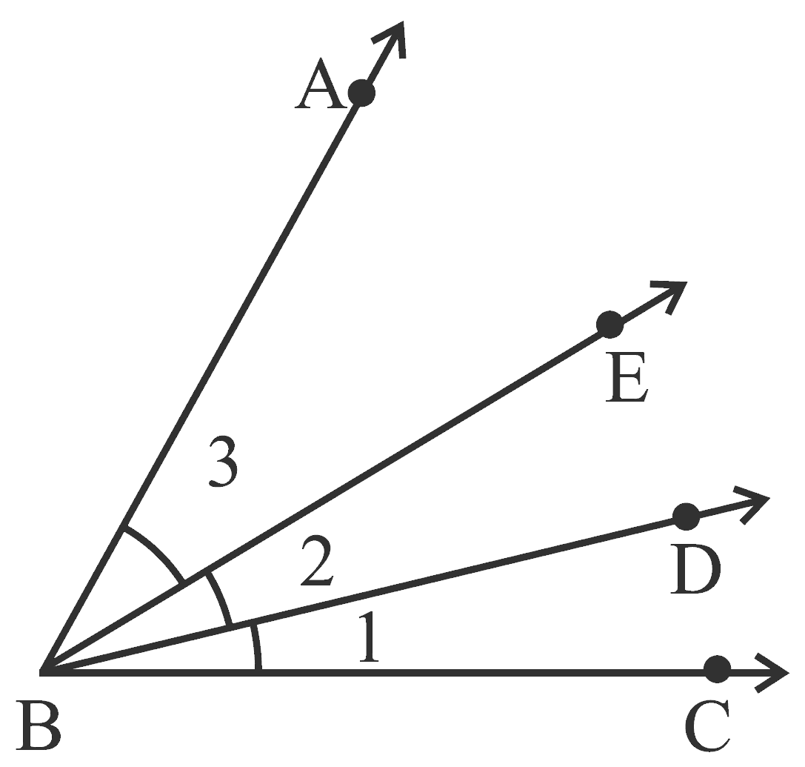
(e) ∠ 2 + ∠ 3 (f) ∠ 1 + ∠ 2 + ∠ 3 (g) ∠ CBA – ∠ 1

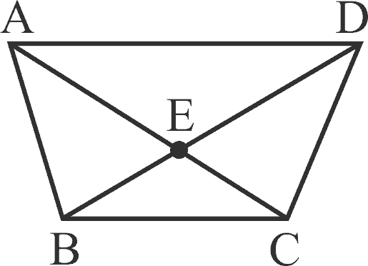
- In the above right sided Fig.,
  - What is AE + EC? (b) What is AC – EC?
(c) What is BD – BE? (d) What is BD – DE?
- In Fig. how many points are marked? Name them. Also, find how many line segments are there? Name them.
- In the above right sided Fig. how many points are marked? Name them. Also, find how many line segments are there? Name them.

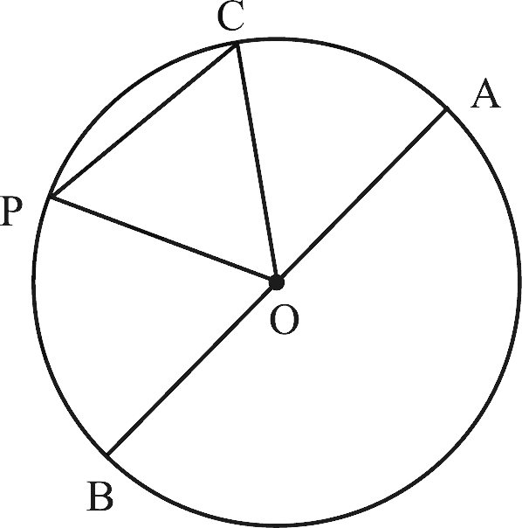
- In Fig., O is the centre of the circle.
  - Name all chords of the circle.
  - Name all radii of the circle.
  - Name a chord, which is not the diameter of the circle.
  - Shade sectors OAC and OPB.
  - Shade the smaller segment of the circle formed by CP.

MCQ WORKSHEET-I

CLASS VI: CHAPTER - 5
UNDERSTANDING ELEMENTARY SHAPES

- An angle whose measure is equal to one-fourth of a revolution is
  - acute angle (b) obtuse angle (c) right angle (d) straight angle

- An angle whose measure is equal to half of a revolution is
  - acute angle (b) obtuse angle (c) right angle (d) straight angle

- An angle whose measure is equal to a full revolution is
  - complete angle (b) obtuse angle (c) right angle (d) straight angle

- An angle whose measure is equal to 90⁰.
  - acute angle (b) obtuse angle (c) right angle (d) straight angle

- An angle whose measure is less than 90⁰.
  - acute angle (b) obtuse angle (c) right angle (d) straight angle

- An angle whose measure is more than 90⁰.
  - acute angle (b) obtuse angle (c) right angle (d) straight angle

- An angle whose measure is less than that of a right angle is .
  - acute angle (b) obtuse angle (c) right angle (d) straight angle

- An angle whose measure is greater than that of a right angle is .
  - acute angle (b) obtuse angle (c) right angle (d) straight angle

- An angle whose measure is the sum of the measures of two right angles is .
  - acute angle (b) obtuse angle (c) right angle (d) straight angle

- When the sum of the measures of two angles is that of a right angle, then each one of them is
.
  - acute angle (b) obtuse angle (c) right angle (d) straight angle

- When the sum of the measures of two angles is that of a straight angle and if one of them is acute then the other should be .
  - acute angle (b) obtuse angle (c) right angle (d) straight angle

- What fraction of a clockwise revolution does the hour hand of a clock turn through, when it goes from 3 to 9

  - 1 2
  - 3 4
  - 1 4
  - none of these

- What fraction of a clockwise revolution does the hour hand of a clock turn through, when it goes from 12 to 3

  - 1 2
  - 3 4
  - 1 4
  - none of these

- What fraction of a clockwise revolution does the hour hand of a clock turn through, when it goes from 3 to 6

  - 1 2
  - 3 4
  - 1 4
  - none of these

- What fraction of a clockwise revolution does the hour hand of a clock turn through, when it goes from 4 to 7

  - 1 2
  - 3 4
  - 1 4
  - none of these

- What fraction of a clockwise revolution does the hour hand of a clock turn through, when it goes from 7 to 10

  - 1 2
  - 3 4
  - 1 4
  - none of these

- What fraction of a clockwise revolution does the hour hand of a clock turn through, when it goes from 12 to 9

  - 1 2
  - 3 4
  - 1 4
  - none of these

- What fraction of a clockwise revolution does the hour hand of a clock turn through, when it goes from 1 to 10

  - 1 2
  - 3 4
  - 1 4
  - none of these

- What fraction of a clockwise revolution does the hour hand of a clock turn through, when it goes from 6 to 3

  - 1 2
  - 3 4
  - 1 4
  - none of these

- What fraction of a clockwise revolution does the hour hand of a clock turn through, when it goes from 5 to 11

  - 1 2
  - 3 4
  - 1 4
  - none of these

- Where will the hand of a clock stop if it starts at 12 and makes 1 of a revolution, clockwise?
2
  - 3 (b) 6 (c) 9 (d) none of these
- Where will the hand of a clock stop if it starts at 12 and makes 1 of a revolution, clockwise?
4
  - 3 (b) 6 (c) 9 (d) none of these

- Where will the hand of a clock stop if it starts at 12 and makes 3
4

of a revolution, clockwise?

  - 3 (b) 6 (c) 9 (d) none of these
- Where will the hand of a clock stop if it starts at 2 and makes 1 of a revolution, clockwise?
2
  - 5 (b) 8 (c) 11 (d) none of these

- Where will the hand of a clock stop if it starts at 2 and makes 3
4

of a revolution, clockwise?

  - 5 (b) 8 (c) 11 (d) none of these
- Where will the hand of a clock stop if it starts at 2 and makes 1 of a revolution, clockwise?
4
  - 5 (b) 8 (c) 11 (d) none of these
- Where will the hand of a clock stop if it starts at 3 and makes 1 of a revolution, clockwise?
2
  - 12 (b) 6 (c) 9 (d) none of these

- Where will the hand of a clock stop if it starts at 3 and makes 1
4

of a revolution, clockwise?

  - 12 (b) 6 (c) 9 (d) none of these

- Where will the hand of a clock stop if it starts at 3 and makes 3
4

of a revolution, clockwise?

  - 12 (b) 6 (c) 9 (d) none of these

- Where will the hand of a clock stop if it starts at 6 and makes 3
4

of a revolution, clockwise?

  - 3 (b) 6 (c) 9 (d) none of these

- Where will the hand of a clock stop if it starts at 6 and makes 1
4

of a revolution, clockwise?

  - 3 (b) 6 (c) 9 (d) none of these

- Where will the hand of a clock stop if it starts at 6 and makes 1
2

of a revolution, clockwise?

  - 3 (b) 6 (c) 9 (d) none of these

- Which direction will you face if you start facing east and make 1 of a revolution clockwise?
2
  - east (b) west (c) north (d) south

- Which direction will you face if you start facing east and make 3
4

of a revolution clockwise?

  - east (b) west (c) north (d) south

- Which direction will you face if you start facing east and make 11
2

of a revolution clockwise?

  - east (b) west (c) north (d) south
- Which direction will you face if you start facing west and make 1 of a revolution clockwise?
2
  - east (b) west (c) north (d) south

- Which direction will you face if you start facing west and make 3
4

of a revolution clockwise?

  - east (b) west (c) north (d) south

- Which direction will you face if you start facing west and make 11
2

of a revolution clockwise?

  - east (b) west (c) north (d) south
- Which direction will you face if you start facing north and make 1 of a revolution clockwise?
2
  - east (b) west (c) north (d) south

- Which direction will you face if you start facing north and make 3
4

of a revolution clockwise?

  - east (b) west (c) north (d) south

- Which direction will you face if you start facing north and make 11
2

of a revolution clockwise?

  - east (b) west (c) north (d) south
- Which direction will you face if you start facing south and make 1 of a revolution clockwise?
2
  - east (b) west (c) north (d) south

- Which direction will you face if you start facing south and make 3
4

of a revolution clockwise?

  - east (b) west (c) north (d) south

- Which direction will you face if you start facing south and make 11
2

of a revolution clockwise?

  - east (b) west (c) north (d) south

- Find the number of right angles turned through by the hour hand of a clock when it goes from 2 to 8.
  - 1 right angle (b) 2 right angles (c) 3 right angles (d) 4 right angles

- Find the number of right angles turned through by the hour hand of a clock when it goes from 5 to 11
  - 1 right angle (b) 2 right angles (c) 3 right angles (d) 4 right angles

- Find the number of right angles turned through by the hour hand of a clock when it goes from 10 to 1
  - 1 right angle (b) 2 right angles (c) 3 right angles (d) 4 right angles

- Find the number of right angles turned through by the hour hand of a clock when it goes from 12 to 9
  - 1 right angle (b) 2 right angles (c) 3 right angles (d) 4 right angles

- Find the number of right angles turned through by the hour hand of a clock when it goes from 1 to 4
  - 1 right angle (b) 2 right angles (c) 3 right angles (d) 4 right angles

- Find the number of right angles turned through by the hour hand of a clock when it goes from 4 to 10
  - 1 right angle (b) 2 right angles (c) 3 right angles (d) 4 right angles

- Find the number of right angles turned through by the hour hand of a clock when it goes from 9 to 3
  - 1 right angle (b) 2 right angles (c) 3 right angles (d) 4 right angles

- Find the number of right angles turned through by the hour hand of a clock when it goes from 6 to 6
  - 1 right angle (b) 2 right angles (c) 3 right angles (d) 4 right angles

- Find the number of right angles turned through by the hour hand of a clock when it goes from 7 to 4
  - 1 right angle (b) 2 right angles (c) 3 right angles (d) 4 right angles

- Find the number of right angles turned through by the hour hand of a clock when it goes from 12 to 6
  - 1 right angle (b) 2 right angles (c) 3 right angles (d) 4 right angles

- Find the number of right angles turned through by the hour hand of a clock when it goes from 1 to 8
  - 1 right angle (b) 2 right angles (c) 3 right angles (d) 4 right angles

- Find the number of right angles turned through by the hour hand of a clock when it goes from 1 to 11
  - 1 right angle (b) 2 right angles (c) 3 right angles (d) 4 right angles

- How many right angles do you make if you start facing south and turn clockwise to west?
  - 1 right angle (b) 2 right angles (c) 3 right angles (d) 4 right angles
- How many right angles do you make if you start facing north and turn anti-clockwise to east?
  - 1 right angle (b) 2 right angles (c) 3 right angles (d) 4 right angles
- How many right angles do you make if you start facing west and turn to west?
  - 1 right angle (b) 2 right angles (c) 3 right angles (d) 4 right angles
- How many right angles do you make if you start facing south and turn to north?
  - 1 right angle (b) 2 right angles (c) 3 right angles (d) 4 right angles
- An angle whose measure is more than 180⁰ but less than 360⁰.
  - reflex angle (b) obtuse angle (c) right angle (d) straight angle

If each angle is less than 90°, then the triangle is called .
  - an acute angled triangle (b) a right angled triangle
(c) an obtuse angled triangle (d) none of these.

If any one angle is a right angle then the triangle is called .
  - an acute angled triangle (b) a right angled triangle
(c) an obtuse angled triangle (d) none of these.

If any one angle is greater than 90°, then the triangle is called .
  - an acute angled triangle (b) a right angled triangle
(c) an obtuse angled triangle (d) none of these.
- Name the type of triangle: Triangle with lengths of sides 7 cm, 8 cm and 9 cm.
  - scalene triangle (b) isosceles triangle (c) right triangle (d) equilateral triangle
- Name the type of triangle: ΔABC with AB = 8.7 cm, AC = 7 cm and BC = 6 cm.
  - scalene triangle (b) isosceles triangle (c) right triangle (d) equilateral triangle
- Name the type of triangle: ΔPQR such that PQ = QR = PR = 5 cm.
  - scalene triangle (b) isosceles triangle (c) right triangle (d) equilateral triangle
- Name the type of triangle: ΔDEF with m∠D = 90°
  - scalene triangle (b) isosceles triangle (c) right triangle (d) equilateral triangle
- Name the type of triangle: ΔXYZ with m∠Y = 90° and XY = YZ.
  - scalene triangle (b) isosceles triangle (c) right triangle (d) both (b) and (c)
- Name the type of triangle: ΔLMN with m∠L = 30°, m∠M 70° and m∠N 80°.
  - an acute angled triangle (b) a right angled triangle
(c) an obtuse angled triangle (d) none of these.
- Name the type of triangle: ΔPQR such that PQ = QR = 5 cm and PR = 7 cm.
  - scalene triangle (b) isosceles triangle (c) right triangle (d) equilateral triangle

- Name the polygon with 3 sides.  - Triangle (b) Quadrilateral | (c) Pentagon | (d) Hexagon
- Name the polygon with 4 sides.  - Triangle (b) Quadrilateral | (c) Pentagon | (d) Hexagon
- Name the polygon with 5 sides.  - Triangle (b) Quadrilateral | (c) Pentagon | (d) Hexagon
- Name the polygon with 6 sides.  - Triangle (b) Quadrilateral | (c) Pentagon | (d) Hexagon
- Name the polygon with 8 sides.  - Octagon (b) Quadrilateral | (c) Pentagon | (d) Hexagon

- Name the quadrilateral with property “One pair of parallel sides”.
  - Trapezium (b) Parallelogram (c) Rectangle (d) Rhombus

- Name the quadrilateral with property “Two pairs of parallel sides”.
  - Trapezium (b) Parallelogram (c) Rectangle (d) Rhombus

- Name the quadrilateral with property “Parallelogram with 4 right angles”.
  - Trapezium (b) Square (c) Rectangle (d) Rhombus

- Name the quadrilateral with property “Parallelogram with 4 sides of equal length”.
  - Trapezium (b) Square (c) Rectangle (d) Rhombus

- Name the quadrilateral with property “A rhombus with 4 right angles”.
  - Trapezium (b) Square (c) Rectangle (d) Rhombus

- A cuboid has rectangular faces.
(a) 4 (b) 6 (c) 8 (d) 12

- A cuboid has edges.
(a) 4 (b) 6 (c) 8 (d) 12

- A cuboid has vertices.
(a) 4 (b) 6 (c) 8 (d) 12

- The number of faces of a cube is .
(a) 1 (b) 6 (c) 2 (d) 3

- The number of faces of a cone is .
(a) 1 (b) 6 (c) 2 (d) 3

- The number of vertices of a cube is .
(a) 4 (b) 6 (c) 8 (d) 12

- The number of vertices of a cone is .

(a) 1 (b) 6 (c) 2 (d) 3

- The number of faces of a triangular prism is .

  - 4 (b) 5 (c) 6 (d) none of these
- The number of faces of a square pyramid is .
  - 4 (b) 5 (c) 6 (d) none of these
- The number of faces of a triangular pyramid or tetrahedron is .
  - 4 (b) 5 (c) 6 (d) none of these
- The number of edges of a triangular prism is .
(a) 6 (b) 8 (c) 9 (d) 12
- The number of edges of a square pyramid is .
(a) 6 (b) 8 (c) 9 (d) 12
- The number of edges of a triangular pyramid is .
(a) 6 (b) 8 (c) 9 (d) 12

- The number of faces of a triangular prism is .
(a) 6 (b) 8 (c) 4 (d) 5
- The number of faces of a triangular pyramid is .
(a) 6 (b) 8 (c) 4 (d) 5
- The number of faces of a square pyramid is .
(a) 6 (b) 8 (c) 4 (d) 5
- The corners of a solid shape are called its .
  - vertices (b) edges (c) faces (d) net
- Name of the solid given below left figure.
  - Cylinder b) Cone c) Sphere d) Cuboid
- Name of the solid given above sided right figure.
  - triangular pyramid b) Cone c) triangular prism d) Cuboid

- How many millimeters make one centimetre?
- Draw any line segment, say AB. Take any point C lying in between A and B. Measure the lengths of AB, BC and AC. Is AB = AC + CB?

- If A,B,C are three points on a line such that AB = 5 cm, BC = 3 cm and AC = 8 cm, which one of them lies between the other two?

- If B is the mid point of AC and C is the mid point of BD, where A,B,C,D lie on a straight line, say why AB = CD?

- Find the number of right angles turned through by the hour hand of a clock when it goes from (a) 3 to 6 (b) 2 to 8 (c) 5 to 11 (d) 10 to 1 (e) 12 to 9 (f) 12 to 6

- How many right angles do you make if you start facing
  - south and turn clockwise to west?
  - north and turn anti-clockwise to east?
  - west and turn to west?
  - south and turn to north?
- The hour hand of a clock moves from 12 to 5. Is the revolution of the hour hand more than 1 right angle?
- What does the angle made by the hour hand of the clock look like when it moves from 5 to 7. Is the angle moved more than 1 right angle?

- Draw the following and check the angle with your RA tester.
  - going from 12 to 2 (b) from 6 to 7
(c) from 4 to 8 (d) from 2 to 5
- Fill in the blanks with acute, obtuse, right or straight :
  - An angle whose measure is less than that of a right angle is .
  - An angle whose measure is greater than that of a right angle is .
  - An angle whose measure is the sum of the measures of two right angles is .
  - When the sum of the measures of two angles is that of a right angle, then each one of them is .
  - When the sum of the measures of two angles is that of a straight angle and if one of them is
acute then the other should be .
- Find the angle measure between the hands of the clock in each figure :
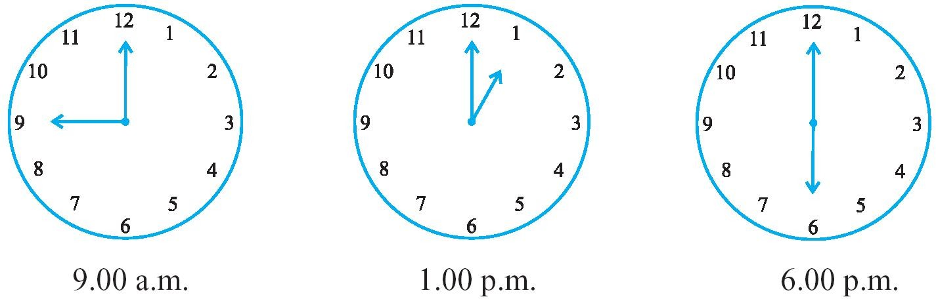

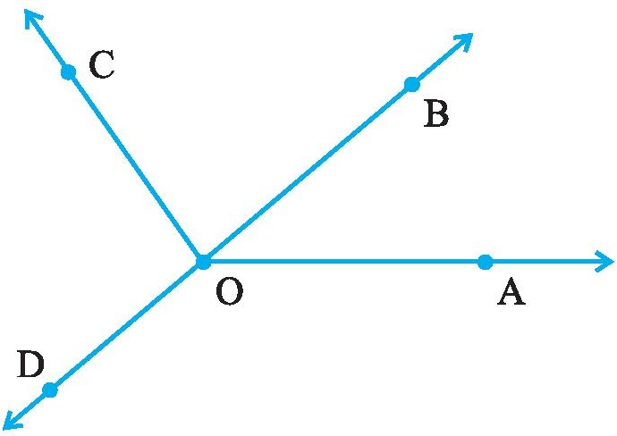
- Measure and classify each angle :

Angle | Measure | Type
∠AOB
∠AOC
∠BOC
∠DOC
∠DOA
∠DOB

- Name the types of following triangles :
  - Triangle with lengths of sides 7 cm, 8 cm and 9 cm.
  - ΔABC with AB = 8.7 cm, AC = 7 cm and BC = 6 cm.
  - ΔPQR such that PQ = QR = PR = 5 cm.
  - ΔDEF with m ∠D = 90°
  - ΔXYZ with m ∠Y = 90° and XY = YZ.
  - ΔLMN with m ∠L = 30°, m ∠M = 70° and m ∠N = 80°.

- Complete the following table with Yes or No:
Quadrilateral | Opposite sides |  | All sides  Equal | Opposite  angle equal | Diagonals
 | Parallel | Equal |  |  | Equal | Perpendicular
Parallelogram
Rectangle
Square
Rhombus
Trapezium

- Give reasons for the following :
  - A square can be thought of as a special rectangle.
  - A rectangle can be thought of as a special parallelogram.
  - A square can be thought of as a special rhombus.
  - Squares, rectangles, parallelograms are all quadrilaterals.
  - Square is also a parallelogram.

- Name each polygon.
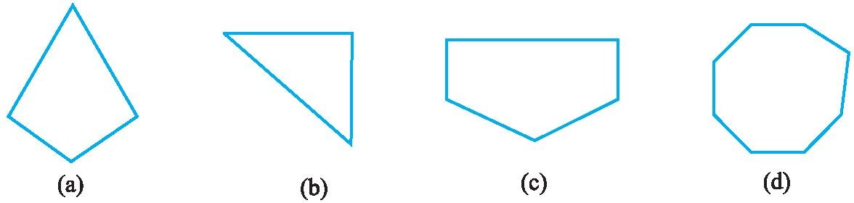

- Draw a rough sketch of a regular hexagon. Connecting any three of its vertices, draw a triangle. Identify the type of the triangle you have drawn.

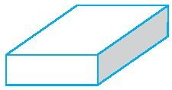
- Complete the following:

- A cuboid looks like a rectangular box. It has faces.
Each face has edges.
Each face has corners (called vertices).

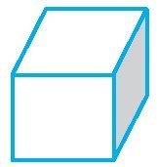
- A cube is a cuboid whose edges are all of equal length. It has faces.
Each face has edges. Each face has vertices.

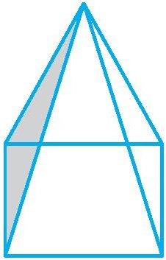
- A square pyramid has a square as its base. Faces :
Edges : Corners :

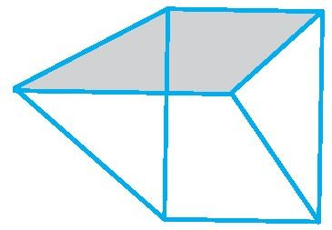
- A triangular prism looks like the shape of a Kaleidoscope. It has triangles as its bases. Faces :
Edges : Corners :

- A triangular pyramid has a triangle as its base. It is also known as a tetrahedron. Faces :
Edges : Corners :

- 2 subtracted from 7 gives
(a) – 9 (b) 5 (c) - 5 (d) 9

- 5 added to – 5 gives
(a) 10 (b) - 10 (c) 0 (d) - 25

- 3 taken away from 0 gives
  - 3 (b) - 3 (c) 0 (d) not possible

- Smallest integer is
  - 0 (b) - 1 (c) we cannot write (d) – 10000

- Which of the following statement is true:
  - 2 subtracted from – 3 gives 1 (b) – 1 subtracted from – 5 gives 6 (c)3 subtracted from – 8 gives – 11 (d)1 subtracted from – 7 gives – 6

- Absolute value of - 11 is
(a) 10 (b) – 1 (c) 11 (d) – 11

- The number 3 less than – 2 is
(a) – 1 (b) 1 (c) 5 (d) – 5

- Which of the following numbers is to the right of -3 on number line ?
(a) -4 (b) -2 (c) -5 (d ) -6

- Which of the following number is not to the left of -10 on the number line ? (a) -9 (b) - 11 (c) -12 (d) -13

- The number of integers between -2 and 2 is-
(a) 5 (b) 4 (c) 3 (d) 2

- The opposite of -7 is
(a) – 6 (b) 6 (c) 5 (d) 7

- Sum of two negative integers is always
  - Positive (b) Negative (c) 0 (d) 1

- Sum of – 30 and – 12 is
(a) 42 (b) - 18 (c) - 42 (d) 18

- In addition and subtraction of the integers the sign of answer depends upon
  - Smaller Number (b) Their Difference (c) Their Sum (d) Greater numerical value

- Sum of -14 and 9 is
(a) 23 (b) – 23 (c) – 5 (d) 5

- Which of the following number is greater than – 1 ?
(a) – 2 (b) – 10 (c) 0 (d) – 3

- The preceding number of - 1 on number line is:
(a) 0 (b) 1 (c) 2 (d) - 2

- Which number is 5 more than – 3?
(a) – 2 (b) 2 (c) 8 (d) - 8

- 7 steps to the left of 4 on number line gives:
(a) 3 (b) 11 (c) - 11 (d) - 3

- 2 steps to the right of – 1 on number line gives:
(a) 0 (b) 1 (c) – 3 (d) 3

- Which number is being represented by the point A on following number line: A

  - – 9
0
(b) 5 (c) -5 (d) - 6

- What number is being represented by points A and B respectively on the number line:
B A
0
  - 3 and 2 (b) 2 and 3 (c) - 3 and – 2 (d) 3 and – 2

- The integer succeeding - 9 is:
(b) – 10 (b) 10 (c) - 8 (d) 8

- What will be the opposite of 3 Km south?
  - 3 km east (b) 3 km north (c) 3 km north east (d) 3 km west

- Which of the following set of numbers is in descending orders?
(a) 2, - 2 , 1 , - 1 (b) 0, 1, 2, 3 (c) 1, 0 , - 1 , -2 (d) – 3 ,- 2 , -1 , 0

- Which of the following statements is false:
  - 0 lies to the left of – 1 (b)2 lies to the right of 1 (c)1 lies to the right of 0 (d) – 2 lies to the left of – 1

- 5 added to the – 1 gives
(a) 4 (b) - 4 (c) 6 (d) - 6

- 7 added to – 1 gives
(a) 6 (b) - 6 (c) - 8 (d) 8

- 3 added to – 3 gives
(a) 0 (b) 6 (c) - 6 (d) 9

- 1 subtracted from – 1 gives
(a) 0 (b) - 1 (c) - 2 (d) 2

- Sum of – 10 , - 5 and 12 is
(a) 27 (b) – 3 (c) 3 (d) – 27

- Which of the following statements is false
(a)– 4 > - 5 (b) – 4 < 5 (c) 4 < - 5 (d) 4 > - 5
- Which of the following is in increasing order
(a) 0 , 1 , - 1 (b) – 1 , - 2 , - 3 (c) – 1 , 0 , 1 (d) – 1 , 1 , - 2

- Which of the following is correct
(a) – 8 > - 7 (b) 1 < 0 (c) – 1 < 0 (d) – 2 > 4

- Which of the following number forms a pattern
(a) – 6 , - 3 , 0 , 3 (b) – 5 , - 3 , - 2 , 0 (c) 0 , 2 , 3 , 4 (d) 1 , 2 , 4 , 6

- Sum of – 36 and 29 is
(a) –65 (b) 65 (c) –7 (d) 7

- Which of the following will give answer with negative sign
(a) – 48 + 79 (b) – 40 + 40 (c) – 48 + 30 (d) 48 + ( - 39 )

- What will be the additive inverse of -1 ?
(a) -2 (b) -1 (c) 0 (d) 1

- Sum of two positive integers is always-
  - Negative (b) positive (c) 0 (d) 1

- Sum of a negative and a positive integer is –
  - Always negative (b) either positive or negative (c) always positive (d) Zero

- The pair of integers whose sum is –5
(a) 1, –4 (b) –1 , 6 (c) –3 , –2 (d) 5, 0

15. 39 – 50 is
  - Not possible (b) -89 (c) -11 (d) 10

- Write the following numbers with appropriate signs :
  - 100 m below sea level.
  - 25°C above 0°C temperature.
  - 15°C below 0°C temperature.
  - any five numbers less than 0.

- Mark –3, 7, –4, –8, –1 and – 3 on the number line.

- By looking at the number line, answer the following questions : Which integers lie between – 8 and – 2? Which is the largest integer and the smallest integer among them?

- (a) One button is kept at – 3. In which direction and how many steps should we move to reach at
– 9?
  - Which number will we reach if we move 4 steps to the right of – 6.

- Represent the following numbers as integers with appropriate signs.
  - An aeroplane is flying at a height two thousand metre above the ground.
  - A submarine is moving at a depth, eight hundred metre below the sea level.
  - A deposit of rupees two hundred.
  - Withdrawal of rupees seven hundred.

- Represent the following numbers on a number line :
(a) + 5 (b) – 10 (c) + 8 (d) – 1 (e) – 6

- (a) Write four negative integers greater than – 20.
(b) Write four negative integers less than – 10.

- Draw a number line and answer the following :
  - Which number will we reach if we move 4 numbers to the right of – 2.
  - Which number will we reach if we move 5 numbers to the left of 1.
  - If we are at – 8 on the number line, in which direction should we move to reach – 13?
  - If we are at – 6 on the number line, in which direction should we move to reach – 1?

- Find the answers of the following additions: (a) (– 11) + (– 12)
(b) (+ 10) + (+ 4)
(c) (– 32) + (– 25)
(d) (+ 23) + (+ 40)

- Find the solution of the following: (a) (– 7) + (+ 8)
(b) (– 9) + (+13)
(c) (+ 7) + (– 10)
(d) (+12) + (– 7)

- Find the solution of the following additions using a number line : (a) (– 2) + 6 (b) (– 6) + 2

- Find the solution of the following without using number line : (a) (+ 7) + (– 11)
(b) (– 13) + (+ 10)
(c) (– 7) + (+ 9)
(d) (+ 10) + (– 5)

- Using the number line, write the integer which is
  - 4 more than –1
  - 5 less than 3

14. Find the sum of (– 9) + (+ 4) + (– 6) + (+ 3)

15. Find the value of (30) + (– 23) + (– 63) + (+ 55)

16. Find the sum of (– 10), (92), (84) and (– 15)

- Find the sum of :
(a) 137 and – 354 (b) – 52 and 52
(c) – 312, 39 and 192 (d) – 50, – 200 and 300

- Find the sum :
(a) (– 7) + (– 9) + 4 + 16
(b) (37) + (– 2) + (– 65) + (– 8)

- Fill in the blanks with >, < or = sign. (a) (– 3) + (– 6) (– 3) – (– 6)
(b) (– 21) – (– 10) (– 31) + (– 11)
(c) 45 – (– 11) 57 + (– 4)
(d) (– 25) – (– 42) (– 42) – (– 25)

- Find
(a) (– 7) – 8 – (– 25)
(b) (– 13) + 32 – 8 – 1
(c) (– 7) + (– 8) + (– 90)
(d) 50 – (– 40) – (– 2)

ASSIGNMENT QUESTIONS

CLASS - VI: CHAPTER - 6
INTEGERS

- Write the opposite of each of the following:
  - Increase in class strength (ii) going north (ii) A loss of Rs 1000

- Indicate the following by integers:
  - 25⁰ above zero (ii) 5⁰ below zero (iii) 300m above the sea level
(iv) 250m below the sea level (v) A profit of Rs. 2000

- Represent the following integers on number line: (i) –4 (ii) 7 (iii) –8

- Write all the integers between:
  - –7 and 3 (ii) – 2 and 2 (iii) –4 and 0

- How many integers are between:
  - – 4 and 3 (ii) 5 and 12 (iii) –9 and –2

- Represent the following using integers with proper sign: (a) 3 km above sea level (b) A loss of Rs 500

- Find the sum of the pairs of integers: (a) – 6, – 4 (b) +3, – 4 (c) +4, –2

- Find the sum of –2 and –3, using the number line.

- Subtract : (i) 3 from –4 (ii) –3 from –4

- Using the number line, subtract : (a) 2 from –3 (b) –2 from –3.

- How many integers are there between –9 and –2 ?

12. Calculate: 1 – 2 + 3 – 4 + 5 – 6 + 7 – 8 + 9 – 10

- The sum of two integers is 47. If one of the integers is – 24, find the other.

- Write the digits 0, 1, 2, 3, 4, 5, 6, 7, 8 and 9 in this order and insert ‘+ ‘or ‘–’ between them to get the result (a) 5 (b) –3

- Compute each of the following:
(a) 30 + (–25) + (–10) (b) (–20) + (–5)
(c) 70 + (–20) + (–30) (d) –50 + (–60) + 50
(e) 1 + (–2) + (– 3) + (– 4) (f) 0 + (– 5) + (– 2)
(g) 0 – (–6) – (+6) (h) 0 – 2 – (–2)

- If we denote the height of a place above sea level by a positive integer and depth below the sea level by a negative integer, write the following using integers with the appropriate signs:
  - 200 m above sea level (b) 100 m below sea level
(c) 10 m above sea level (d) sea level

- Write the opposite of each of the following:
  - Decrease in size (b) Failure
(c) Profit of Rs.10 (d) 1000 A.D.
(e) Rise in water level (f) 60 km south
- 10 m above the danger mark of river Ganga
- 20 m below the danger mark of the river Brahmaputra
- Winning by a margin of 2000 votes
- Depositing Rs.100 in the Bank account
- 20°C rise in temperature.

- Temperature of a place at 12:00 noon was +5°C. Temperature increased by 3°C in first hour and decreased by 1°C in the second hour. What was the temperature at 2:00 pm?

- Write the digits 0, 1, 2, 3, ..., 9 in this order and insert ‘+’ or ‘–’ between them to get the result 3.

- Write the integer which is its own additive inverse.

- Write six distinct integers whose sum is 7.

- Write the integer which is 4 more than its additive inverse.

- Write the integer which is 2 less than its additive inverse.

- Write two integers whose sum is less than both the integers.

- Write two distinct integers whose sum is equal to one of the integers.

- Using number line, how do you compare (a) two negative integers? (b) two positive integers? (c) one positive and one negative integer?

27. Observe the following : 1 + 2 – 3 + 4 + 5 – 6 – 7 + 8 – 9 = –5

- Change one ‘–’ sign as ‘+’ sign to get the sum 9.

- Arrange the following integers in the ascending order : –2, 1, 0, –3, +4, –5

- Arrange the following integers in the descending order : –3, 0, –1, –4, –3, –6

- Write two integers whose sum is 6 and difference is also 6.

- Write five integers which are less than –100 but greater than –150.

- Write four pairs of integers which are at the same distance from 2 on the number line.

- The sum of two integers is 30. If one of the integers is –42, then find the other.

- Sum of two integers is –80. If one of the integers is –90, then find the other.

MCQ WORKSHEET-I

CLASS VI: CHAPTER - 7
FRACTIONS

- Write the fraction representing the shaded region in the below left figure.

  - 3 7
  - 5 7
  - 4 7
  - none of these

- Write the fraction representing the shaded region in the above sided right figure.

  - 3 7
  - 5 7
  - 4 7
  - none of these

- Write the fraction representing the shaded region in the below left figure.

  - 1 4
  - 2 4
  - 3 4
  - none of these

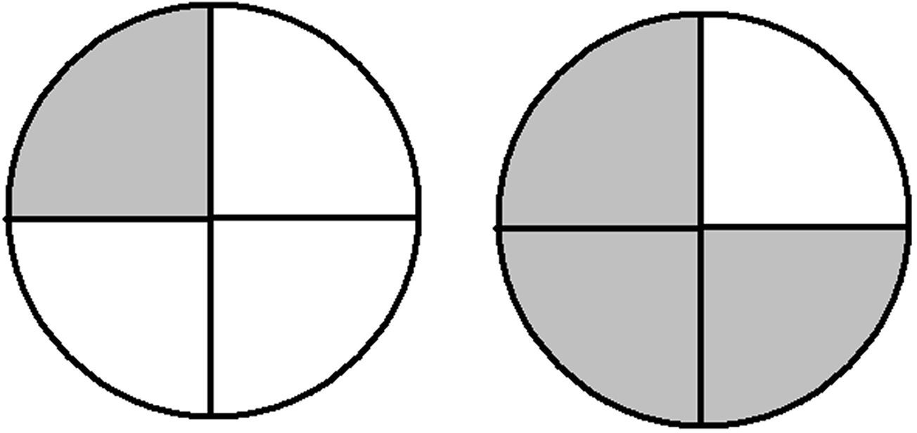
- Write the fraction representing the shaded region in the above sided right figure.

  - 1 4
  - 2 4
  - 3 4
  - none of these

- Write the fraction representing the shaded region in the below left figure.

  - 1 4
  - 2 4
  - 3 4
  - none of these

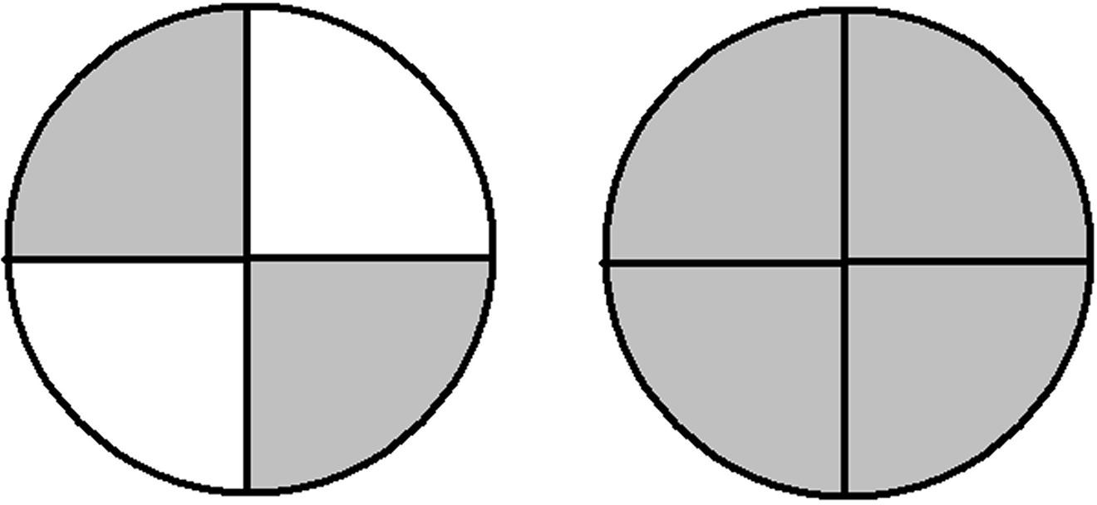
- Write the fraction representing the shaded region in the above sided right figure.

  - 1 4
  - 2 4
  - 3 4
  - none of these

- Write the fraction representing the shaded region in the below left figure.

  - 1 8
  - 4 8
  - 5 8
  - 3 8

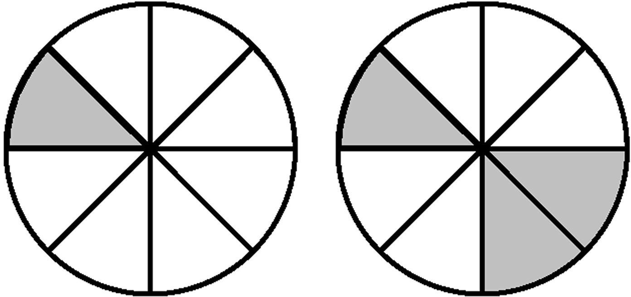
- Write the fraction representing the shaded region in the above sided right figure.

  - 1 8
  - 4 8
  - 5 8
  - 3 8

- Write the fraction representing the shaded region in the below left figure.

  - 1 8
  - 4 8
  - 5 8
  - 3 8

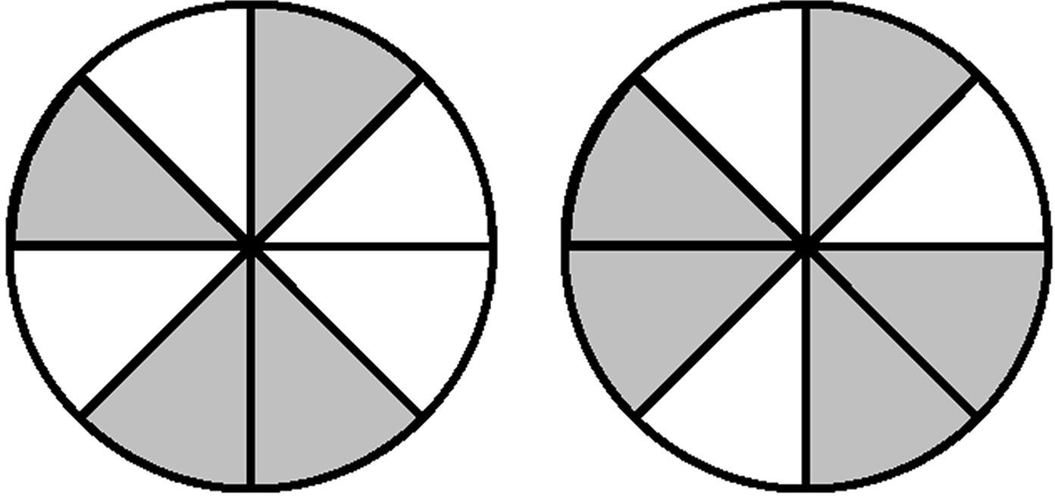
- Write the fraction representing the shaded region in the above sided right figure.

  - 1 8
  - 4 8
  - 5 8
  - 3 8

- Write the fraction representing the shaded region in the below left figure.

  - 4 16
  - 10
16
  - 16
  - 16

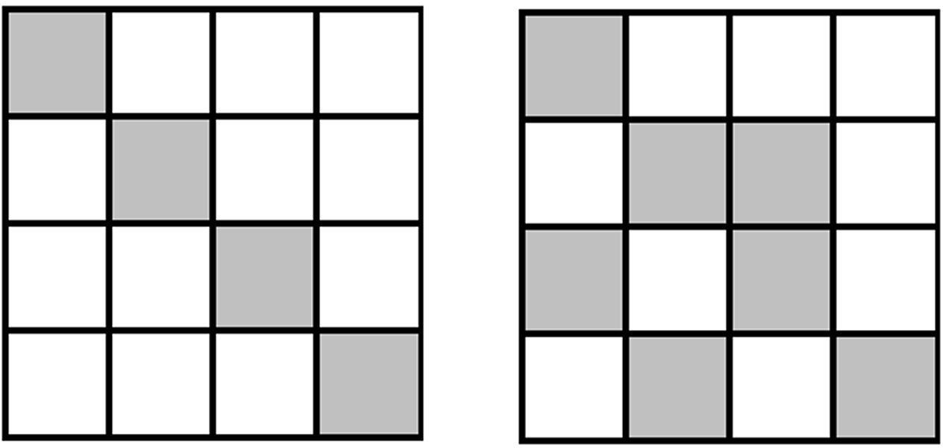
- Write the fraction representing the shaded region in the above sided right figure.

  - 4 16
  - 10
16
  - 16
  - 16

MCQ WORKSHEET-II

CLASS VI: CHAPTER - 7
FRACTIONS

- Write the fraction representing the shaded region in the below left figure.

  - 4 16
  - 10
16
  - 16
  - 16

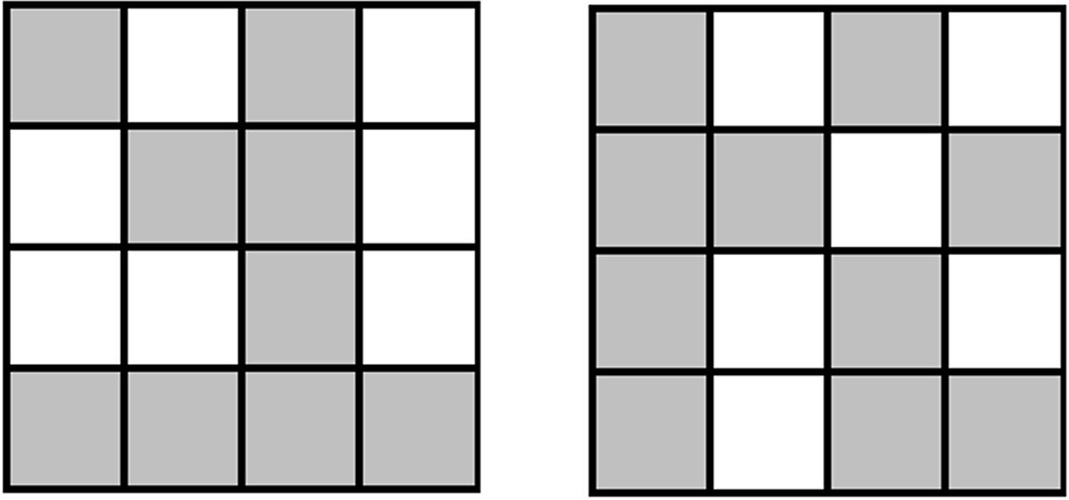
- Write the fraction representing the shaded region in the above sided right figure.

  - 4 16
  - 10
16
  - 16
  - 16

- Write the fraction representing the shaded region in the below left figure.

  - 4 7
  - 6 7
  - 5 7
  - 3 7

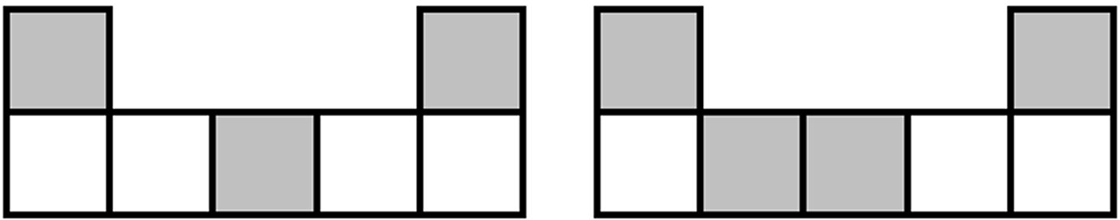
- Write the fraction representing the shaded region in the above sided right figure.

  - 4 7
  - 6 7
  - 5 7
  - 3 7

- Write the fraction representing the shaded region in the below left figure.

  - 4 7
  - 6 7
  - 5 7
  - 3 7

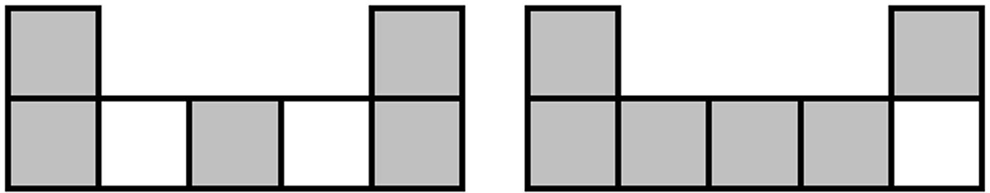
- Write the fraction representing the shaded region in the above sided right figure.

  - 4 7
  - 6 7
  - 5 7
  - 3 7

- Write the fraction representing the shaded region in the below left figure.

  - 6 8
  - 4 8
  - 5 8
  - 7 8

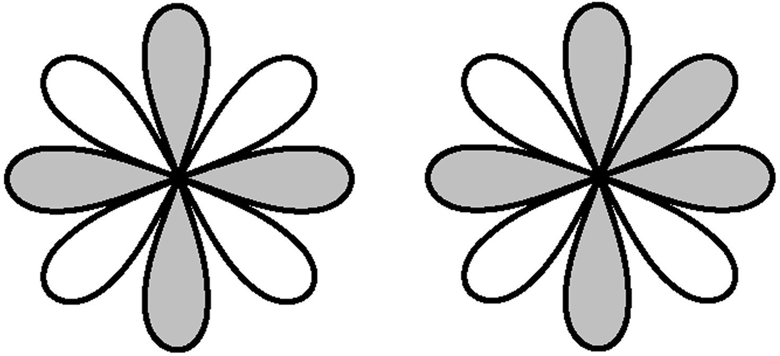

- Write the fraction representing the shaded region in the above sided right figure.

  - 6 8
  - 4 8
  - 5 8
  - 7 8

- Write the fraction representing the shaded region in the below left figure.

  - 6 8
  - 4 8
  - 5 8
  - 7 8

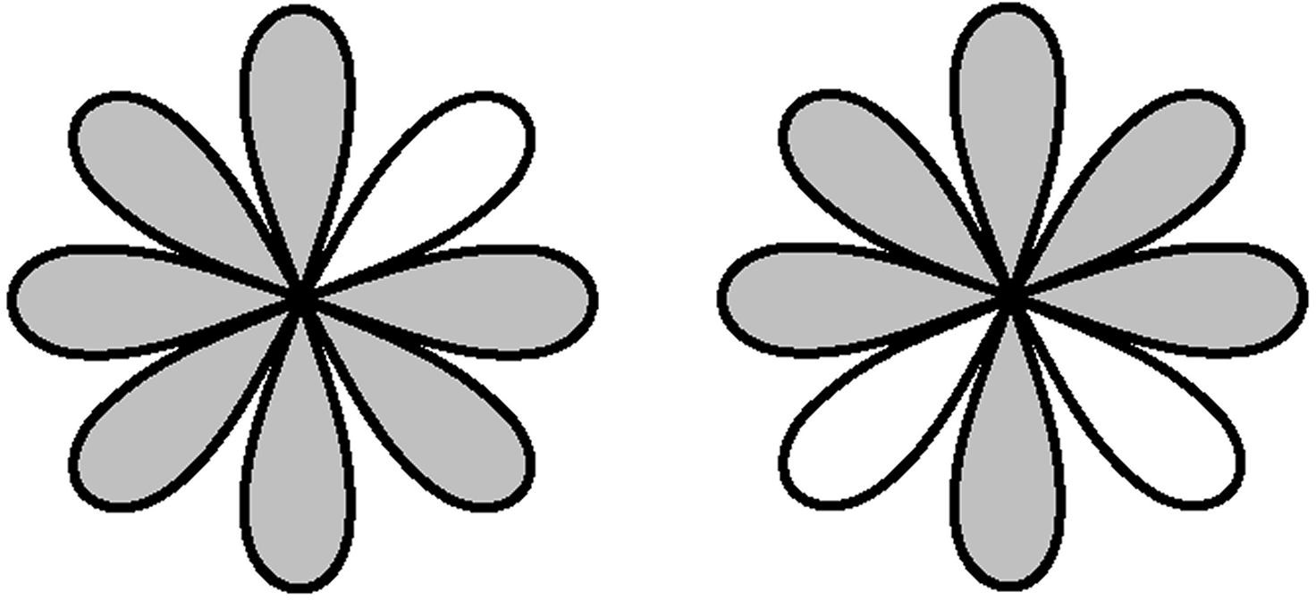
- Write the fraction representing the shaded region in the above sided right figure.

  - 6 8
  - 4 8
  - 5 8
  - 7 8

- Fill in the boxes with the correct symbol: 1 1
2 1
  - > (b) < (c) = (d) none of these

- Fill in the boxes with the correct symbol:
3 ..... 1
3 1
  - > (b) < (c) = (d) none of these

- Fill in the boxes with the correct symbol: 1 7
1 6
  - > (b) < (c) = (d) none of these

- Fill in the boxes with the correct symbol: 1 3
2 2
  - > (b) < (c) = (d) none of these

MCQ WORKSHEET-III

CLASS VI: CHAPTER - 7
FRACTIONS

- Fill in the boxes with the correct symbol: 3 2
4 4
  - > (b) < (c) = (d) none of these
- Fill in the boxes with the correct symbol: 5 7
8 8
  - > (b) < (c) = (d) none of these
- Fill in the boxes with the correct symbol: 5 7
5 7
  - > (b) < (c) = (d) none of these
- What fraction of a day is 8 hours?

  - 4 3
  - 3 4
  - 1 2
  - 4 5

- What fraction of an hour is 45 minutes?

  - 1 8
  - 8 1
  - 3 1
  - 1 3

The points P, Q, R, S, T, U and V on the number line are such that, US = SV = VR, and WT
= TP = PQ. Answer the following question from Q6 – Q15.
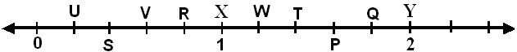

- The fraction represented by P

  - 6 5
  - 9 5
  - 8 5
  - 7 5

- The fraction represented by Q

  - 6 5
  - 9 5
  - 8 5
  - 7 5

- The fraction represented by T

  - 6 5
  - 9 5
  - 8 5
  - 7 5

- The fraction represented by W

  - 6 5
  - 9 5
  - 8 5
  - 7 5

- The fraction represented by U

  - 3 5
  - 2 5
  - 4 5
  - 1 5

- The fraction represented by S

  - 3 5
  - 2 5
  - 4 5
  - 1 5

- The fraction represented by V

  - 3 5
  - 2 5
  - 4 5
  - 1 5

- The fraction represented by R

  - 3 5
  - 2 5
  - 4 5
  - 1 5

- The fraction represented by X

  - 5 5
  - 2 5
  - 4 5
  - 10
5

- The fraction represented by Y

  - 5 5
  - 2 5
  - 4 5
  - 10
5

- The equivalent fraction of 3 with denominator 20 is
5

(a) 12 (b)
20
20 (c)
12
10 (d) 15
20 20

- The equivalent fraction of 3 with numerator 9 is
5

(a) 15 (b)
9
9 (c)
11
9 (d) 9
15 5

- The simplest form of
48 is
60

- 5 (b)
4 (c)
8 (d) 12

4 5 10 15
- Which one of the following is a proper fraction?

  - 5 (b)
6
7 (c)
3
4 (d) 8
3 5

- Which one of the following is an improper fraction?

  - 7 (b)
8
8 (c)
3
3 (d) 9
4 11

- A proper fraction with denominator 7 is

  - 8 (b)
4 (c)
9 (d) 11

7 7 7 7
- A improper fraction with denominator 9 is
(a) 2 (b) 7 (c) 11 (d) 5
9 9 9 9
- 20 can be written in mixed fraction as
3

  - 3 6
2
  - 6 2
3
  - 2 6
3
  - 5 5
3

9. 6 2
3
can be written in improper fraction as

(a)
3 (b) 15 (c)
20 (d) 3

20 3 3 15
- Which of the following can be written in the box 2 = 8
7 .....
(a)16 (b)13 (c) 28 (d) 35

- Which of the following can be written in the box 3 =
5
.... 20

(a) 18 (b)12 (c) 60 (d) 15
- The next equivalent fraction of the given fraction

1 , 2 ,
2 4
3 4 ,……, is
6 8

(a) 7 (b) 6 (c) 15 (d) 5
14 12 5 15

- Which of the following pair of fractions are equivalent

  - 5
9
, 30
54
(b) 3 , 12
10 50
(c) 7 , 5
13 11
(d) 8 7
, 16
21

- Which of the following fraction is a like fraction of 1
15
(a) 2 (b) 15 (c) 3 (d) 5
15 2 7 7
- Which of the following fraction is a unlike fraction of 3
7

  - 5 (b)
7
8 (c)
7
3 (d) 9
5 7

- Which of the following is a larger fraction

  - 1 (b)
9
4 (c)
9
5 (d) 7
9 9

- Which of the following is a smaller fraction

  - 7 (b)
8
5 (c)
8
3 (d) 1
8 8

- Which of the following is a greater fraction

  - 4 (b)
5
5 (c)
6
5 (d) 5
3 2

- Which of the following is a smaller fraction

  - 5 (b)
6
4 (c)
5
5 (d) 5
2 3

- The sum of the fraction
1 and
18
1 is given by
18

- 1 (b)
18
1 (c)
9
2 (d) 36
36 18

- Shubham painted 2 of the wall and his sister painted 1 of the wall space. How much did they
3 3
paint together?

(a)
2 (b)
3
1 (c) 1 (d) 1
3 2

- Javed was given
5 of a basket of oranges. What fraction of oranges was left in the basket?
7

- 4 (b)
2 (c)
5 (d) 12

7
- The value of 1+ 2 is
3
  - 1 (b)
7

7 (c)
3
7 7

5 (d) 3
3 5

- The value of 12 –
15
7 is
15

(a)
1 (b)
3
5 (c)
2
5 (d) 1
1 5

- The value of 3 –
2
2 is
3

- 1 (b)
- The value of 3 – 12 is
5
5 (c) 0 (d) 1
6 6

(a)
9 (b)
5
9 (c)
4
3 (d) 5
5 3

- Which of the following should be put in the given box 4 + = 7
....
10 10

(a) 3 (b) 10 (c)
3
1 (d) 3
3 10

- Which of the following should be put in the given box 7 − = 3
....
10 10

(a)
2 (b) 4 (c)
5
1 (d) 5
4 2

- The value of 1 +
2
3 + 5 is
2 2

  - 5 (b)
9 (c) 17 (d) 9

- The value of 2 +
3
2 2 6
3 + 1 is
4 2

(a)
6 (b)
9
23 (c)
12
21 (d) 6
12 12

- The value of 1 3 2 is
+
1
3 3
(a) 10 (b) 6 (c) 15 (d) 15
3 3 3 6
- The value of 31 – 1 2 is
5 3

  - 9 (b)
9 (c)
1
23 (d) 9
5 5

PRACTICE QUESTIONS

CLASS VI: CHAPTER - 7
FRACTIONS

- Write the fraction representing the shaded portion.
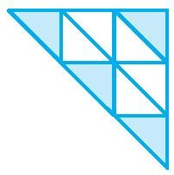
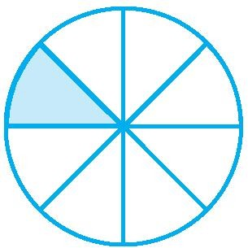
  - (ii) (iii) (iv)

- What fraction of a day is 12 hours?

- What fraction of an hour is 20 minutes?

- Show 3
5

on a number line.

5. Show 1 , 0 , 5 , 10
10 10 10 10

on a number line.

- Can you show any other fraction between 0 and 1? Write five more fractions that you can show and depict them on the number line.

- Give a proper fraction :
  - whose numerator is 5 and denominator is 7.
  - whose denominator is 9 and numerator is 5.
  - whose numerator and denominator add up to 10. How many fractions of this kind can you make?
  - whose denominator is 4 more than the numerator.

- A fraction is given. How will you decide, by just looking at it, whether, the fraction is (a) less than 1? (b) equal to 1?

- Fill up using one of these : ‘>’, ‘<’ or ‘=’

- In a class A of 25 students, 20 passed in first class; in another class B of 30 students, 24 passed in first class. In which class was a greater fraction of students getting first class?

- My mother divided an apple into 4 equal parts. She gave me two parts and my brother one part. How much apple did she give to both of us together?

- Mother asked Neelu and her brother to pick stones from the wheat. Neelu picked one fourth of the total stones in it and her brother also picked up one fourth of the stones. What fraction of the stones did both pick up together?
- Sohan was putting covers on his note books. He put one fourth of the covers on Monday. He put another one fourth on Tuesday and the remaining on Wednesday. What fraction of the covers did he put on Wednesday?

- Find the difference between 7 and 3 .
8 8

- Mother made a gud patti in a round shape. She divided it into 5 parts. Seema ate one piece from it. If I eat another piece then how much would be left?

- My elder sister divided the watermelon into 16 parts. I ate 7 out them. My friend ate 4. How much did we eat between us? How much more of the watermelon did I eat than my friend? What portion of the watermelon remained?

- Ramesh had 20 pencils, Sheelu had 50 pencils and Jamaal had 80 pencils. After 4 months, Ramesh used up 10 pencils, Sheelu used up 25 pencils and Jamaal used up 40 pencils. What fraction did each use up? Check if each has used up an equal fraction of her/his pencils?

- Simplify: 8 1 − 2 5 .
4 6

- Find
4 2 − 2 1 .
5 5

- In a class A of 25 students, 20 passed in first class; in another class B of 30 students, 24 passed in first class. In which class was a greater fraction of students getting first class?

- Mohan was given 3
8

of a basket of oranges. What fraction of oranges was left in the basket?

- Uday read 75 pages of a book containing 200 pages. Sandesh read 3
5
of the same book. Who

read less?

- Express the following as mixed fractions:
(a) 17 (b) 11 (c) 27 (d ) 7 (e) 11
4 3 5 3 5
- Express the following mixed fractions as improper fractions:

  - 2 3
4
  - 2 4
9
(c) 10 3
5
    - 5 6
7
    - 7 3
4
    - 5 3
7
    - 7 1
9

- Draw number lines and locate the points on them:

1 1 3 4
(a)
, , , 2 4 4 4
(b)
1 2 3 4 7
, , , , 8 8 8 8 8
(c)
1 2 3 4 7
, , , , 5 5 5 5 5

- Five five equivalent fractions of each of the following:

  - 5 9
  - 2 7
  - 3 5
  - 1 5
  - 2
3

- Fill in the box in each of the following by the correct number:
10
....

(a) 2 = 8
(b) 18 =
....
(c) 45 = 15
- 3 =
....
- 5 =

7 ....
24 4
60 ....
5 20 8

- Reduce the following fractions to simplest form:

  - 48
60
  - 56
  - 12
52
  - 84
98
(e) 150
60

- Write these in ascending and also in descending order:

1 1 5 3 4 0
(a)
, , , , , 2 4 4 4 4 4
(b)
1 12 8 4 7
, , , 8 8 8 8 8
,
(c)
11 12 3 1 7
, , , 5 5 5 5 5
,

- Solve:
(a) 2 + 1

(b) 3 + 1

(c) 4 + 2

(d) 3 + 7

(e) 5 + 1

(f) 1 + 1 + 1

3 7

(g) 2 + 3 + 1
3 4 2

(h)
4 3

4 2 − 2 1
3 3
5 3

(i)11 − 2 1
3 3
10 15

(j) 4 2 + 3 1
3 4
6 3

(k)11 + 3 2
3 3
2 3 6

(l) 16 − 4
5 3

ASSIGNMENT QUESTIONS

CLASS VI: CHAPTER - 7
FRACTIONS

- Fill in the blanks:
(a) 11 14
8
(b)

..... 95
(c) 12 32

16 15
15 14

75 200

- Ali divided one fruit cake equally among six persons. What part of the cake he gave to each person?

- Express
11
20 as a decimal.

- Express 6 2

3
- Express 3 2
5

as an improper fraction.

as a decimal.

- Express 0.041 as a fraction.

- Express 6.03 as a mixed fraction.

2 3 1 5
- Arrange the fractions , , and in ascending order

3 4 2 6
6 7 4 3
- Arrange the fractions , , and in descending order.

7 8 5 4
3

- Write

- Write

- Write
4 as a fraction with denominator 44

5
6 as a fraction with numerator 60

129
8 as a mixed fraction.

3 2

- Add the fractions
and . 8 3

3 3

- Add the fractions 8
and 6 .

4

1 1

- Subtract
from . 6 2

1 100

- Subtract 8 3
from .

9

1 1

- Subtract 1 4
from 6 .

2

1 1
- Add 1 4 and 6 2 .

- Katrina rode her bicycle 6 1

2
km in the morning and 8 3

4
km in the evening. Find the distance

travelled by her altogether on that day.

- A rectangle is divided into certain number of equal parts. If 16 of the parts so formed represent

1
the fraction 4 , find the number of parts in which the rectangle has been divided.

- Grip size of a tennis racquet is 11 9

80

cm. Express the size as an improper fraction.

- Mr. Rajan got a job at the age of 24 years and he got retired from the job at the age of 60 years. What fraction of his age till retirement was he in the job?

1
- On an average 10 of the food eaten is turned into organism’s own body and is available for the
nextlevel of consumer in a food chain. What fraction of the food eaten is not available for the next level?

- The food we eat remains in the stomach for a maximum of 4 hours. For what fraction of a day, does it remain there?

- It was estimated that because of people switching to Metro trains, about 33000 tonnes of CNG, 3300 tonnes of diesel and 21000 tonnes of petrol was saved by the end of year 2007. Find the fraction of : (i) the quantity of diesel saved to the quantity of petrol saved. (ii) the quantity of diesel saved to the quantity of CNG saved.

1
- A cup is 3 full of milk. What part of the cup is still to be filled by milk to make it full?

- Mary bought with her?
3 1 m of lace. She used

2
13 m of lace for her new dress. How much lace is left

4

- When Sunita weighed herself on Monday, she found that she had gained
11 kg. Earlier her

4

weight was
46 3 kg. What was her weight on Monday?

8

- Sunil purchased

12 1
2

litres of juice on Monday and

14 3
4

litres of juice on Tuesday. How

many litres of juice did he purchase together in two days?

- Nazima gave 2 3

4
litres out of the 5 1

2

litres of juice she purchased to her friends. How many

litres of juice is left with her?

- Roma gave a wooden board of length

150 1
4

cm to a carpenter for making a shelf. The

Carpenter sawed off a piece of 40 1

5

cm from it. What is the length of the remaining piece?

- Nasir travelled 3 1

2
km in a bus and then walked 11

8

km to reach a town. How much did he

travel to reach the town?

- The fish caught by Neetu was of weight 3 3

4

kg and the fish caught by Narendra was of weight

2 1 kg. How much more did Neetu’s fish weigh than that of Narendra?

2

- Neelam’s father needs 13

4
1
m of cloth for the skirt of Neelam’s new dress and 2

m for the

scarf. How much cloth must he buy in all?

- Write a pair of fractions whose sum is
- Simplify: 5 + 3 + 1

6 4 2
- Simplify: 5 + 2 + 3

8 5 4
7 2
11 and the difference is 11

3 7 3
+
+
- Simplify:

- Simplify:

- Simplify:

- Simplify:

- Simplify:

- Simplify:

10 15 5
4 2 + 3 1 + 7 1

3 4 2

7 1 + 3 2 + 5 1

3 3 6
2 1 + 1 2 + 5 1

3 3 6

2 1 −1 2 + 5 1

3 3 6

7 1 + 3 2 − 5 1

3 3 6

- If 5 = 20 , then find the value of p.
8 p

- Arrange in descending order:

8 8 8 8
, , , 17 5 9 13

- Arrange in descending order: 5 ,

3 , 1 , 4

9 12 3 15

- Arrange in descending order: 2 , 11 , 9

, 13

- Arrange in ascending order:

- Arrange in ascending order:

- Arrange in ascending order:

7 35 14 28
2 3 1 3

, , , 5 4 2 5

4 3 6 5

, , ,
6 8 12 16

5 3 6 1 6
, , , , 6 8 12 3 8

- What is the place value of 2 in the given decimal 924.75
  - ones b) tens c) tenth d) hundredth

- What is the place value of 5 in the given decimal 924.75
  - ones b) tens c) tenth d) hundredth

- What is the decimal expansion of 125
100
a) 125 b) 12.5 c) 12.05 d) 1.25

- What is the decimal expansion of 5
10
a) 0.5 b) 5.0 c) 0.05 d) 0.005

- Write the following as decimals: “Thirty and one-tenth”
  - 301 b) 3.01 c) 30.1 d) none of these

- Write the following as decimals: “Two ones and five-tenths”
  - 2.5 b) 25 c) 21.5 d) none of these

7. 30 + 6 + 2
10

can be written in decimal form as

a) 3062 b) 362 c) 36.2 d) none of these

8. 600 + 2 + 8
10

can be written in decimal form as

a) 6002.8 b) 602.8 c) 628 d) none of these

9. 60 + 2 +
8

100

can be written in decimal form as

a) 62.8 b) 62.008 c) 62.08 d) none of these

- What is the place value of 9 in the given decimal 19.4
  - ones b) tens c) tenth d) hundredth

11. What is the place value of 9 in the given | decimal 19.4
a) ones b) tens | c) tenth | d) | hundredth

12. What is the decimal expansion of
8

100

a) 0.8 b) 8.00 c) 800 d) 0.08

1. What is the decimal expansion of
9

1000

a) 0.9 b) 9000 c) 0.009 d) 0.09

2. 20+9+ 4 + 1
can be written in decimal as

10 100
a) 29.04 b) 29.40 c) 2940 d) 0.2940

3. The decimal form
7 + 6 +
10 100
4 can be written as
1000

a) 76.40 b) 7.640 c) 0.764 d) 764.0

4. 700 +20 + 5 +
9 can be written in decimal form as
100

a) 725.09 b) 725.9 c) 72.59 d) 7.259

5. 70 +2 +
9 can be written in decimal form as
100

a) 72.9 b) 729 c) 72.09 d) 7.209

The points on the number line are shown in below number line. Answer the following question from Q13 – Q20.

- Write the decimal number represented by the points G on the given number line. a) 2.1 b) 2.2 c) 2.4 d) 2.6

- Write the decimal number represented by the points C on the given number line. a) 2.1 b) 2.2 c) 2.4 d) 2.6

- Write the decimal number represented by the points R on the given number line. a) 2.1 b) 2.2 c) 2.4 d) 2.6

- Write the decimal number represented by the points M on the given number line. a) 2.1 b) 2.2 c) 2.4 d) 2.6

- Write the decimal number represented by the points D on the given number line. a) 2.9 b) 2.2 c) 2.4 d) 2.6

- Write the decimal number represented by the points B on the given number line. a) 1.1 b) 1.3 c) 1.5 d) 1.7

- Write the decimal number represented by the points S on the given number line. a) 1.1 b) 1.3 c) 1.5 d) 1.7

- Write the decimal number represented by the points Q on the given number line. a) 1.1 b) 1.3 c) 1.5 d) 1.7

- Write the decimal number represented by the points T on the given number line. a) 1.9 b) 1.3 c) 1.5 d) 1.7

- Write the decimal number represented by the points N on the given number line. a) 0.8 b) 0.5 c) 0.6 d) 0.1

- Write the decimal number represented by the points F on the given number line. a) 0.8 b) 0.5 c) 0.6 d) 0.1

- Write the decimal number represented by the points E on the given number line. a) 0.8 b) 0.5 c) 0.6 d) 0.1

- Write the decimal number represented by the points U on the given number line. a) 0.8 b) 0.3 c) 0.6 d) 0.1

- Write the decimal number represented by the points P on the given number line. a) 0.8 b) 0.3 c) 0.6 d) 0.1

- Write the decimal number represented by the points T on the given number line. a) 1.1 b) 1.3 c) 1.5 d) 1.7

- 108.56 can be written in words as
  - One hundred eight point fifty six b) One hundred eight point five six
c) Ten thousand eight hundred fifty six d) none of these
- 5.008 can be written in words as
  - Five thousand eight b) Five point eight
c) Fifty point eight d) five point zero zero eight
- Which of the following point lies between 0.1 and 0.2
a) 0.19 b) 1.9 c) 10.9 d) 1.09
- 0.60in the form of a fraction can be written as

  - 3 b)
5
60 c)
100
6 d) .6
100 10

- Which of the following is greater?
a) 1.09 b) 0.19 c) 1.90 d) 1.009
- Which of the following is smaller?
a) 0.7 b) 0.07 c) 0.007 d) 0.0007
- Which of the following is true
a) 0.3 > 0.4 b) 0.07<0.02 c) 3>0.8 d) 0.5 =0.05

8. 137 +
5 can be written in the decimal form as
100

a) 137.5 b) 137.05 c) 13.75 d) 1.375
- Three hundred six and seven hundredth in decimal form can be written as
a) 306700 b) 306.7 c) 306.07 d) 30670

- Two tens and nine tenths in decimal form is given by
a) 2.9 b) 20.09 c) 2.09 d) 20.9
11. 32.549 > 32.458 because
  - Tenth part is more b) Hundredth is more
c)Thousandth is more d) Whole part of both number are equal
- 725 Paisa in rupees can be written as
a) 72.5 b) 0.725 c) 7.25 d) 0.0725
- 4.19 m in cm can be written as
a) 419cm b) 41.9cm c) 0.419cm d) 41.09cm
- 8888m in Km can be written as
a) 88.88Km b) 888.8Km c) 8.888Km d) 8888Km

- 22g in Kg can be written as
a) 2.2Kg b) 0.022Kg c) 2.002Kg d) 2.02Kg

- Write the numbers given in the following place value table in decimal form
Hundred 100 | Tens 10 | Ones 1 | Tenth  1  10 | Hundredth  1  100 | Thousandth  1  1000
0 | 1 | 2 | 9 | 0 | 2
a) 129.02 b) 1.29.2 c) 12.902 d) 129.02

The place value table is shown in below table. Answer the following question from Q13 – Q20.

Hundred 100 | Tens 10 | Ones 1 | Tenth  1  10 | Hundredth  1  100 | Thousandth  1  1000
- Which of the following number can be placed in the tenth column if the given number is 97.50 a) 9 b) 5 c) 7 d) 0

- Which of the following number can be placed in the tens column if the given number is 297.35 a) 2 b) 9 c) 7 d) 3

- Which of the following number can be placed in the ones column if the given number is 97.50 a) 9 b) 5 c) 7 d) 0
- Which of the following number can be placed in the ones column if the given number is 297.35 a) 2 b) 9 c) 7 d) 3
- Which of the following number can be placed in the hundred column if the given number is 297.35
a) 2 b) 9 c) 7 d) 3
- Which of the following number can be placed in the tenth column if the given number is 297.35 a) 2 b) 9 c) 7 d) 3

- Which of the following number can be placed in the tenth column if the given number is 489.75 a) 8 b) 9 c) 7 d) 5

- Which of the following number can be placed in the hundredth column if the given number is 489.75
a) 8 b) 9 c) 7 d) 5
- Which of the following number can be placed in the ones column if the given number is 489.75 a) 8 b) 9 c) 7 d) 5
- Which of the following number can be placed in the tens column if the given number is 489.75 a) 8 b) 9 c) 7 d) 5
- Which of the following number can be placed in the tens column if the given number is 69.25 a) 6 b) 9 c) 2 d) 6

1. The sum of 0.007 + 8.5 +30.08 is
a) 38.587 b) 3.100 c) 18.508 d) 385.87
- Lata spend Rs 9.50 for buying a pen and Rs 2.50 for one pencil .How much money did she spend a) Rs 3.450 b) Rs 7 c) Rs 9.750 d) Rs 12
- Find the value of 9.756 – 6.28
a)16.036 b)9.128 c)3.476 d)34.76
- Find the value of 35 – 2.54
a)32.46 b)1.46 c)3.246 d)37.54
- Subtract Rs. 18.25 from Rs. 20.75
a)Rs. 25 b) Rs. 39 c) Rs. 2.50 d)Rs. 3.9
- Raju bought a book for Rs. 35.65. He gave Rs. 50 to the shopkeeper. How much money did he get back from the shopkeeper?
a)Rs. 36.15 b)Rs. 14.35 c)Rs. 80.65 d) Rs. 1.435
- Akash bought vegetables weighing 10kg.Out of this 3kg 500g is onions, 2kg 75g is tomatoes and the rest is potatoes. What is the weight of the potatoes?
a)9.500kg b) 1.425kg c)5.575kg d)4.425kg
- The number 0.125 can be written as fractions in lowest terms

  - 1 b)
8
9. 1mm =
125 c)
1000
25 d) 5
200 40

a)0.1cm b)0.01 cm c) 1.0 cm d)0.001cm
- Which one of the following is not true
a)1.431 < 1.490 b)3.3 > 3.300 c)0.3 < 0.4 d) 3 > 0.8
- The length of a young gram plant is 65mm. its length in cm will be
a)6.5cm b)0.65cm c)0.065cm d)6.05 cm.
- The length of Ramesh’s notebook is 9 cm 5 mm. What will be its length in cm? a)9.5cm b)0.95cm c)0.095cm d)9.05 cm.
- Write 0.04 as fractions in lowest terms.

  - 1 5
  - 25
  - 25
  - none of these

- Write 2.34 as fractions in lowest terms.

  - 17 20
b) 2 171
500
c) 2 17
20
d) none of these

- Write 0.342 as fractions in lowest terms.

a) 2 171
500
b) 171
500
- 17 20
- none of these

PRACTICE QUESTIONS

CLASS VI: CHAPTER - 8
DECIMALS

- Write the following as decimals?
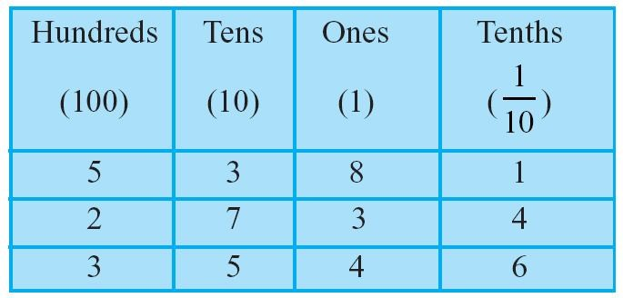

- Write the following numbers in the place value table : (a) 20.5 (b) 4.2

- Write each of the following as decimals : (a) Two ones and five-tenths (b) Thirty and one-tenth

- Express the following as cm using decimals. (a) 2 mm (b) 30 mm (c) 116 mm (d) 4 cm 2 mm (e) 162 mm (f) 83 mm

- Show the following numbers on the number line. (a) 0.5 (b) 1.3 (c) 1.8 (d) 2.1

- Fill the blank in the table and write the corresponding number in decimal form using ‘block’ information given below.
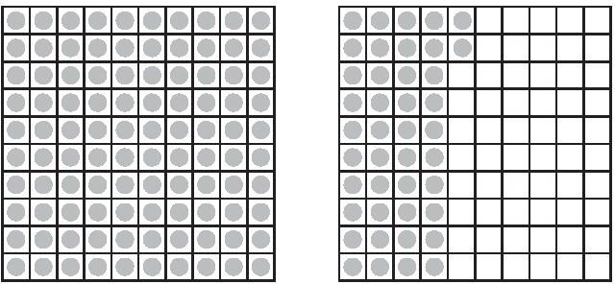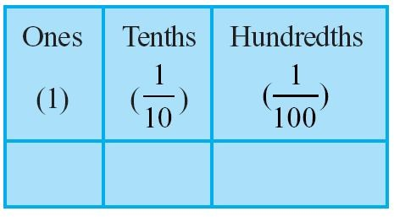

Write as fractions in lowest terms. (a) 0.04 (b) 2.34 (c) 0.342

- Write each of the following as a decimal.

Three hundred six and seven-hundredths
  - Eleven point two three five

Nine and twenty five thousandths

- Which is greater? (a) 1 or 0.99 (b) 1.09 or 1.093

- Express as rupees using decimals.
  - 15 paise
  - 175 paise
  - 270 paise
  - 95 rupees 9 paise

- Express as metres using decimals.
  - 13 cm
  - 5 cm
  - 4 m 5 cm
  - 8 m 7 cm

- Express as cm using decimals.
  - 15 mm
  - 6 mm
  - 194 mm
  - 3 cm 8 mm

- Express as km using decimals.
  - 9 m
  - 85 m
(c) 9988 m
(d) 7 km 5 m

- Express as kg using decimals.
  - 12 g
  - 190 g
(c) 9750 g
- 3 kg 8 g
- 6 kg 50 g

- Lata spent Rs 9.50 for buying a pen and Rs 2.50 for one pencil. How much money did she spend?

- Samson travelled 5 km 52 m by bus, 2 km 265 m by car and the rest 1km 30 m he walked. How much distance did he travel in all?

- Rahul bought 4 kg 90 g of apples, 2 kg 60 g of grapes and 5 kg 300 g of mangoes. Find the total weight of all the fruits he bought.

- Radhika’s mother gave her Rs 10.50 and her father gave her Rs 15.80, find the total amount given to Radhika by the parents.

- Nasreen bought 3 m 20 cm cloth for her shirt and 2 m 5 cm cloth for her trouser. Find the total length of cloth bought by her.

- Abhishek had Rs 7.45. He bought toffees for Rs 5.30. Find the balance amount left with Abhishek.

- Urmila’s school is at a distance of 5 km 350 m from her house. She travels 1 km 70 m on foot and the rest by bus. How much distance does she travel by bus?

- Namita travels 20 km 50 m every day. Out of this she travels 10 km 200 m by bus and the rest by auto. How much distance does she travel by auto?

- Kanchan bought a watermelon weighing 5 kg 200 g. Out of this she gave 2 kg 750 g to her neighbour. What is the weight of the watermelon left with Ruby?

- Namita travels 20 km 50 m every day. Out of this she travels 10 km 200 m by bus and the rest by auto. How much distance does she travel by auto?

- Tina had 20 m 5 cm long cloth. She cuts 4 m 50 cm length of cloth from this for making a curtain. How much cloth is left with her?

- Subtract :
  - Rs 18.25 from Rs 20.75
(b) 202.54 m from 250 m
- Rs 5.36 from Rs 8.40
- 2.051 km from 5.206 km
- 0.314 kg from 2.107 kg

- Find the value of : (a) 9.756 – 6.28 (b) 21.05 – 15.27 (c) 18.5 – 6.79 (d) 11.6 – 9.847

- Find the sum in each of the following : (a) 0.007 + 8.5 + 30.08
(b) 15 + 0.632 + 13.8
(c) 27.076 + 0.55 + 0.004
(d) 25.65 + 9.005 + 3.7
(e) 0.75 + 10.425 + 2
(f) 280.69 + 25.2 + 38

ASSIGNMENT QUESTIONS

CLASS VI: CHAPTER - 8
DECIMALS

- Round off 20.83 to nearest tenths.

- Round off 75.195 to nearest hundredths.

- Round off 27.981 to nearest tenths.

4. Arrange in ascending order: 0.011, 1.001, 0.101, 0.110

- Add the following: 20.02 and 2.002

- Which one is greater? 1 metre 40 centimetres + 60 centimetres or 2.6 metres.

- What should be added to 25.5 to get 50?

- Alok purchased 1kg 200g potatoes, 250g dhania, 5kg 300g onion, 500g palak and 2kg 600g tomatoes. Find the total weight of his purchases in kilograms.

- Convert 2009 paise to rupees and express the result as a mixed fraction.

- Convert 1537cm to m and express the result as an improper fraction.

- Convert 2435m to km and express the result as mixed fraction.

- Express 0.041 as a fraction.
- Express 6.03 as a mixed fraction.
- Convert 5201g to kg.
15. Arrange 12.142, 12.124, 12.104, 12.401 and 12.214 in ascending order.
16. Add 1.452 to 1.3
17. Add 3.25, 0.075 and 5
18. What is 7.368 − 1.15 ?
- The sum of two number is 100. If one of them is 68.02, find the other.

- Neeranjan’s school is at a distance of 5 km350m from his house. He travels 1km70m on foot and the rest he travels by bus. How much distance does he travel by bus?

21. Find the value of 102.36 + 7.054 + 0.8

22. Find the value of 0.06 + 4.108 + 91.5

23. Find the value of 312.8 + 290.02 + 128.457

24. Find the value of 113.285 + 6.7 + 9.34 + 30.08

25. Find the value of 18.003 + 41.7 + 10.95 + 5.057

- Find the sum of 0.007, 8.5 and 30.08

- Arun, Abhinav and Vaibhav bought 8.5 litres, 7.25 litres and 9.4 litres milk respectively from a milk booth. How much milk did they buy in all? If there was 40 litres of milk in booth, find the quantity of milk left.

- Manoj bought vegetables weighing 15kg. Out of this 3 kg500g is onion, 2kg75g is tomato and the rest is potato. What is the weight of potato?
- Harshita travels 20km500m everyday. Out of this she travels 10km200m by bus and the rest bus auto. How much distance does she travel by auto?

- Shyam bought a book for Rs. 35.65. He gave Rs. 100 to the shopkeeper. How much money did he get back from the shopkeeper?

31. Add: 15.44, 7.524 and 25

32. Find the value of 25.65 + 9.005 + 3.7

33. Chandan spent Rs. 35.75 maths book and Rs. 32.60 for Science book. Find the total amount spent by Chandan.

34. Add: 5.4, 12.84 and 115.2

35. Ravi purchased 5kg400g rice, 2kg20g sugar and 10kg850g wheat. Find the toal weight of his purchases.

36. Find the value of 3.42 + 294.08 + 7.6 + 95.321
37. Add: 41.8, 39.24, 5.01 and 62.6
38. Add: 4.702, 4.2, 6.02 and 1.27
39. Add: 18.03, 146.3, 0.829 and 5.324
- Express as rupees using decimals.
  - 5 paise (b) 350 paise (c) 2rupees 60paise (d) 5 rupees 9 paise

- Express as metres using decimals.
  - 15 cm (b) 8 cm (c) 2 m 15 cm (d) 3 m 70 cm
- Express as cm using decimals.
  - 25 mm (b) 5 mm (c) 176 mm (d) 4 cm 5 mm
- Express as km using decimals.
(a) 6 m (b) 55 m (c) 4545 m (d) 6 km 50 m
- Express as kg using decimals.
(a) 8 g (b) 160g (c) 7550 g (d) 6 kg 80 g (e) 5 kg 20 g
- Express each of the following without using decimals: (a)Rs.5.25 (b)8.354 g (c)3.5cm (d)3.05km (e)7.54m (f)15.005 kg (g)12.05m (h)0.2m

MCQ WORKSHEET-I

CLASS - VI: CHAPTER - 9
DATA HANDLING

The following pictograph shows the number of absentees in a class of 30 students during the previous week. Read the table and answer the questions given bellow (Q1-Q6) :
Days | Number of Absentees | = 5 students
Monday
Tuesday
Wednesday
Thursday
Friday
Saturday
- On which day were the maximum number of students absent?
  - Thursday b. Friday c. Wednesday d. Saturday
- Which day had full attendance?
  - Thursday b. Friday c. Wednesday d. Saturday
- What was the total number of absentees in that week?
a. 600 b. 125 c. 50 d. 100
- What was the total number of absentees on Tuesday?
a. 20 b. 25 c. 50 d. 10
- On which day 5 students were absent?
  - Thursday b. Friday c. Wednesday d. Saturday
- On which day 30 students were absent?
  - Thursday b. Tuesday c. Wednesday d. Saturday
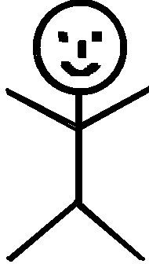
The colours of fridges preferred by people living in a locality are shown by the following pictograph. Read the table and answer the questions given bellow (Q7-Q13):
Colours | Number of Peoples | = 10 People
Blue
Red
Green
Yellow
White
Black

- Find the number of people preferring blue colour.
a. 20 b. 80 c. 50 d. 10

- How many people liked red colour?
a. 120 b. 80 c. 50 d. 110

- Find the number of people preferring white colour.
a. 20 b. 80 c. 50 d. 10

- Which colour preferred most?
  - red b. blue c. yellow d. black

- Which colour preferred least?
  - green b. white c. yellow d. black

- Which two colours liked by same number of people?
  - green and red b. white and yellow c. green and black d. black and red

- Find the number of people preferring yellow colour.
a. 20 b. 80 c. 50 d. 60

- A data is a collection of numbers gathered to give some information.
  - bar graph b. data c. frequency d. tally mark

- The tally mark
  - 6
frequency
b. 5 c. 10 d. 8

- In a bar graph bars are made
  - Horizontally b. vertically
c. sometime horizontally some time vertically d. oblique

- Representation of data in the form of picture ism called
  - bar graph b. pictograph c. histogram d. none of these

- In a bar graph space between rectangles is always
  - Unequal b. increasing c. decreasing d. equal

- The tally mark
  - 6
frequency
b. 5 c. 0 d. 4

- In a bar graph the width of the rectangle is
  - Unequal b. increasing c. decreasing d. equal

Following table shows the number of bicycles manufactured in a factory during the year 1998 to 2002. Read the table and answer the questions given bellow (Q7-Q12)
Years | No.of bicycles manufactured
1998 | 800
1999 | 600
2000 | 900
2001 | 1100
2002 | 1200
- In which year were the maximum number of bicycles manufactured ?
a. 2002 b. 2001 c. 2000 d. 1999

- In which year were the minimum number of bicycles manufactured ?
a. 2002 b. 1999 c. 2000 d. 1998

- How many bicycles were manufactured from 1998 to 2002?
a. 4600 b. 4000 c. 2400 d. 2800

- What is the difference between number of bicycles manufactured in 2002 and 1999 ? a. 600 b. 1200 c. 500 d. 1800

- How many bicycles were manufactured from 1998 to 2000?
a. 2300 b. 2000 c. 2400 d. 2800

- In which year were the difference is more manufactured ?
a. 2002 b. 1999 c. 2000 d. 1998

- On which year did the number of bicycles differ the most from the preceeding year? a. 2002 b. 1999 c. 2000 d. 1998

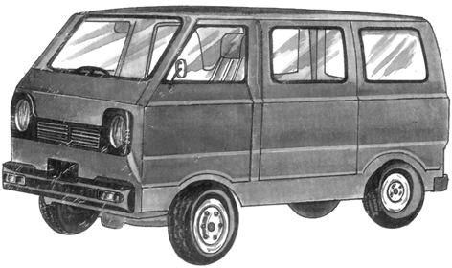
The following pictograph shows the number of Maruti van manufactured during a week. Read the table and answer the questions given bellow (Q1-Q7) :
Days | Number of Maruti Van manufactured | = 100 Maruti Vans
Monday
Tuesday
Wednesday
Thursday
Friday
Saturday

On which day were the least number of Maruti Vans manufactured?
  - Thursday b. Friday c. Wednesday d. Saturday
- Find the number of Maruti Vans manufactured on Wednesday.
a. 600 b. 100 c. 500 d. 800

On which day were the maximum number of Maruti Vans manufactured?
  - Thursday b. Friday c. Wednesday d. Saturday

Find out the approximate number of Maruti Vans manufactured in the particular week?
a. 2300 b. 2000 c. 2400 d. 2800

On which days were the same number of Maruti Vans manufactured?
  - Monday and Thursday b. Monday and Friday
c. Monday and Wednesday d. Monday and Saturday
- Find the number of Maruti Vans manufactured on Monday.
a. 600 b. 100 c. 500 d. 400
- Find the number of Maruti Vans manufactured on Thursday.
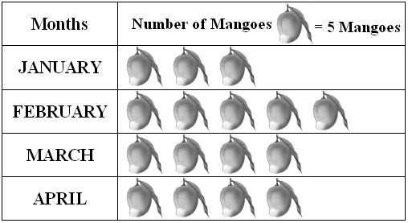
a. 600 b. 100 c. 500 d. 400

From the following above pictograph, answer the questions from Q8 – Q10
- Find the number of mangoes purchased for a home during February is
(a) 20 (b) 25 (c) 30 (d) 15

- Find the number of mangoes purchased for a home during January is
(a) 20 (b) 25 (c) 30 (d) 15

- Find the number of mangoes purchased for a home during March is (a) 20 (b) 25 (c) 30 (d) 15

PRACTICE QUESTIONS

CLASS - VI: CHAPTER - 9
DATA HANDLING

- Suryakant is asked to collect data for size of shoes of students in her Class VI. Her finding are recorded in the manner shown below :
5
4
5
4
5
7
7
6
6
5
8
7
6
7
5
7
4
7
6
6
6
5
5
4
6
6
8
6
4
7
5
6

Find (i) the size of shoes worn by the maximum number of students. (ii) the size of shoes
worn by the minimum number of students.
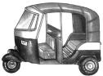
- Following is the pictograph of the number of Auto manufactured by a factory in a particular week.
Days | Number of Maruti Van manufactured | = 300 Autos
Monday
Tuesday
Wednesday
Thursday
Friday
Saturday
  - On which day were the least number of Auto manufactured?
  - On which day were the maximum number of Auto manufactured?
  - Find out the approximate number of Auto manufactured in the particular week?
- Following table shows the number of bicycles manufactured in a factory during the years 1998 to 2002. Illustrate this data using a bar graph. Choose a scale of your choice.
Years | Number of bicycles manufactured
1998 | 800
1999 | 600
2000 | 900
2001 | 1100
2002 | 1200
  - In which year were the maximum number of bicycles manufactured?
  - In which year were the minimum number of bicycles manufactured?
- The sale of electric bulbs on different days of a month is shown below. From the following above pictograph,
  - Find the number of electric bulb purchased for a lodging house during February
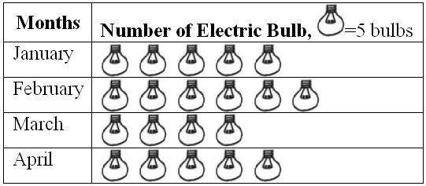
  - Find the number of electric bulb purchased for a lodging house during April
  - In which month the sale of electric bulb is least.
(c) In which month the sale of electric bulb is maximum.

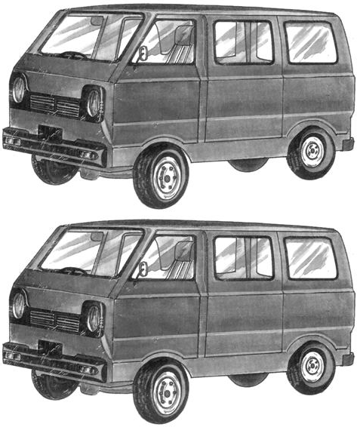
- Following is the pictograph of the number of Maruti Van manufactured by a factory in a particular week.

Days | Number of Maruti Van manufactured | = 200 MarutiVan
Monday
Tuesday
Wednesday
Thursday
Friday
Saturday
- On which day were the least number of Maruti Van manufactured?
- On which day were the maximum number of Maruti Van manufactured?
- Find out the approximate number of Maruti Van manufactured in the particular week?
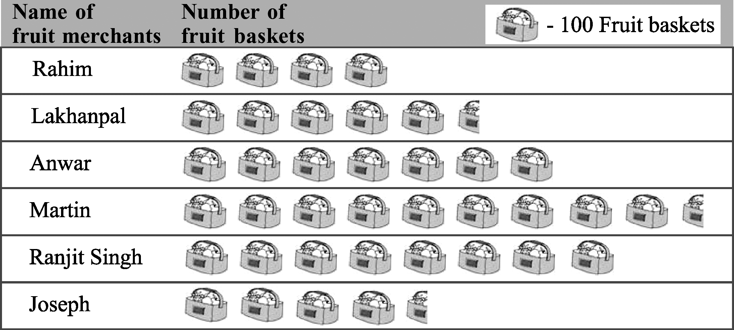
- In a village six fruit merchants sold the following number of fruit baskets in a particular season :
Observe this pictograph and answer the following questions :
  - Which merchant sold the maximum number of baskets?
  - How many fruit baskets were sold by Anwar?
  - The merchants who have sold 600 or more number of baskets are planning to buy a godown for the next season. Can you name them?
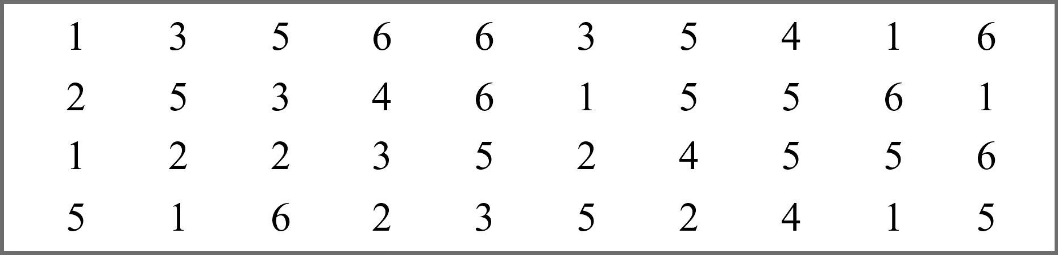
- Mohan threw a dice 40 times and noted the number appearing each time as shown below :
Make a table and enter the data using tally marks. Find the number that appeared.
  - The minimum number of times (b) The maximum number of times
(c) Find those numbers that appear an equal number of times.

- The following are the details of number of students present in a class of 30 during a week. Represent it by a pictograph.
Days | Number of students present
Monday | 24
Tuesday | 26
Wednesday | 28
Thursday | 30
Friday | 29
Saturday | 22

- The following are the number of electric bulbs purchased for a lodging house during the first six months of a year. Represent the details by a pictograph.

Months | Number of bulbs
January | 20
February | 26
March | 30
April | 34
May | 40
June | 25

- The bar graph given alongside shows the amount of wheat purchased by government during the year 1998-2002. Read the bar graph and write down your observations. In which year was (a) the wheat production maximum? (b) the wheat production minimum?
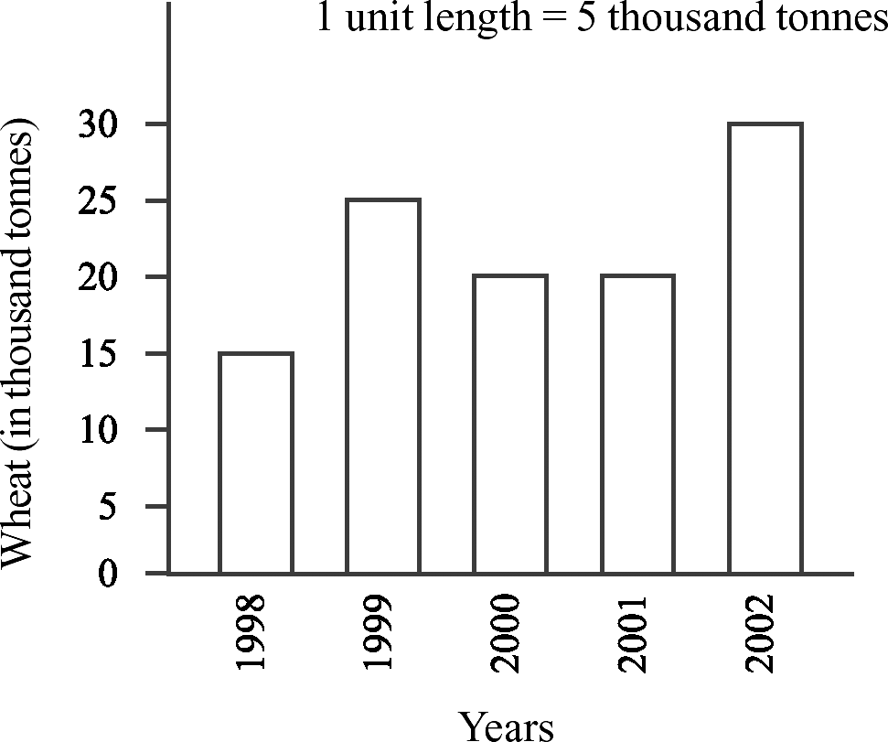
- The number of Mathematics books sold by a shopkeeper on six consecutive days is shown below
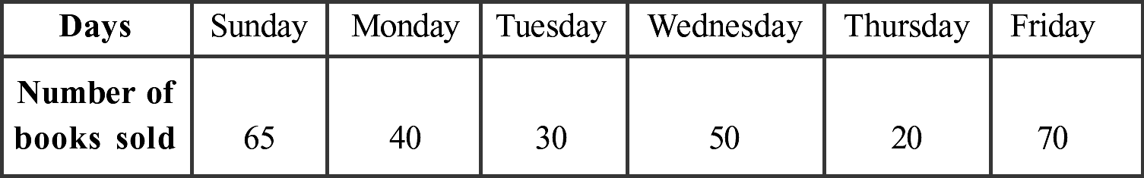
:

Draw a bar graph to represent the above information choosing the scale of your choice.

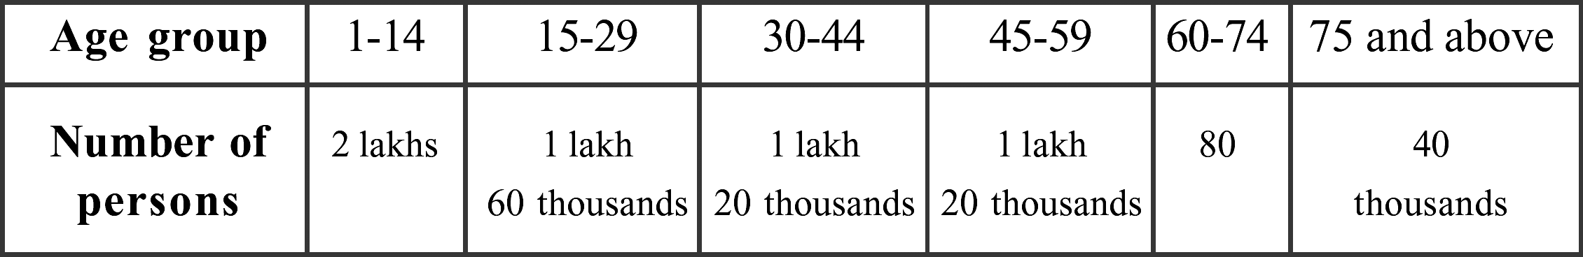
- Number of persons in various age groups in a town is given in the following table.
Draw a bar graph to represent the above information and answer the following questions. (take 1 unit length = 20 thousands)
  - Which two age groups have same population?
  - All persons in the age group of 60 and above are called senior citizens. How many senior citizens are there in the town?
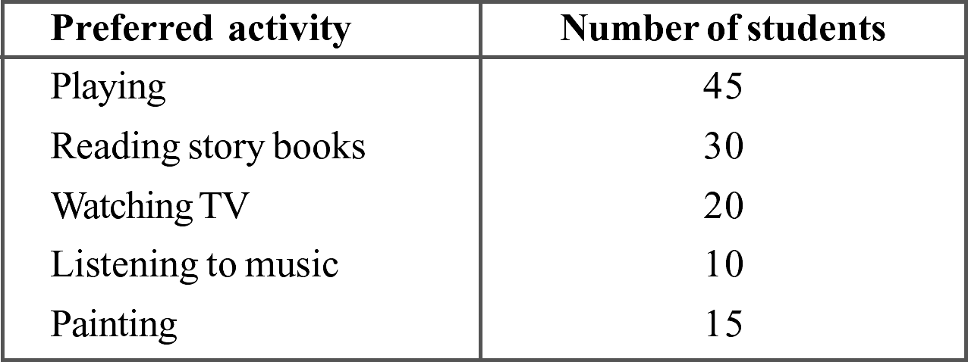
- A survey of 120 school students was done to find which activity they prefer to do in their free time.

Draw a bar graph to illustrate the above data taking scale of 1 unit length = 5 students. Which activity is preferred by most of the students other than playing?

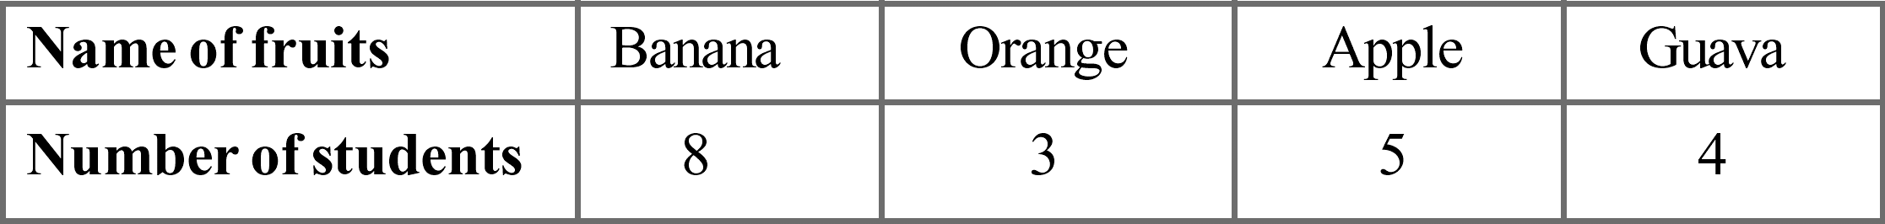
- Following table representing choice of fruits made by his classmates. Draw a bar graph to represent the given information choosing the scale of your choice.

- Total number of animals in five villages are as follows :
Village A : 80 Village B : 120 Village C : 90 Village D : 40 Village E : 60 Prepare a pictograph of these animals using one proper symbol to represent 10 animals and answer the following questions :
  - How many symbols represent animals of village E?
  - Which village has the maximum number of animals?
  - Which village has more animals : village A or village C?

- The length and breadth of a rectangle are 40 cm and 10 cm respectively. Its perimeter is
  - 100 cm (b) 120 cm (c) 140 cm (d) none of these

- The side of a square is 8 cm. Its area is
  - 64 cm² (b) 84 cm² (c) 100 cm² (d) none of these

- The length of a rectangle is 150 cm. If its breadth is 1m, then its perimeter is
  - 7 m (b) 5 m (c) 6 m (d) none of these

- The area of a rectangle is 40 cm². If its breadth is 4 cm, then its length is
  - 20 cm (b) 30 cm (c) 10 cm (d) none of these

- The area of square is 100 cm². Its side is
  - 20 cm (b) 30 cm (c) 10 cm (d) none of these

- The perimeter of a square is 100 cm. Its side is
  - 25 cm (b) 35 cm (c) 15 cm (d) none of these

- The side of a square is 12 m. Its perimeter is
  - 7 m (b) 5 m (c) 9 m (d) none of these

- If the perimeter of a square is 44 cm, then its area is
  - 64 cm² (b) 81 cm² (c) 121 cm² (d) none of these

- If the area of a square is 64 cm², then its perimeter is
  - 25 cm (b) 32 cm (c) 15 cm (d) none of these

- If the perimeter of a square is 16 cm, then its area is
  - 64 cm² (b) 81 cm² (c) 121 cm² (d) none of these

- If the area of a square is 2.25 m², then its perimeter is
  - 7 m (b) 5 m (c) 6 m (d) none of these

- The side of a square is 8 cm. If its side is doubled, then its new perimeter is
  - 64 cm (b) 81 cm (c) 121 cm (d) none of these

- The side of a square is 6 cm. If its side is doubled, then its new perimeter is
  - 64 cm (b) 48 cm (c) 44 cm (d) none of these

- The length and breadth of a rectangle are 10 cm and 8 cm respectively. If its length is doubled, then its new area is
  - 80 cm² (b) 160 cm² (c) 240 cm² (d) none of these

- The area of a rectangular sheet is 500 cm². If the length of the sheet is 25 cm, what is its width?
(a) 20 cm (b) 17 cm (c) 30 cm (d) 25 cm

- If the area of rectangle increases from 2 cm² to 4 cm² the perimeter will
  - increase (b) decrease (c) remains same (d) none of these

- The area of a square whose perimeter is 4 m
(a) 1 m² (b) 4 m² (c) 2 m² (d) 3 m²

- Which figure encloses more area : a square of side 2 cm ; a rectangle of side 3 cm & 2 cm ;An equilateral triangle of side 4 cm
  - rectangle (b) square (c) triangle (d) same of rectangle & square

- The area of rectangle whose length is 15 cm & breadth is 6 m
(a) 9000 cm² (b) 90 cm² (c) 9 cm² (d) 900 cm²

- The distance covered along the boundary of a rectangle is called its
  - area (b) perimeter (c) length (d) breadth

- The perimeter of a square is
  - 4 + side (b) 4 x side (c) side x side (d) length +breadth

- The perimeter of an equilateral triangle is
  - side + side + side (b) side x side x side (c) 3 + side (d) side + side

- The amount of surface enclosed by a closed figure is called its
  - perimeter (b) area (c) flat surface (d) interior region

- Area of which figure is length x breadth
  - rectangle (b) square (c) isosceles triangle (d) equilateral triangle

- What will be the distance covered by Shalini by taking three rounds around a square park of side 2 cm
  - 6 cm (b) 12 cm (c) 18 cm (d) 24 cm

- What is the perimeter of a regular pentagon whose each side measuring 5 cm
(a) 10 cm (b) 20 cm (c) 15 cm (d) 25 cm

- The shape of your class blackboard is
  - square (b) rectangle (c) triangle (d) parallelogram

- What is the area of the rectangle whose side are 5 cm
(a) 10 cm (b) 20 cm (c) 15 cm (d) 25 cm

- If the cost of painting one black-board is Rs.50, what will be the cost of painting 10 black- boards
(a) Rs.60 (b) Rs.500 (c) Rs.5000 (d) Rs.10

- What will be the cost of tilting a rectangular plot of area 800 sq.m, if the cost of tiling 100 sq.m is Rs.6
(a) Rs.14 (b) Rs.48 (c) Rs.4800 (d) Rs.900

- What is the length of the garden if area of rectangular garden of width 60 m is 300 sq.m (a) 900 m (b) 90 m (c) 18 m (d) 5 m

- The perimeter of a triangle whose sides are 5 cm, 2 cm and 3 cm.
(a) 30 cm (b) 11 cm (c) 17 cm (d) 10 cm

- The width in area of rectangle is
  - length + area (b) area
length

- length
area

- area x length

- What is the length of side of square whose area is 64 m²
(a) 16 m (b) 32 m (c) 8 m (d) 64 m

- The perimeter of a rectangle whose length is 4 cm and breadth is 5 cm
  - 9 cm (b) 20 cm (c) 18 cm (d) 36 cm

- If the area of one tile is 10². What will be the area of 5 tiles?
(a) 50 m² (b) 2 m² (c) 15 m² (d) 11 m²

- 7 m is cm.
(a) 700 cm (b) 0.7 cm (c) 0.07 cm (d) 700 cm

- To find the perimeter of floor of your class-room , we will
  - add the lengths of sides (b) subtract the lengths of sides
(c) multiply the lengths of sides (d) divide the length of one side by the other side

- The perimeter of regular hexagon of side 4 cm will be
(a) 20 cm (b) 24 cm (c) 10 cm (d) 14 cm

- The formula for finding area of square is
  - side x side (b) 4 x side (c) 1 × side
2

(d) 2 x side

- The formula for finding area of rectangle is
  - length x breadth (b) length +breadth
(c) length/breadth (d) 2( length x breadth)

- The cost of fencing a square park of side 100 m at the rate of Rs.10 per m will be (a) Rs.4000 (b) Rs.10000 (c) Rs.1000 (d) Rs.400

- The perimeter of regular octagon is 16 cm, the length of each side will be
  - 4 cm (b) 2 cm (c) 1 cm (d) 8 cm

- The perimeter of an isosceles triangle with equal side of length 4 cm and third side of length 6 cm will be
  - 10 cm (b) 8 cm (c) 20 cm (d) 14 cm

- 1 m 25 cm is cm.
(a) 125 cm (b) 1.25 cm (c) 1025 cm (d) 12.5 cm

- Which has larger perimeter a square of side 2 cm, decagon of side 1 cm, pentagon of side 3 cm and equilateral triangle of side 1 cm
  - decagon (b) pentagon (c) square (d) triangle

- Which appropriate unit of measurement will be used to find the length of your thumb
  - cm (b) m (c) km (d) m²

- In below left figure what will be the area of 4 squares on the corners whose each side is 1 cm?
(a) 4 cm² (b) 1 cm² (c) 64 cm² (d) 8 cm
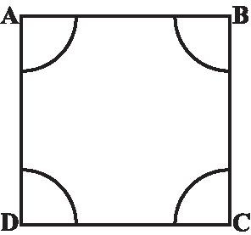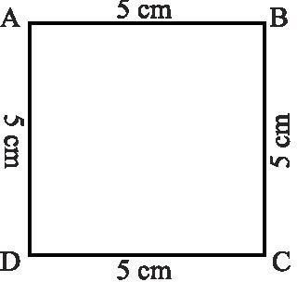
- The perimeter of above sided right figure is
(a) 20 cm (b) 20 cm² (c) 20 cm³ (d) 20 m

- Which formula will be used to find the area of wall of a room

  - l x b (b) 1
2
x l x b (c) l + b (d) 2 (l + b)

- Area of rectangular garden of 50 m broad is 300 sq. m, the length of garden is (a) 250 m (b) 6m (c) 6m² (d) 60m
- If perimeter of triangle is 15 cm and any two sides are of length 4 cm and 3 cm , then length of third side will be
(a) 7 cm (b) 15 cm² (c) 15 cm³ (d) 15 m

- A table top measures 3 m by 50 cm, the area in sq. m will be
(a) 150 sq.m (b) 15 sq.m (c) 1.5 sq.m (d) 150 m

- The perimeter of a regular pentagon is 100 cm. How long is its each side?
  - 20 cm (b) 30 cm (c) 40 cm (d) none of these

- Area of blackboard of your class will be than the area floor is
  - less (b) greater (c) equal (d) none of these

- If the area of one rectangular box is 50 m² , the area of 10 boxes will be
(a) 500 m (b) 5 m (c) 50 m (d) 500 m²

- 1 cm² is mm².
(a) 100 (b) 10 (c) 1000 (d) 1
10

- Which has larger perimeter
  - a regular pentagon of side 3 cm (b) a regular hexagon of side 3 cm
(c) a regular heptagon of side 3 cm (d) a regular octagon of side 3 cm

- Area of floor of room will be as the area roof
  - greater (b) equal (c) less equal (d) none of these

- The length and the breadth of a rectangular piece of land are 500 m and 300 m respectively. Find its area
(a) 1500 m² (b) 15000 m² (c) 150000 m² (d) none of these

- Find the area of a square park whose perimeter is 320 m.
(a) 6400 m² (b) 10240 m² (c) 102400 m² (d) none of these

- Find the breadth of a rectangular plot of land, if its area is 440 m² and the length is 22 m.
  - 40 m (b) 20 m (c) 10 m (d) none of these

- The perimeter of a rectangular sheet is 100 cm. If the length is 35 cm, find its breadth.
  - 15 cm (b) 20 cm (c) 10 cm (d) none of these

- The perimeter of a rectangular sheet is 100 m. If the length is 35 m, find its area.
  - 500 m² (b) 525 m² (c) 600 m² (d) none of these

- Find the perimeter of a rectangular sheet, if its area is 440 cm² and the length is 22 cm.
  - 64 cm (b) 84 cm (c) 100 cm (d) none of these

- The perimeter of a rectangle is 130 cm. If the breadth of the rectangle is 30 cm, find its length.
  - 35 cm (b) 30 cm (c) 40 cm (d) none of these

- The perimeter of a rectangle is 130 m. If the breadth of the rectangle is 30 m, find its area.
  - 640 m² (b) 600 m² (c) 700 m² (d) none of these

- The sides of a rectangle are in the ratio 5 : 4. If its perimeter is 72 cm then the length is
  - 20 cm (b) 30 cm (c) 40 cm (d) none of these

- The cost of putting a fence around a square field at Rs. 2.50 per metre is Rs. 200. The length of each side of the field is
  - 40 m (b) 20 m (c) 80 m (d) none of these

- The area of a rectangle is 650 cm² and one of its sides is 13 cm. Find the perimeter of the rectangle.
  - 120 cm (b) 130 cm (c) 126 cm (d) none of these

- A room is 5m 40cm long and 3m 75cm wide. Find the area of the carpet needed to cover the floor.
  - 20 m² (b) 20.25 m² (c) 21 m² (d) none of these

- The total cost of flooring a room at Rs. 8.50 per m² is Rs. 510. If the length of the room is 8m, find its breadth.
  - 7 m (b) 7.5 m (c) 7.25 m (d) none of these

- The length and the breadth are in the ratio 3 : 2. If its perimeter is 30 cm, find its breadth.
  - 6 cm (b) 7 cm (c) 8 cm (d) none of these

- The perimeter of the below left figure is
  - 490 m (b) 500 m (c) 495 m (d) none of these
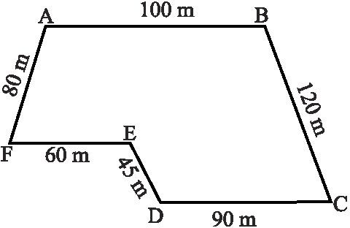
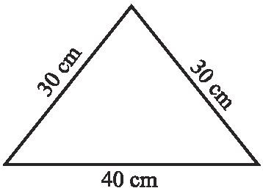
- The perimeter of the above-sided right figure is
  - 1 m (b) 1.5 m (c) 1.25 m (d) none of these

PRACTICE QUESTIONS

CLASS VI: CHAPTER – 10
MENSURATION

- Meera went to a park 150 m long and 80 m wide. She took one complete round on its boundary. What is the distance covered by her?

- Find the perimeter of the following figures:
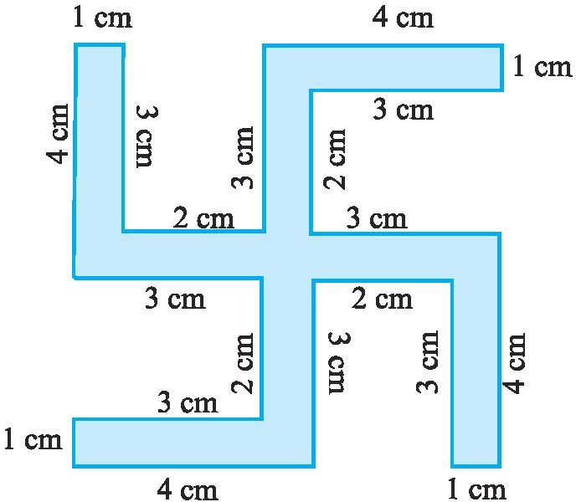
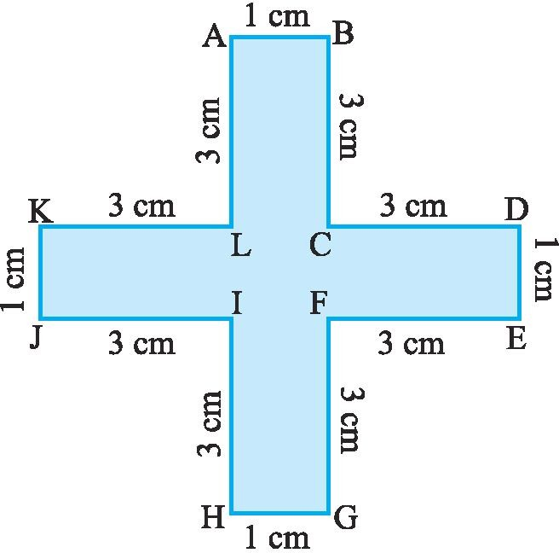
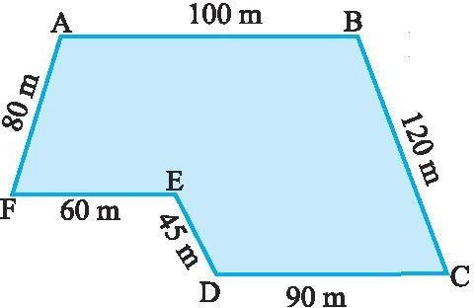
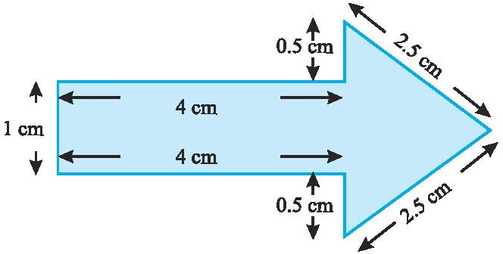
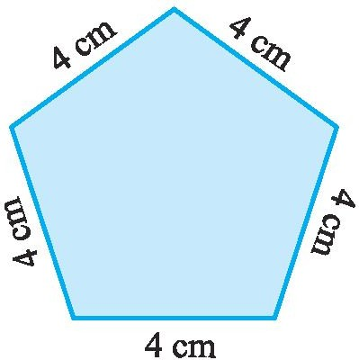
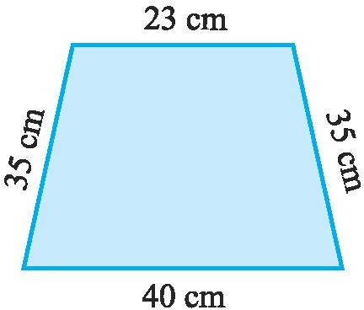

- Shabana wants to put a lace border all around a rectangular table cover, 3 m long and 2 m wide. Find the length of the lace required by Shabana.

- An athlete takes 10 rounds of a rectangular park, 50 m long and 25 m wide. Find the total distance covered by him.

- Find the perimeter of a rectangle whose length and breadth are 150 cm and 1 m respectively.

- A farmer has a rectangular field of length and breadth 240 m and 180 m respectively. He wants to fence it with 3 rounds of rope. What is the total length of rope he must use?

- Find the cost of fencing a rectangular park of length 250 m and breadth 175 m at the rate of Rs 12 per metre.

- Find the distance travelled by Shaina if she takes three rounds of a square park of side 70 m.

- Pinky runs around a square field of side 75 m, Bob runs around a rectangular field with length 160 m and breadth 105 m. Who covers more distance and by how much?

- Find the perimeter of a regular pentagon with each side measuring 3 cm.

- The perimeter of a regular hexagon is 18 cm. How long is its one side?

- Find the perimeter of a triangle with sides measuring 10 cm, 14 cm and 15 cm.

- Find the perimeter of a regular hexagon with each side measuring 8 m.

- Find the side of the square whose perimeter is 20 m.

- The perimeter of a regular pentagon is 100 cm. How long is its each side?

- Two sides of a triangle are 12 cm and 14 cm. The perimeter of the triangle is 36 cm. What is its third side?

- Find the cost of fencing a square park of side 250 m at the rate of Rs 20 per metre.

- Find the cost of fencing a rectangular park of length 175 m and breadth 125 m at the rate of Rs 12 per metre.

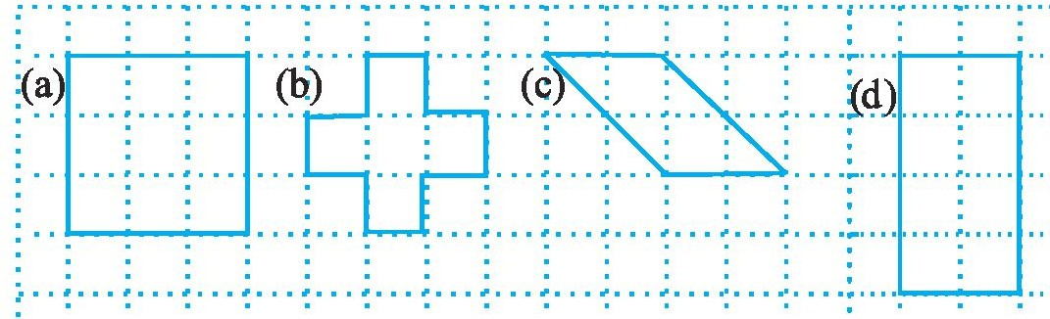
- Find the areas of the following figures by counting square:
- Find the area of a rectangle whose length and breadth are 12 cm and 4 cm respectively.

- Find the area of a square plot of side 8 m.

- The area of a rectangular piece of cardboard is 36 sq cm and its length is 9 cm. What is the width of the cardboard?

- Bob wants to cover the floor of a room 3 m wide and 4 m long by squared tiles. If each square tile is of side 0.5 m, then find the number of tiles required to cover the floor of the room.

- Find the area in square metre of a piece of cloth 1m 25 cm wide and 2 m long.

- What is the cost of tiling a rectangular plot of land 500 m long and 200 m wide at the rate of Rs 8 per hundred sq m.?

- A table-top measures 2 m by 1 m 50 cm. What is its area in square metres?

- A room is 4 m long and 3 m 50 cm wide. How many square metres of carpet is needed to cover the floor of the room?

- A floor is 5 m long and 4 m wide. A square carpet of sides 3 m is laid on the floor. Find the area of the floor that is not carpeted.

- Five square flower beds each of sides 1 m are dug on a piece of land 5 m long and 4 m wide. What is the area of the remaining part of the land?

- How many tiles whose length and breadth are 12 cm and 5 cm respectively will be needed to fit in a rectangular region whose length and breadth are respectively:
  - 100 cm and 144 cm (b) 70 cm and 36 cm.

- By splitting the following figures into rectangles, find their areas (The measures are given in centimetres).
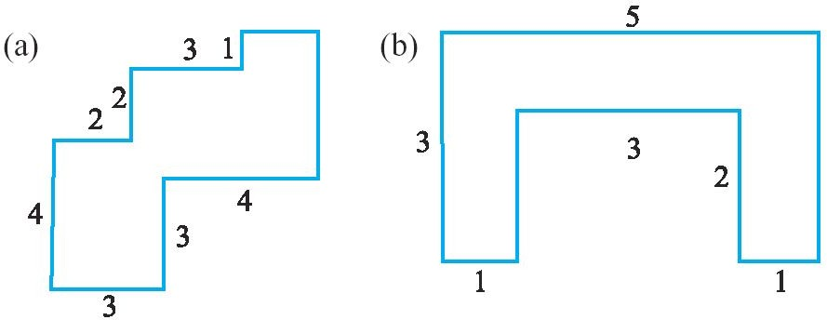
- Find the cost of fencing a rectangular park of length 500 m and breadth 250 m at the rate of Rs 20 per metre.
- Find the distance travelled by Uday Kiran if he takes fifty rounds of a square park of side 25 m.

- Find the perimeter of a regular pentagon with each side measuring 10 cm.

- The perimeter of a regular hexagon is 78 cm. How long is its one side?

- Find the perimeter of a triangle with sides measuring 20 cm, 24 cm and 35 cm.

- Find the perimeter of a regular hexagon with each side measuring 15 m.

- Find the side of the square whose perimeter is 84 m.
- Two sides of a triangle are 22 cm and 28 cm. The perimeter of the triangle is 70 cm. What is its third side?

- Find the cost of fencing a square park of side 125 m at the rate of Rs 15 per metre.

Find the area of a rectangle whose length and breadth are 20 cm and 15 cm respectively.

- Find the perimeter of the following figures:
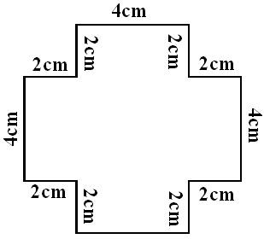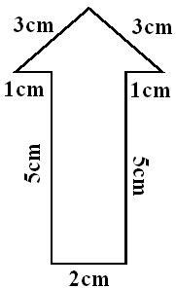

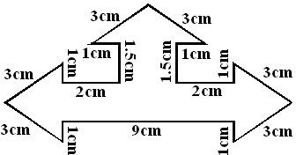

The area of a rectangular bulleting board is 18750 sq cm and its length is 150 cm. What is the width of the bulleting board?

- Vandana wants to cover the floor of a room 6 m wide and 8 m long by squared tiles. If each square tile is of side 0.5 m, then find the number of tiles required to cover the floor of the room.

Find the area in square metre of a piece of cloth 2m 25 cm wide and 4 m long.

- What is the cost of tiling a rectangular plot of land 800 m long and 250 m wide at the rate of Rs 12 per 100 m²?

A tabletop measures 3 m 50 cm by 2 m 50 cm. What is its area in square metres?

- A room is 6 m long and 4 m 50 cm wide. How many square metres of carpet is needed to cover the floor of the room?

How many tiles whose length and breadth are 15 cm and 12 cm respectively will be needed to fit in a rectangular region whose length and breadth are respectively:
  - 100 cm and 144 cm (b) 70 cm and 36 cm.

By splitting the following figures into rectangles, find their areas

2cm
4.5 cm
5 cm

(i) (ii)
4.5 cm
2 cm
2.5 cm
5 cm
10 cm

(iii)
5 cm

ASSIGNMENT QUESTIONS

CLASS VI: CHAPTER – 10
MENSURATION

- Four regular hexagons are drawn so as to form the design as shown in below figure. If the perimeter of the design is 28cm, find the length of each side of the hexagon.
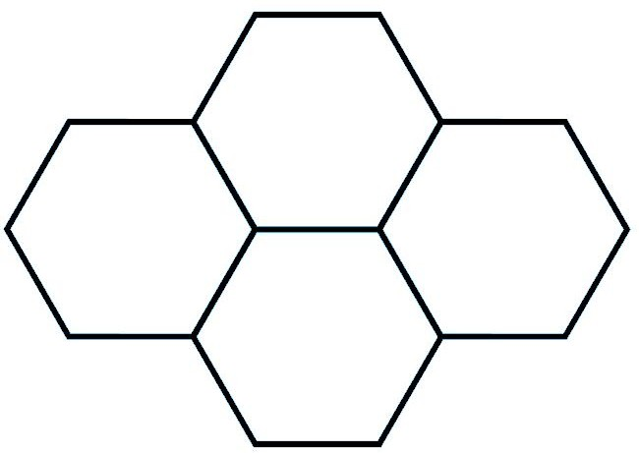
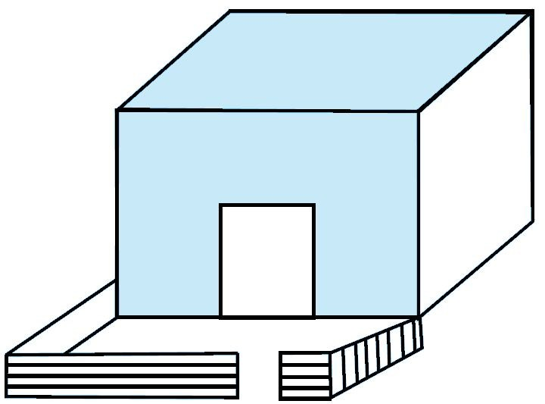
- There is a rectangular lawn 10m long and 4m wide in front of Meena’s house (see above right sided figure). It is fenced along the two smaller sides and one longer side leaving a gap of 1m for the entrance. Find the length of fencing.

- Perimeter of an isosceles triangle is 50cm. If one of the two equal sides is 18cm, find the third side.

- Find (a) area and (b) perimeter of a square whose side is 12 cm.

- The side of a square wall is 3m 50 cm. Determine the cost of colour washing it at the rate of Rs. 2 per sq.m.

- The perimeter of a square playground is 1200m. Find its area

- Find the area of the squares, whose sides are given below : (a) 7cm (b) 12 dm (c) 2 m 25 cm (d)
3.2 m

- Find the area of square land in hectares whose side is 250 m.

- Calculate the cost of levelling a square garden of side 75 m at the rate of Rs. 8 per sq.m

- The side of a square hall is 8 m 5 dm. Find the cost of fixing tiles on its floor at the rate of Rs. 300 per sq.m.

- Find the area of a square whose perimeter is 600 m.

- The perimeter of the floor of a square room is 22m. Find its area.

- Find the area and perimeter of a rectangle whose length is 2m and breadth is 70cm.

- The area of a rectangular field is 3.75 hectares. If the length is 250 m find its breadth.

- Find the cost of fencing a rectangular park of length 170 m and breadth 100 m at the rate of Rs. 5 per metre.

- The perimeter of the floor of a rectangular hall is 24 m. Its length is 7 m. Find its area.

- Find the area of the rectangles whose lengths and breadths are given below : (a) 15cm, 8 cm (b) 3 dm, 5.6 cm (c) 2 m 5 dm, 1 m 20 cm (d) 6.5 m, 4.5 m

- A carpet is 5 m long and 3 m 5 dm wide. If the cost of 1 sq.m is Rs. 40 find the cost of the carpet.

- The length and breadth of a rectangular field are 500 m and 69 m. Find its area in hectares.

- The area of the floor of a class room is 2880 sq.m. If its length is 60m, find its breadth and the perimeter.

- The perimeter of a rectangular garden is 160m. Its breadth is 30m. Find the cost of leveling it at the rate of Rs. 2.50 per sq.m.

- A rectangular plot is 130m long and 70m broad. Find the cost of fencing it at Rs. 3.50 per metre.

- The cost of levelling a rectangular football ground is Rs. 27,000 at the rate of Rs. 500 per Are. If the breadth of the ground is 60m find its length.

- The length of a rectangular field is 180 m and its breadth is 120 m. Sandhya walks round the field 5 times, find the distance she covers?

- Ramesh bought a square plot of side 50m. Adjacent to this Daniel bought a rectangular plot of length 60 m and breadth 40 m for the same price. Find out who is benefitted more.

- Length of a rectangle is three times its breadth. Perimeter of the rectangle is 40cm. Find its length and width.

- Tahir measured the distance around a square field as 200 rods (lathi). Later he found that the length of this rod was 140cm. Find the side of this field in metres.

- The length of a rectangular field is twice its breadth. Jamal jogged around it four times and covered a distance of 6km. What is the length of the field?

- Length of a rectangular field is 250m and width is 150m. Anuradha runs around this field 3 times. How far did she run? How many times she should run around the field to cover a distance of 4km?

- Bajinder runs ten times around a square track and covers 4km. Find the length of the track.

- The lawn in front of Molly’s house is 12m× 8m, whereas the lawn in front of Dolly’s house is 15m×5m. A bamboo fencing is built around both the lawns. How much fencing is required for both?

- The perimeter of a regular pentagon is 1540cm. How long is its each side?

- The perimeter of a triangle is 28cm. One of it’s sides is 8cm. Write all the sides of the possible isosceles triangles with these measurements.

- Base of a tent is a regular hexagon of perimeter 60cm. What is the length of each side of the base?

- In the below figure, all triangles are equilateral and AB = 8 units. Other triangles have been formed by taking the mid points of the sides. What is the perimeter of the figure?
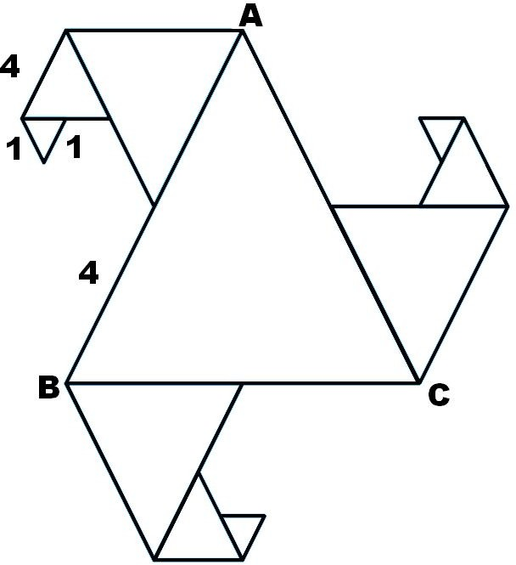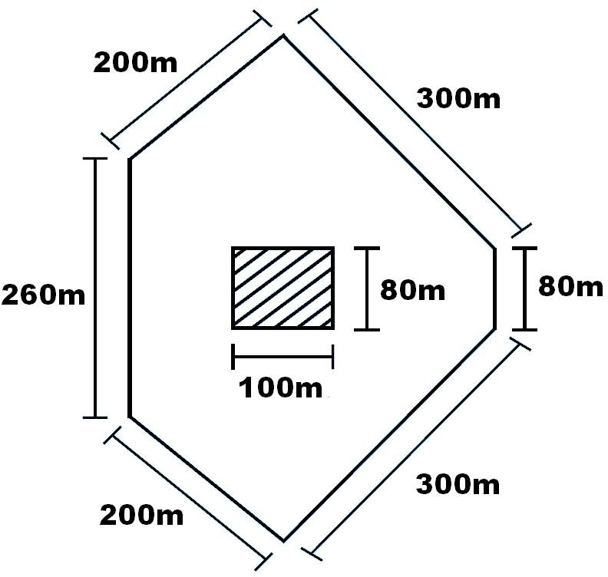

- What is the length of outer boundary of the park shown in the above right figure? What will be the total cost of fencing it at the rate of Rs 20 per metre? There is a rectangular flower bed in the center of the park. Find the cost of manuring the flower bed at the rate of Rs 50 per square metre.

- The length of an aluminium strip is 40cm. If the lengths in cm are measured in natural numbers, write the measurement of all the possible rectangular frames which can be made out of it. (For example, a rectangular frame with 15cm length and 5cm breadth can be made from this strip.)

- In an exhibition hall, there are 24 display boards each of length 1m 50cm and breadth 1m. There is a 100m long aluminium strip, which is used to frame these boards. How many boards will be framed using this strip? Find also the length of the aluminium strip required for the remaining boards.

- In the above question, how many square metres of cloth is required to cover all the display boards? What will be the length in m of the cloth used, if its breadth is 120cm?

- Length of a rectangular field is 6 times its breadth. If the length of the field is 120cm, find the breadth and perimeter of the field.

- Anmol has a chart paper of measure 90cm × 40cm, whereas Abhishek has one which measures 50cm × 70cm. Which will cover more area on the table and by how much?

- A rectangular path of 60m length and 3m width is covered by square tiles of side 25cm. How many tiles will there be in one row along its width? How many such rows will be there? Find the number of tiles used to make this path?

- How many square slabs each with side 90cm are needed to cover a floor of area 81sqm.

- The length of a rectangular field is 8m and breadth is 2m. If a square field has the same perimeter as this rectangular field, find which field has the greater area.

- Parmindar walks around a square park once and covers 800m. What will be the area of this park?

- The side of a square is 5cm. How many times does the area increase, if the side of the square is doubled?

- Amita wants to make rectangular cards measuring 8cm × 5cm. She has a square chart paper of side 60cm. How many complete cards can she make from this chart? What area of the chart paper will be left?

- A wire is cut into several small pieces. Each of the small pieces is bent into a square of side 2cm. If the total area of the small squares is 28 square cm, what was the original length of the wire?

- Perimeter of a square and a rectangle is same. If a side of the square is 15cm and one side of the rectangle is 18cm, find the area of the rectangle.

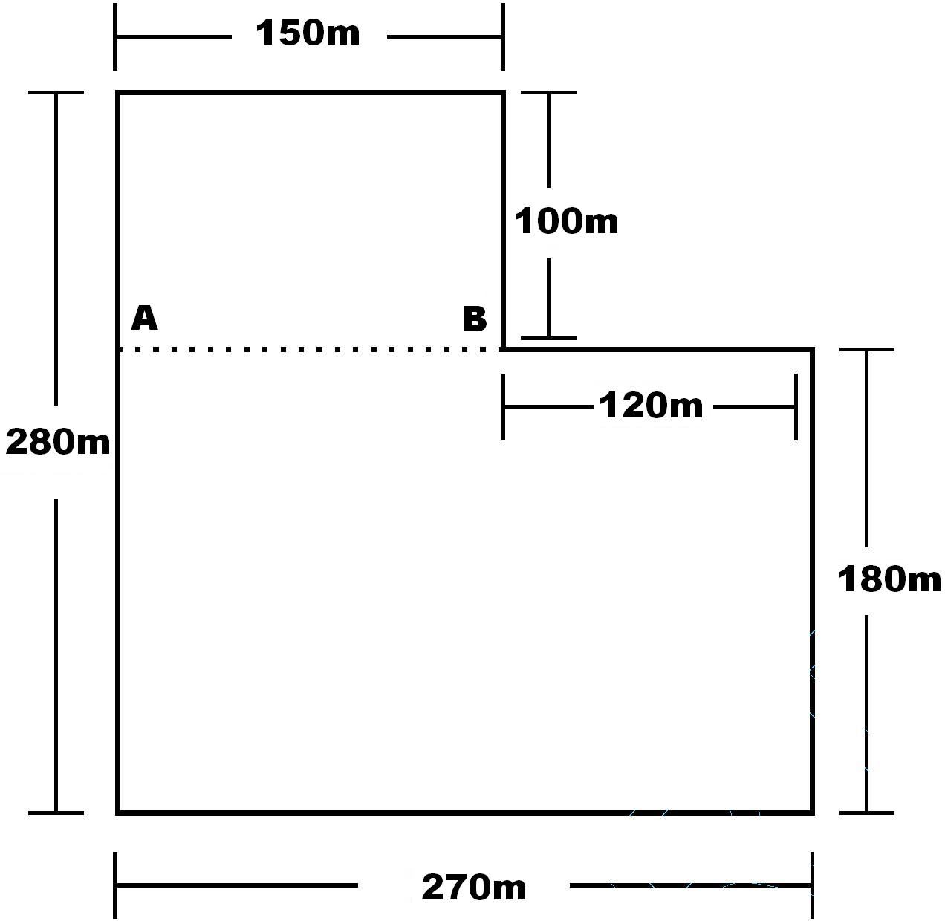
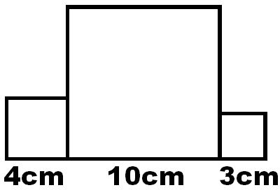
- Total cost of fencing the park shown in below figure is Rs 55000. Find the cost of fencing per metre.

- Three squares are joined together as shown in above right sided figure. Their sides are 4cm, 10cm and 3cm. Find the perimeter of the figure.

- A magazine charges Rs 300 per 10sqcm area for advertising. A company decided to order a half page advertisment. If each page of the magazine is 15cm × 24cm, what amount will the company has to pay for it?

- The perimeter of a square garden is 48m. A small flower bed covers 18sqm area inside this garden. What is the area of the garden that is not covered by the flower bed? What fractional part of the garden is covered by flower bed? Find the ratio of the area covered by the flower bed and the remaining area.

- Divide the park shown in Fig. 6.17 of question 40 into two rectangles. Find the total area of this park. If one packet of fertilizer is used for 300sqm, how many packets of fertilizer are required for the whole park?

- The area of a rectangular field is 1600sqm. If the length of the field is 80m, find the perimeter of the field.

- The area of each square on a chess board is 4sqcm. Find the area of the board. (a) At the beginning of game when all the chess men are put on the board, write area of the squares left unoccupied. (b) Find the area of the squares occupied by chess men.

- (a) Find all the possible dimensions (in natural numbers) of a rectangle with a perimeter 36cm and find their areas.
  - Find all the possible dimensions (in natural numbers) of a rectangle with an area of 36sqcm, and find their perimeters.

- A wire is in the shape of a square of side 10 cm. If the wire is rebent into a rectangle of length 12 cm, find its breadth. Which encloses more area, the square or the rectangle?

- The area of a square and a rectangle are equal. If the side of the square is 40 cm and the breadth of the rectangle is 25 cm, find the length of the rectangle. Also, find the perimeter of the rectangle.

- The length and the breadth of a rectangular piece of land are 500 m and 300 m respectively. Find
  - its area (ii) the cost of the land, if 1 m2 of the land costs Rs 10,000.

- Find the breadth of a rectangular plot of land, if its area is 440 m2 and the length is 22 m. Also find its perimeter.

- The perimeter of a rectangular sheet is 100 cm. If the length is 35 cm, find its breadth. Also find the area.

- What will happen to the area of a rectangle if (i) its length is doubled and breadth is trebled (ii) its length nad breadth are doubled?

- What will happen to the area of a square if its side is (i) doubled (ii) halved?

- Find the perimeter of a rectangular field whose length is four times its width and which has an area equal to 30976 cm².

- Number of matchsticks required to make a pattern of “T”
(a) 5 (b) 2 (c) 3 (d) 4

- Number of matchsticks required to make a pattern of “V”
(a) 5 (b) 2 (c) 3 (d) 4

- Number of matchsticks required to make a pattern of “U”
(a) 5 (b) 2 (c) 3 (d) 4

- Number of matchsticks required to make a pattern of “Z ”
(a) 5 (b) 2 (c) 3 (d) 4
- Number of matchsticks required to make a pattern of “ E ”
(a) 5 (b) 2 (c) 3 (d) 4
- Number of matchsticks required to make a pattern of “ A ”
(a) 5 (b) 6 (c) 3 (d) 4

- A basket has x mangoes, how many mangoes are there in 5 baskets?
(a) x + 5 (b) 5x (c) x – 5 (d) x 5

- A teacher distribute 15 pencils per student, how many pencils are needed for ‘y’ students:

(a) 15 – y (b) 15 + y (c) 15
y
(d) 15y

- Perimeter of the square, whose each side is ‘n’ cm is
(a) n + 4 (b) 4n (c) n – 4 (d) n 4

- Perimeter of an equilateral triangle, whose each side is ‘x’ unit is
(a) 3x (b) 3 – x (c) 3 x

(d) 3 + x

- Diameter of circle whose radius is ‘r’ is

  - r 2
(b) 2r (c) 2 – r (d) 2 + r

- x + y = 5 + x is
  - Commutative property (b) Associative property
(c) Closure property (d) Distributive property

- How many variables are used in the expression 2x + 3y +5
(a) 1 (b) 2 (c) 3 (d) 5

- What is an expression for the statement: “p is multiplied by 16”

  - 16p (b) p
16
(c) p +16 (d) p –16

- The expression for the statement: “ y multiplied by 10 and then 7 added to product”. (a) 10 + y + 7 (b) 7y +10 (c) 10y +7 (d) 10y

- What is the statement for the expression 2y – 9
  - 2y subtracted from 9 (b) 9 subtracted from y and multiplied by 2
(c) 9 subtracted from 9 (d) thrice of y minus 9

- Give expression for: “ 5 times of ‘y’ to which 3 is added”

(a) y +15 (b) 5y +3 (c) 5
y
+3 (d) 3y +5

- Which of the following is an equation
(a) 2x +3 + 5 (b) 2x + 3< 5 (c) 2x + 3 >5 (d) 2x + 3 = 5

- Which of the solution of equation 3x + 2 =11
(a) 0 (b) 11 (c) 3 (d)27

- p = 3 is a solution of equation
(a) 2p + 5 = 17 (b) 5p +2 = 17 (c) 2p +17 = 5 (d) 5p+17 = 2

- The equation for the statement: one forth of a number minus 4 gives 4.
(a) 4x – 4 = 4 (b) 4 – 4 = 4 (c) 1 x – 4 = 4 (d) x – 4 = 1
x 4 4

- Which of the following is expression with one variable
(a) y + 1 (b) x +y – 5 (c) x + y + z (d) 1

- a x b = b x a is
  - Commutative property under addition (b) Associative property under multiplication
(c) Distributive property of multiplication over addition (d) Closure property

- a x (b + c) = a x b + a x c is
  - Commutative property under addition (b) Associative property under multiplication
- Distributive property of multiplication over addition (d) Closure property

- Which of the following is an equation:
(a) x – 3 >0 (b) x +3 < 0 (c) x (d) x +3 = 0

- The variable from the equation 2n +1=11 is
(a) 2 (b) n (c) 1 (d) 11

- Which of the following is the solution of the equation
q = 7
2

(a) 14 (b) 3.5 (c) 5 (d) 9

- Value of the variable in the equation b+5=9 is
(a) 14 (b) 9/5 (c) 4 (d) 5

- Sarita’s present age is ‘m’ years. What will be her age after ten years?
(a) 10m (b) m –10 (c) 10 – m (d) m+10

- The price of potatoes is Rs. X per kg and price of onion is Rs. 10 more than the price of potatoes. Therefore the price of onion is

(a) 10x (b) x +10 (c) x 10
- x –10

- The expression x- 3 is read as
  - x subtracted from 3 (b) 3 subtracted from x
- sum of x and 3 (d) multiplication of x and 3

- The value of variable in the expression is
  - fixed (b) not fixed (c) zero (d) one

- The diameter of a circle whose radius is
r is equal to
2

  - r (b) 2r (c)

- Z multiplied by 5 and then subtracted from 7 is
r (d) r²
4

(a) 5z – 7 (b) z – 35 (c) 7 – 5z (d)
z – 7
5

- The age of Siddarth is x years , Sahil is 5 years older than Siddharth therefore Sahils age is
(a) 5x (b) x – 5 (c) x + 5 (d) x
5
- The number of rows is 6 class is equal to the number of colums. If the number of rows is ‘b’ then the total students in the 6 class are:
(a) 2b (b) 2 + b (c) b² (d) 0

- x + y + z is
  - an equation (b) constant (c) a variable (d) an expression

- The value of p – q +pq for p= –1, q = –2 is
(a) 0 (b) –1 (c) –5 (d) 3

- x = 5 satisfies the equation
(a) x +10=30 (b) x – 3 = 7 (c) x + 3 = 7 (d) x – 3 = 2

- Number of variables used in the expression x² +1 is
(a) x² (b) 1 (c) 2 (d) 3

- Equation for the statement “ 2 multiplies by p and then subtracted from 5 is 10” is (a) 2p – 5 = 10 (b) 2 + p – 5 = 10 (c) 5 – 2p = 10 (d) 2(5 – p)=10

- Solution of equation 3q =5 is
2

(a) 10 (b) 30 (c) 3
10
- 10
3

- Age of Avneet is ‘ y’ years. Avishi is four years younger than Avneet. Therefore age of Avishi is
(a) y – 4 (b) y + 4 (c) 4y (d) 4 – y

- 2x – 3 may be expressed as
  - Ram’s age is 3 years less than Shyam’s age
  - Ram’s age is 3 years less than twice Shyam’s age. (c)Ram’s age is 3 years more than twice the Shyam’s age. (d)Ram’s age is 3 years morre than Shyam;s age.

- Write the statements “The sum of three times x and 11 is 32”in the form of equations:
. (a) 6x – 5 (b) 3x + 11 (c) 11x + 3 (d) 3x

- Write the statements “If you subtract 5 from 6 times a number, you get 7.”in the form of equations:
. (a) 6x – 5 = 7 (b) 5x – 6 = 7 (c) x – 5 = 7 (d) x – 6 = 7

- Which is a solution of the equation 2x = 12
. (a) x = 2 (b) x = 3 (c) x = 4 (d) x = 6

- Which is a solution of the equation x + 4 = 6
. (a) x = 2 (b) x = 3 (c) x = 4 (d) x = 6

1. Which is a solution of the equation 7x + 5 = 19  . (a) x = 2 (b) x = 3 | (c) x = 4 | (d) x = 6
2. Which is a solution of the equation 4x – 3 = 13  . (a) x = 2 (b) x = 3 | (c) x = 4 | (d) x = 6
3. Which is a solution of the equation 5x + 2 = 17  . (a) x = 2 (b) x = 3 | (c) x = 4 | (d) x = 6
4. Which is a solution of the equation 3x – 14 = 4.  (a) x = 2 (b) x = 3 | (c) x = 4 | (d) x = 6

- Write the statements “The sum of numbers x and 4 is 9”in the form of equations:
. (a) x – 4 = 9 (b) x + 4 = 9 (c) x + 9 = 4 (d) none of these

- Write the statements “2 subtracted from a number is 8”in the form of equations:
. (a) x – 8 = 2 (b) x – 2 = 8 (c) x + 2 = 8 (d) none of these

- Write the statements “Seven times a number plus 7 gets you 77”in the form of equations:
. (a) 7x – 7 = 77 (b) 7x + 7 = 77 (c) x + 7 = 77 (d) none of these

- Write the statements “If you take away 6 from 6 time a number, you get 60”in the form of equations:
. (a) 6x + 6 = 60 (b) 6x – 6 = 60 (c) x – 6 = 60 (d) none of these

- Write the statements “12 subtracted from z” in the form of expression:
. (a) 12 – z (b) z – 12 (c) 12z (d) none of these

- Write the statements “25 added to r” in the form of expression:
. (a) 25 – r (b) r + 25 (c) 25r (d) none of these
- Write the statements “p multiplied by 16” in the form of expression:
. (a) p + 16 (b) p – 16 (c) 16p (d) 16
p
- Write the statements “y divided by 8” in the form of expression:
. (a) y – 8 (b) y + 8 (c) 8y (d) y
8
- Write the statements “m multiplied by –9” in the form of expression:
. (a) m – 9 (b) 9 – m (c) –pm (d) none of these

- Write the statements “n multiplied by 2 and 1 subtracted from the product” in the form of expression:
. (a) 2n + 1 (b) 2n – 1 (c) 2n (d) none of these

- Write the statements “y multiplied by 10 and then 7 added to the product” in the form of expression:
. (a) 10y x 7 (b) 10y + 7 (c) 10y – 7 (d) none of these

- Students are marching in a parade. There are 3 cadets in a row. What is the rule which gives the number of cadets, given the number of rows? (Use n for the number of rows.)

- If there are 20 mangoes in a box, how will you write the total number of mangoes in terms of the number of boxes? (Use b for the number of boxes.)

- The teacher distributes 4 pencils per student. Can you tell how many pencils are needed, given the number of students? (Use s for the number of students.)

- A bird flies 5 kilometer in one minute. Can you express the distance covered by the bird in terms of its flying time in minutes? (Use t for flying time in minutes.)

- Vandana is Meghna's younger sister. Vandana is 4 years younger than Meghna. Can you write Vandana 's age in terms of Meghna 's age? Take Meghna 's age to be x years.

- Father has brought laddus. He gives some laddus to guests and family members; still 9 laddus remain. If the number of laddus father gave away is l, how many laddus did he brought?

- Apples are to be transferred from larger boxes into smaller boxes. When a large box is emptied, the apples from it fill three smaller boxes and still 20 apples remain outside. If the number of apples in a small box are taken to be x, what is the number of apples in the larger box?
- Radha is drawing a dot Rangoli (a beautiful pattern of lines joining dots with chalk powder. She has 10 dots in a row. How many dots will her Rangoli have for r rows? How many dots are there if there are 9 rows? If there are 12 rows?

- The side of an equilateral triangle is denoted by l. Express the perimeter of the equilateral triangle using l.
- The side of a regular hexagon (shown in below left fig.) is denoted by l. Express the perimeter of the hexagon using l.
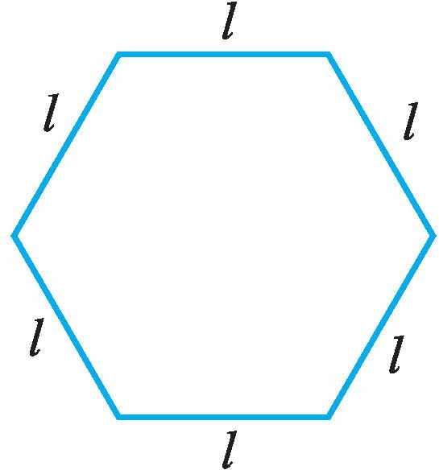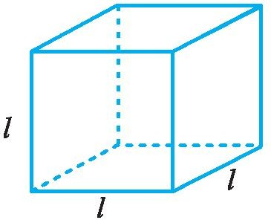

- A cube is a three-dimensional figure as shown in above sided right Fig . It has six faces and all of them are identical squares. The length of an edge of the cube is given by l. Find the formula for the total length of the edges of a cube.

- Give expressions in the following cases.
  - 11 added to 2m
  - 11 subtracted from 2m
  - 5 times y to which 3 is added
  - 5 times y from which 3 is subtracted
  - y is multiplied by – 8
  - y is multiplied by – 8 and then 5 is added to the result
  - y is multiplied by 5 and the result is subtracted from 16
  - y is multiplied by – 5 and the result is added to 16.

- (a) Form expressions using t and 4. Use not more than one number operation. Every expression must have t in it.
(b) Form expressions using y, 2 and 7. Every expression must have y in it. Use only two number operations. These should be different.
- Express the following situations in statements using expressions:
- Sarita has 10 more marbles than Ameena.
- Balu is 3 years younger than Raju.
- Bikash is twice as old as Raju.
- Raju’s father’s age is 2 years more than 3 times Raju’s age.
- How old will Susan be 5 years from now?
- How old was Susan 4 years ago?
- Price of wheat per kg is Rs 5 less than price of rice per kg.
- Price of oil per litre is 5 times the price of rice per kg.
- The speed of a bus is 10 km/hour more than the speed of a truck going on the same road.

- The length of a rectangular hall is 4 meters less than 3 times the breadth of the hall. What is the length, if the breadth is b meters?

- Complete the entries in the third column of the table.

 | Equation | Value of the variable | Solution (Yes/No)
 | x + 10 = 30 | x = 10
 | x + 10 = 30 | x = 30
 | x + 10 = 30 | x = 20
 | p – 3 = 7 | p = 5
 | p – 3 = 7 | p = 15
 | p – 3 = 7 | p = 10
 | 3n = 21 | n = 9
 | 3n = 21 | n = 7
 | t = 4  5 | t = 25
 | t = 4  5 | t = 20
 | t = 4  5 | t = 30
 | 2m + 3 = 7 | m = 5
 | 2m + 3 = 7 | m = 1
 | 2m + 3 = 7 | m = 2

- Complete the table and by inspection of the table find the solution to the equation m + 9 = 16.

m | 1 | 2 | 3 | 4 | 5 | 6 | 7 | 8 | 9 | 10 | 11 | 12 | 13
m + 9 | ….. | ….. | ….. | ….. | ….. | ….. | ….. | ….. | ….. | ….. | ….. | ….. | …..

- Complete the table and by inspection of the table find the solution to the equation n – 2 = 10.

n | 1 | 2 | 3 | 4 | 5 | 6 | 7 | 8 | 9 | 10 | 11 | 12 | 13
n – 2 | ….. | ….. | ….. | ….. | ….. | ….. | ….. | ….. | ….. | ….. | ….. | ….. | …..

- A bus travels at v km per hour. It is going from Daspur to Beespur. After the bus has travelled 5 hours, Beespur is still 20 km away. What is the distance from Daspur to Beespur? Express it using v.

- Change the following statements using expressions into statements in ordinary language.
  - A notebook costs Rs p. A book costs Rs 3 p.
  - Tony puts q marbles on the table. He has 8 q marbles in his box.
  - Our class has n students. The school has 20 n students.
  - Jaggu is z years old. His uncle is 4 z years old and his aunt is (4z – 3) years old.
  - In an arrangement of dots there are r rows. Each row contains 5 dots.

ASSIGNMENT QUESTIONS

CLASS VI: CHAPTER – 11
ALGEBRA

Give an expression for each

- The perimeter of an equilateral triangle, if side of the triangle is m.
- Area of the rectangle with length k units and breadth n units.
- Omar helps his mother 1 hour more than his sister does.
- Two consecutive odd integers.
- Two consecutive even integers.
- Multiple of 5.
- Anagha, Sushant and Faizal are climbing the steps to a hill top. Anagha is at the step p. Sushant is 10 steps ahead and Faizal is 6 steps behind Anagha. Where are Sushant and Faizal? The total number of steps to the hill top is 3 steps less than 8 times what Anagha has reached. Express the total number of steps using p.
- Raju’s age (in years) is 2 more than 5 times her daughter’s age.
- 13 subtracted from thrice of a number.
- One more than twice the number.
- 20⁰C less than the present temperature.
- The successor of an integer.
- The denominator of a fraction is 1 more than its numerator.
- The height of Mount Everest is 20 times the height of Empire State building.
- If a note book costs Rs p and a pencil costs Rs 3, then the total cost (in Rs) of two note books and one pencil.
- z is multiplied by –3 and the result is subtracted from 13.
- p is divided by 11 and the result is added to 10.
- x times of 3 is added to the smallest natural number.
- 6 times q is subtracted from the smallest two digit number.
- Write two equations for which 2 is the solution.
- Write an equation for which 0 is a solution.
- Write an equation whose solution is not a whole number.
- one-half of the sum of number x and y.
- 2 less than the quotient of x by y.
- 4 times x taken away from one-third of y.
- quotient of x by 3 is multiplied by y.

Convert the expressions into statements in ordinary language.

- Cost of a pencil is Rs x. A pen costs Rs 6x.
- Manisha is z years old. Her uncle is 5z years old and her aunt is (5z – 4) years old.
- A pencil costs Rs p and a pen costs Rs 5p.
- Leela contributed Rs y towards the Prime Minister’s Relief Fund. Leela is now left with Rs (y + 10000).
- Kartik is n years old. His father is 7n years old.
- The maximum temperature on a day in Delhi was poC. The minimum temperature was (p – 10)⁰C.
- John planted t plants last year. His friend Jay planted 2t + 10 plants that year.
- Sharad used to take p cups tea a day. After having some health problem, he takes p – 5 cups of tea a day.
- The number of students dropping out of school last year was m. Number of students dropping out of school this year is m – 30.
- Price of petrol was Rs p per litre last month. Price of petrol now is Rs (p – 5) per litre.
- Khader’s monthly salary was Rs P in the year 2005. His salary in 2006 was Rs (P + 1000).
- The number of girls enrolled in a school last year was g. The number of girls enrolled this year in the school is 3g – 10.

- Translate each of the following statements into an equation, using x as the variable:
  - 13 subtracted from twice a number gives 3.
  - One fifth of a number is 5 less than that number.
  - Two-third of number is 12.
  - 9 added to twice a number gives 13.
  - 1 subtracted from one-third of a number gives 1.

- Translate each of the following statements into an equation:
  - The perimeter (p) of an equilateral triangle is three times of its side (a).
  - The diameter (d) of a circle is twice its radius (r).
  - The selling price (s) of an item is equal to the sum of the cost price (c) of an item and the profit (p) earned.
  - Amount (a) is equal to the sum of principal (p) and interest (i).
- A class with p students has planned a picnic. Rs 50 per student is collected, out of which Rs 1800 is paid in advance for transport. How much money is left with them to spend on other items?

- In a village, there are 8 water tanks to collect rain water. On a particular day, x litres of rain water is collected per tank. If 100 litres of water was already there in one of the tanks, what is the total amount of water in the tanks on that day?
- What is the area of a square whose side is m cm?
- Perimeter of a triangle is found by using the formula P = a + b + c, where a, b and c are the sides of the triangle. Write the rule that is expressed by this formula in words.
- Perimeter of a rectangle is found by using the formula P = 2 ( l + w), where l and w are respectively the length and breadth of the rectangle. Write the rule that is expressed by this formula in words.
- On my last birthday, I weighed 40kg. If I put on m kg of weight after a year, what is my present weight?
- Length and breadth of a bulletin board are r cm and t cm, respectively.
- What will be the length (in cm) of the aluminium strip required to frame the board, if 10cm extra strip is required to fix it properly.
- If x nails are used to repair one board, how many nails will be required to repair 15 such boards?
- If 500sqcm extra cloth per board is required to cover the edges, what will be the total area of the cloth required to cover 8 such boards?
- What will be the expenditure for making 23 boards, if the carpenter charges Rs x per board.
- Sunita is half the age of her mother Geeta. Find their ages
- after 4 years?
- before 3 years?
- Manoj spends Rs. x daily and saves Rs. y per week. What is his income after 2 weeks?
- One pencil costs Rs. 4 and one pen cots Rs. 10. What is the cost of x pencils and y fountain pens?
- Ajay spends Rs. x per week and saves Rs. y daily. What is his income after 3 weeks?
- Deepa scores 90 marks in Mathematics and x marks in Science. What is her total score in Science and Mathematics?
- The score of Abhay in Maths is 25 more than the two third of his score in science. If he scored x marks in Science, find his score in Mathematics.
- The score of Manoj in Maths is 15 less than the one-third of his score in science. If he scored x marks in Science, find his score in Mathematics.
- Rakesh covers x centimeters in one step. How many centimeteres does he covers in 10 steps?
- Think of a number. Multiply it by 6. Add 5 to the result. Subtract y from this result. What is the result?
- Rakesh spends Rs. x per week and saves Rs. y daily. What is his income after 4 weeks?

- One pencil costs Rs. 2 and one fountain pen cots Rs. 15. What is the cost of x pencils and y fountain pens?
- Rohit scores 80 marks in Maths and x marks in English. What is his total score in the two subjects?
- The number of rooms on the ground floor of a building is 15 less than the twice of the number of rooms on first floor. If the first floor has x rooms, how many rooms does the ground floor has?

- If 12,14, 9 and x are in proportion then find the value of x.
  - 105 (b) 10.5 (c) 21 (d) none of these

- If x, 30,24 and 16 are in proportion then find the value of x.
  - 45 (b) 60 (c) 80 (d) none of these

- If 8, 18, 18 are x in proportion then find the value of x.
  - 405 (b) 40.5 (c) 81 (d) none of these

- If 14, 16, x and 24 are in proportion then find the value of x.
  - 105 (b) 10.5 (c) 21 (d) none of these

- If 3, 8, 15 and x are in proportion then find the value of x.
  - 40 (b) 50 (c) 60 (d) none of these

- If 5, 30, 3 and x are in proportion then find the value of x.
  - 20 (b) 25 (c) 18 (d) none of these

- If 2, 3, 28 and x are in proportion then find the value of x.
  - 42 (b) 52 (c) 62 (d) none of these

- If x, 24, 30 and 16 are in proportion then find the value of x.
  - 45 (b) 60 (c) 80 (d) none of these

- If 9, 18, x and 8 are in proportion then find the value of x.
  - 4.5 (b) 9 (c) 8 (d) none of these

- If 49, 35, x and 25 are in proportion then find the value of x.
  - 49 (b) 35 (c) 25 (d) none of these

- If 7, 14, x and 12 are in proportion then find the value of x.
  - 5 (b) 6 (c) 8 (d) none of these

- If 18, 16, 99 and x are in proportion then find the value of x.
  - 44 (b) 22 (c) 88 (d) none of these

- If 10, x, 15 and 3 are in proportion then find the value of x.
  - 2 (b) 6 (c) 8 (d) none of these

- The mean proportion of 9 and 16 is
(a) 3 (b) 12 (c) 33 (d) 11

- The mean proportion of 11 and 44 is
(a) 3 (b) 22 (c) 33 (d) 11

- The mean proportion of 4 and 16 is
(a) 8 (b) 16 (c) 4 (d) 11

- The ratio of 90 cm to 1.5 m is...........
(a) 3 : 5 (b) 5 : 3 (c) 60 : 1 (d) 4 : 3
- 6 : 4 is equivalent ratio of ..............
(a) 2 : 3 (b) 3 : 2 (c) 1 : 2 (d) 1 : 4
- Find the ratio of 81 to 108 ?
(a) 3 : 4 (b) 5 : 9 (c) 4 : 3 (d) 9 : 20
- Fill in the blank :- 15 = ......
18 6
(a) 5 (b) 4 (c) 3 (d) 7
- Find the value of x in 4 : 3 = x : 12 ?
(a) 4 (b) 12 (c) 16 (d) 3
- In proportion first and the last terms are called .
  - Mean terms (b) Extreme terms (c) Middle terms (d) None of these
- The ratio is said to be in simplest form if common factor is .
  - 1 (b) 0 (c) -1 (d) None of these
- Three terms a , b , c are said to be in proportion if .
  - a : b = b : c (b) a : b = c : b (c) b : a = c : a (d) c : a = a : b
- Four terms a , b , c , d are said to be in proportion if .
  - a : b = c : d (b) a : c = d : b (c) a : d = b : c (d) None of these

- If the cost of 6 cans of juice is Rs 210, then what is the cost of 4 cans of juice is ?
(a) Rs 120 (b) Rs 140 (c) Rs 100 (d) Rs 80

11. Fill in the blank :- | 32 m : 64 m = 6 sec :
(a) 13 sec | (b) 12 sec | (c) 8 sec | (d) | 24sec

12. Which of the following is correct :-
(a) 3 : 4 = 15 : 25 (b) 12 : 24 = 6 : 12 (c) 7 : 3 = 14 : 3 (d) 5 : 10 = 9 : 20

13. The ratio of 15 Kg to | 75 Kg is...........
(a) 1 : 5 | (b) 5 : 1 | (c) 3 : 5 | (d) | 15 : 3

- 7 : 42 is equivalent ratio of ..............
(a) 7 : 6 (b) 6 : 1 (c) 1 : 6 (d) 6 : 7

- Find the ratio of 33 Km to 121 Km ?
(a) 3 : 11 (b) 11 : 3 (c) 3 : 7 (d) 7 : 3

- Fill in the blank :- 35 = .....
42 6
(a) 5 (b) 4 (c) 3 (d) 7
- Find the value of x in 3 : 4 = x : 16?
(a) 4 (b) 16 (c) 12 (d) 3
- Two quantities can be compared only if they are in the same .
  - Ratio (b) Units (c) Proportion (d) None of these
- The ratio is said to be not in simplest form if common factor is ............
  - 1 (b) Other than 1 (c) -1 (d) None of these
- In Proportion the Symbol :: is used for .
  - To show greater ratio (b) Two equate the two ratios
(c) Two show smaller ratio (d) None of these.

- Fill in the blank:- 30 , 40 , ............. , and 60 are in proportion
(a) 15 (b) 45 (c) 35 (d) 10

- The cost of 105 envelopes is Rs 35. How many envelopes can be purchased for Rs 10 ?
(a) 12 (b) 40 (c) 30 (d) 50

- Fill in the blank :- 36 m : 72 m = 6 sec :
  - 13 min (b) 24 sec (c) 8 min (d) 12 sec

- Which of the following is correct :-
(a) 3 : 4 = 15 : 25 (b) 16 : 32 = 10 : 20 (c) 7 : 3 = 14 : 3 (d) 5 : 15 = 9 : 20

10. The ratio of 20 Km to  (a) 1 : 5 |  |  | 100 Km is  (b) 5 : 1 |  | (c) | 3 : 5 | (d) 5 : 3
11. 30 : 45  (a) | is equivalent ratio of ..............  15 : 3 (b) 3 : 15 |  |  |  | (c) | 2 : 3 | (d) 3 : 2
12. Find the ratio of  (a) 1 : 4 |  | 500 ml to  (b) |  | 2 lt ?  4 : 3 | (c) 3 : 4 | (d) 4 : 1
- Fill in the blank :- 36 = 72
..... 6
(a) 8 (b) 12 (c) 3 (d) 6

- Fill in the blank:- 25 , 30 , and 48 are in proportion
(a) 15 (b) 40 (c) 35 (d) 42

- Divide 20 pens between Sheela and Sangeeta in the ratio of 3 : 2.
(a) 12 , 8 (b) 11 , 9 (c) 10 , 10 (d) 14 , 6

- Fill in the blank :- 12 : 108 = 1 :
(a) 1 (b) 9 (c) 8 (d) 12

- The ratio of 98 to 63 is
(a) 14 : 5 (b) 9 : 14 (c) 5 : 14 (d) 14 : 9

- 60 : 120 is equivalent ratio of
(a) 1 : 2 (b) 2 : 1 (c) 2 : 3 (d) 3 : 2

- Find the ratio of 55 paise to Re 1 ?
(a) 11 : 25 (b) 11 : 20 (c) 5 : 1 (d) 25: 4

- Fill in the blank :- 22 = 2
...... 3
(a) 3 (b) 22 (c) 33 (d) 11

- The ratio of 20 cm to 2 m is
(a) 1 : 10 (b) 25 : 20 (c) 20 : 5 (d) 4 : 5

- 36 : 84 is equivalent ratio of
(a) 7 : 3 (b) 3 : 7 (c) 6 : 7 (d) 12 : 7

- Find the ratio of 25 to 125 ?
(a) 5 : 1 (b) 5 : 15 (c) 1 : 5 (d) 10 : 25
- Fill in the blank :- 35 = .....
45 9
(a) 5 (b) 4 (c) 3 (d) 7
- Find the ratio of 3 km to 300 m.
  - 10 : 1 b) 1 : 10 c) 1 : 5 d) none of these

- 6 bowls cost Rs 90. What would be the cost of 10 such bowls?
a) Rs 300 b) Rs 150 c) Rs 200 d) Rs 250

- The car that I own can go 150 km with 25 litres of petrol. How far can it go with 30 litres of petrol?
  - 125 km b) 150 km c) 250 km d) none of these

- The ratio of 90 cm to 1.5 m is
  - 2 : 5 b) 3 : 5 c) 4 : 5 d) none of these

- Find the ratio of Speed of a cycle 15 km per hour to the speed of scooter 30 km per hour.
  - 2 : 1 b) 1 : 2 c) 4 : 5 d) none of these

- Find the ratio of 5 m to 10 km
a) 2000 : 1 b) 1 : 2000 c) 1 : 2 d) none of these

If cost of a dozen pencils is Rs. 30 then answer the following questions Q1 to Q5:
- pencils can be bought for Rs. 30
(a) 12 (b) 6 (c) 24 (d) 36

- cost of 1 pencil = Rs.
(a) 2 (b) 3 (c) 2.50 (d) 3.50

- pencils can be bought for Rs. 15.
(a) 12 (b) 6 (c) 24 (d) 36

- pencils can be bought for Rs. 60.
(a) 12 (b) 6 (c) 24 (d) 36

- pencils can be bought for Rs. 90.
(a) 12 (b) 6 (c) 24 (d) 36

If a car can go 90 km on 6 litres of petrol then answer the following questions Q6 to Q10:
- litres of petrol will be needed to go 600 km.
  - 40 (b) 50 (c) 60 (d) none of these

- litres of petrol will be needed to go 1500 km.
  - 100 (b) 50 (c) 60 (d) none of these

- The car can go km on 10 litres of petrol.
  - 140 (b) 150 (c) 160 (d) none of these

- The car can go km on 15 litres of petrol.
  - 200 (b) 225 (c) 250 (d) none of these

- litres of petrol will be needed to go 1200 km.
  - 45 (b) 60 (c) 80 (d) none of these

If Manoj earns Rs. 1200 in 10 days, then answer the following questions Q11 to Q15
- Manoj’s per day income is Rs.
  - 120 (b) 150 (c) 160 (d) none of these

- Manoj’s income for 18 days is Rs.
(a) 2140 (b) 2150 (c) 2160 (d) none of these

- Manoj’s income for 32 days is Rs.
(a) 3840 (b) 3850 (c) 3860 (d) none of these

- Manoj will earn Rs. 9600 in days.

  - 45 (b) 60 (c) 80 (d) none of these

- Manoj’s income for 30 days is Rs.

(a) 3000 (b) 3400 (c) 3600 (d) none of these

If 12 boxes are required to hold 48 litres of milk, then answer the following questions Q1 to Q5:

- boxes will be required to hold 60 litres of milk.
  - 15 (b) 16 (c) 18 (d) none of these

- 36 boxes will be required to hold litres of milk.
  - 155 (b) 146 (c) 144 (d) none of these

- boxes will be required to hold 16 litres of milk.
(a) 8 (b) 16 (c) 4 (d) 11

- 48 boxes will be required to hold litres of milk.
  - 195 (b) 192 (c) 144 (d) none of these

- 60 boxes will be required to hold litres of milk.
  - 240 (b) 225 (c) 250 (d) none of these

If the weight of 81 books is 9 kg, then answer the following questions Q6 to Q10:

- The weight of 36 such books is kg.
  - 8 (b) 16 (c) 4 (d) none of these

- The weight of 180 such books is kg.
  - 20 (b) 25 (c) 18 (d) none of these

- The weight of 108 such books is kg.
(a) 12 (b) 6 (c) 24 (d) 36

- The weight of 72 such books is kg.
  - 8 (b) 16 (c) 4 (d) none of these

- books will weighs 1 kg.
  - 8 (b) 10 (c) 9 (d) none of these

If the cost of 3 dozens of banana is Rs. 60, then answer the following questions Q11 to Q15:

- Cost of 5 dozens of banana is Rs.
  - 100 (b) 50 (c) 60 (d) none of these

- Cost of 1 dozen of banana is Rs.
  - 20 (b) 25 (c) 18 (d) none of these

- dozens of banana can be bought for Rs. 120.
(a) 12 (b) 6 (c) 24 (d) 36

- bananas can be bought for Rs. 30.
  - 18 (b) 16 (c) 14 (d) none of these

- Cost of 15 dozen of banana is Rs.
  - 100 (b) 150 (c) 300 (d) none of these

If the cost of 10 kg of wheat is Rs. 172.50, then answer the following questions:

- Cost of 8 kg of wheat will be Rs.
  - 131 (b) 135 (c) 138 (d) none of these

- Cost of 18 kg of wheat will be Rs.
(a) 310 (b) 310.50 (c) 621 (d) none of these

- kg of wheat can be purchased for Rs. 103.50
(a) 12 (b) 6 (c) 24 (d) 36

- kg of wheat can be purchased for Rs. 431.25
  - 20 (b) 25 (c) 18 (d) none of these

- Cost of 100 kg of wheat will be Rs.
(a) 1725 (b) 17250 (c) 17.25 (d) none of these

PRACTICE QUESTIONS

CLASS VI: CHAPTER - 12
RATIO AND PROPORTION

- In a class, there are 20 boys and 40 girls. What is the ratio of the number of boys to the number of girls?

- Ravi walks 6 km in an hour while Roshan walks 4 km in an hour. What is the ratio of the distance covered by Ravi to the distance covered by Roshan?

- Saurabh takes 15 minutes to reach school from his house and Sachin takes one hour to reach school from his house. Find the ratio of the time taken by Saurabh to the time taken by Sachin.

- Cost of a toffee is 50 paise and cost of a chocolate is Rs 10. Find the ratio of the cost of a toffee to the cost of a chocolate.

- In a school, there were 73 holidays in one year. What is the ratio of the number of holidays to the number of days in one year?

- Length and breadth of a rectangular field are 50 m and 15 m respectively. Find the ratio of the length to the breadth of the field.

- Find the ratio of 90 cm to 1.5 m.

- There are 45 persons working in an office. If the number of females is 25 and the remaining are males, find the ratio of :
  - The number of females to number of males.
  - The number of males to number of females.

- Give two equivalent ratios of 6 : 4.

- Fill in the missing numbers : 14 =

.... = 6

21 3 ....
- Ratio of distance of the school from Mary’s home to the distance of the school from John’s home is 2 : 1.
  - Who lives nearer to the school?
  - Complete the following table which shows some possible distances that Mary and John could live from the school.
  - If the ratio of distance of Mary’s home to the distance of Kalam’s home from school is 1 : 2, then who lives nearer to the school?

- Divide Rs 60 in the ratio 1 : 2 between Kriti and Kiran.

- In a year, Seema earns Rs 1,50,000 and saves Rs 50,000. Find the ratio of
  - Money that Seema earns to the money she saves.
  - Money that she saves to the money she spends.

- In a college, out of 4320 students, 2300 are girls. Find the ratio of
  - Number of girls to the total number of students.
  - Number of boys to the number of girls.

- Divide 20 pens between Sheela and Sangeeta in the ratio of 3 : 2.

- Fill in the following blanks : 15 =
18
- Find the ratio of the following:
  - 30 minutes to 1.5 hours
  - 40 cm to 1.5 m
  - 55 paise to Re 1
  - 500 ml to 2 litres
.... 6
= 10 =
....
.... 30
[Are these equivalent ratios?]

- Cost of a dozen pens is Rs 180 and cost of 8 ball pens is Rs 56. Find the ratio of the cost of a pen to the cost of a ball pen.

- Check whether the given ratios are equal, i.e. they are in proportion. If yes, then write them in the proper form.
1. 1 : 5 and 3 : 15
2. 2 : 9 and 18 : 81
3. 15 : 45 and 5 : 25
4. 4 : 12 and 9 : 27
5. Rs 10 to Rs 15 and 4 to 6

- If the cost of 6 cans of juice is Rs 210, then what will be the cost of 4 cans of juice?

- A motorbike travels 220 km in 5 litres of petrol. How much distance will it cover in 1.5 litres of petrol?

- If the cost of a dozen soaps is Rs 153.60, what will be the cost of 15 such soaps?

- Cost of 105 envelopes is Rs 35. How many envelopes can be purchased for Rs 10?
- A car travels 90 km in 2 1 hours.
2
  - How much time is required to cover 30 km with the same speed?
  - Find the distance covered in 2 hours with the same speed.
- Cost of 5 kg of wheat is Rs 30.50.
  - What will be the cost of 8 kg of wheat?
  - What quantity of wheat can be purchased in Rs 61?

- The temperature dropped 15 degree celsius in the last 30 days. If the rate of temperature drop remains the same, how many degrees will the temperature drop in the next ten days?

- Cost of 4 dozens bananas is Rs 60. How many bananas can be purchased for Rs 12.50?

- The weight of 72 books is 9 kg. What is the weight of 40 such books?

- A truck requires 108 litres of diesel for covering a distance of 594 km. How much diesel will be required by the truck to cover a distance of 1650 km?

- Anish made 42 runs in 6 overs and Anup made 63 runs in 7 overs. Who made more runs per over?

ASSIGNMENT QUESTIONS

CLASS VI: CHAPTER - 12
RATIO AND PROPORTION

- The length and breadth of a steel tape are 10m and 2.4cm, respectively. Find the ratio of the length to the breadth.

- Find the missing number in the box in the following proportion: : 8 ::12 : 32

- Income of Rahim is Rs 12000 per month and that of Ami is Rs 191520 per annum. If the monthly expenditure of each of them is Rs 9960 per month find the ratio of their savings.

- 20 tons of iron costs Rs 600000. Find the cost of 560kg of iron.

- Find the ratio of the number of sides of a square to the number of edges of a cube.

- The cost of a notebook is Rs. 20 and the cost of a pen is Rs. 15. What is the ratio between the cost of a notebook and the cost of a pen?

- Find the ratio of 3 Kg to 750 g

- Find the ratio of 50 cm to 3m.

- Cheran gets Rs. 10000 as salary and his savings is Rs. 2000. Find the ratio of a) his salary to savings b) his salary to expenditure c) his savings to expenditure.
- Express the following ratios in the lowest form (a) 6 : 15 (b) 10 : 25 (c) 4 : 20 (d) 35 : 77 (e) 1.2 : 4.8 (f) 1 :11
3 3

- Express the following ratios in the lowest form (a) 1 Kg to 250g (b) 20 cm to 2m (c) 500 ml to 3 litres (d) 30 min to 2 hours (e) 25 paise to 2 Rs. (f) 60 students to 2 teachers

- There are 2000 students in a school. 500 students went for an excursion. Find the ratio between
  - the total number of students and the number of students who went for the excursion (b) the total number of students and the number of students who did not go for the excursion.

- John is 50 years old, his son is 10 years old. Write down the ratio between their ages (a) 5 years ago (b) at present (c) after 5 years

- A picture is 60cm wide and 1.8m long. Find the ratio of its width to its perimeter in lowest form.

- 250 people are working in an office, out of which 150 are men and the remaining are women. Find the ratio of (a) the total number of people to that of men (b) the total number of people to that of women (c) the number of men to that of women.

- Divide Rs. 240 in the ratio 3 : 5

- The length and breadth of a rectangle are in the ratio 4 : 3. If the breadth is 21 cm, find the length?

- Divide Rs. 300 in the ratio 2 : 3

- Divide 5 kg 600 gm in the ratio 4 : 3

- Divide 2m 25 cm in the ratio 5 : 4

- Divide 2 hour 30 minutes in the ratio 1 : 4

- Mixture 'A' has cement and sand in the ratio 1 : 4 and Mixture 'B' has cement and sand in the ratio 2 : 7. Which mixture has more sand?

- If Rs. 5,500 is divided between Vivek and Deepak in the ratio 6 : 5, who will get more and how much more?

- The length and breadth of a rectangle are in the ratio 7 : 2. If the length is 35 cm, find the breadth.

- The ratio of expenditure and savings in a family is 5 : 2. If the expenditure is Rs. 2,500, what is the savings?

- A box of Sweets was divided between Saravanan and Kumaran in the ratio of 3 : 4. If Saravanan got 36 sweets , how many sweets did Kumaran get? What was the total number of sweets in the box?

- Neelam’s annual income is Rs. 288000. Her annual savings amount to Rs. 36000. Find the ratio of her savings to her expenditure.

- Mathematics textbook for Class VI has 320 pages. The chapter ‘symmetry’ runs from page 261 to page 272. Find the ratio of the number of pages of this chapter to the total number of pages of the book.

- On a shelf, books with green cover and that with brown cover are in the ratio 2:3. If there are 18 books with green cover, then the number of books with brown cover.

- Find the greatest ratio among the ratios 2 : 3, 5 : 8, 75 : 121 and 40 : 25

- If a bus travels 160 km in 4 hours and a train travels 320km in 5 hours at uniform speeds, then find the ratio of the distances travelled by them in one hour.

- Saturn and Jupiter take 9 hours 56 minutes and 10 hours 40 minutes, respectively for one spin on their axes. Find the ratio of the time taken by Saturn and Jupiter in lowest form.

- 10g of caustic soda dissolved in 100mL of water makes a solution of caustic soda. Find the amount of caustic soda needed for 1 litre of water to make the same type of solution.

- The marked price of a table is Rs 625 and its sale price is Rs 500. What is the ratio of the sale price to the marked price?

- Reshma prepared 18kg of Burfi by mixing Khoya with sugar in the ratio of 7 : 2. How much
Khoya did she use?

- A line segment 56cm long is to be divided into two parts in the ratio of 2 : 5. Find the length of each part.

- The number of milk teeth in human beings is 20 and the number of permanent teeth is 32. Find the ratio of the number of milk teeth to the number of permanent teeth.

- Sex ratio is defined as the number of females per 1000 males in the population. Find the sex ratio if there are 3732 females per 4000 males in a town.

- In a year, Ravi earns Rs 360000 and paid Rs 24000 as income tax. Find the ratio of his (a) income to income tax. (b) income tax to income after paying income tax.

- Ramesh earns Rs 28000 per month. His wife Rama earns Rs 36000 per month. Find the ratio of
  - Ramesh’s earnings to their total earnings (b) Rama’s earnings to their total earnings.

- Of the 288 persons working in a company, 112 are men and the remaining are women. Find the ratio of the number of (a) men to that of women. (b) men to the total number of persons. (c) women to the total number of persons.

- A rectangular sheet of paper is of length 1.2m and width 21cm. Find the ratio of width of the paper to its length.

- A scooter travels 120km in 3 hours and a train travels 120km in 2 hours. Find the ratio of their speeds.

- An office opens at 9 a.m. and closes at 5.30 p.m. with a lunch break of 30 minutes. What is the ratio of lunch break to the total period in the office?

- The shadow of a 3m long stick is 4m long. At the same time of the day, if the shadow of a flagstaff is 24m long, how tall is the flagstaff?

- A recipe calls for 1 cup of milk for every 2 1
2

cups of flour to make a cake that would feed 6

persons. How many cups of both flour and milk will be needed to make a similar cake for 8 people?

- In a school, the ratio of the number of large classrooms to small classrooms is 3:4. If the number of small rooms is 20, then find the number of large rooms.

- Samira sells newspapers at Janpath crossing daily. On a particular day, she had 312 newspapers out of which 216 are in English and remaining in Hindi. Find the ratio of (a) the number of English newspapers to the number of Hindi newspapers. (b) the number of Hindi newspapers to the total number of newspapers.

- The students of a school belong to different religious backgrounds. The number of Hindu students is 288, the number of Muslim students is 252, the number of Sikh students is 144 and the number of Christian students is 72. Find the ratio of (a) the number of Hindu students to the number of Christian students. (b) the number of Muslim students to the total number of students.

- When Chinmay visted chowpati at Mumbai on a holiday, he observed that the ratio of North Indian food stalls to South Indian food stalls is 5:4. If the total number of food stalls is 117, find the number of each type of food stalls.

- At the parking stand of Ramleela ground, Kartik counted that there are 115 cycles, 75 scooters and 45 bikes. Find the ratio of the number of cycles to the total number of vehicles.

- A train takes 2 hours to travel from Ajmer to Jaipur, which are 130km apart. How much time will it take to travel from Delhi to Bhopal which are 780km apart if the train is travelling at the uniform speed?

- A tea merchant blends two varieties of tea costing her Rs 234 and Rs 130 per kg in the ratio of their costs. If the weight of the mixture is 84kg, then find the weight of each variety of tea.

- An alloy contains only zinc and copper and they are in the ratio of 7:9. If the weight of the alloy is 8kg, then find the weight of copper in the alloy.

- Find two numbers whose sum is 100 and whose ratio is 9 :16.

- A typist has to type a manuscript of 40 pages. She has typed 30 pages of the manuscript. What is the ratio of the number of pages typed to the number of pages left?

- The cost of 4 notebooks is 24 and the cost of 7 notebooks is Rs. 42. What is the proportion?

- The income and Savings of a family are in the ratio 7 : 2. If the income of the family is Rs. 5,600. Find how much is being saved.

- If the cost of 7m cloth is Rs. 49, find the cost of 5m cloth.

- The length and breadth of the rectangular ground are in the ratio 6 : 5. If its length is 120m, find the breadth of the ground.]

- Cement and sand are mixed in the ratio 2 : 7 in a mixture. If the weight of cement is 100 kg, What will be the weight of the sand?

- The cost of 3m cloth is Rs. 135. Find the cost of 7m of the same cloth.

- Using 4 and 15 as means, write two proportions.

- Using 4 and 10 as extremes, write two proportions.

- A car can travel 240km in 15 litres of petrol. How much distance will it travel in 25 litres of petrol?

- Bachhu Manjhi earns Rs 24000 in 8 months. At this rate, (a) how much does he earn in one year?
(b) in how many months does he earn Rs 42000?

- The yield of wheat from 8 hectares of land is 360 quintals. Find the number of hectares of land required for a yield of 540 quintals?

- The earth rotates 360o about its axis in about 24 hours. By how much degree will it rotate in 2 hours?

- Shivangi is suffering from anaemia as haemoglobin level in her blood is lower than the normal range. Doctor advised her to take one iron tablet two times a day. If the cost of 10 tablets is Rs 17, then what amount will she be required to pay for her medical bill for 15 days?

- The quarterly school fee in Kendriya Vidyalaya for Class VI is Rs 540. What will be the fee for seven months?

- In an election, the votes cast for two of the candidates were in the ratio 5 : 7. If the successful candidate received 20734 votes, how many votes did his opponent receive?

- A metal pipe 3 metre long was found to weigh 7.6kg. What would be the weight of the same kind of 7.8m long pipe?

- A recipe for raspberry jelly calls for 5 cups of raspberry juice and 2 1
2
amount of sugar needed for 6 cups of the juice?

cups of sugar. Find the

- A farmer planted 1890 tomato plants in a field in rows each having 63 plants. A certain type of worm destroyed 18 plants in each row. How many plants did the worm destroy in the whole field?

- Length and breadth of the floor of a room are 5m and 3m, respectively. forty tiles, each with area
1 m² are used to cover the floor partially. Find the ratio of the tiled and the non tiled portion of
16
the floor.

- A carpenter had a board which measured 3m × 2m. She cut out a rectangular piece of 250cm × 90cm. What is the ratio of the area of cut out piece and the remaining piece?

- A bus covers 135 km in 3 hours. What will be the distance covered in 8 hours in the same speed?

- The mass of a rod whose length 10 cm is 250 gm. What will be the mass if the rod is 25 cm long?

- The interest for a certain principal for 5 years is Rs. 600. At the same rate, what will be the interest for 8 years for the same principal?

- The rent for a room for 2 months is Rs. 4400. What will be the rent for one year for that room?

- A machine prints 750 pages in 30 minutes. How much time will the machine take to print 4500 pages?

- The cost of 15 chairs is Rs. 2250. Find the number of such chairs that can be purchased for Rs. 10500.

- The cost of 5 books is Rs. 250. Find the cost of 12 books.

- The cost of 10 kg rice is Rs. 200. Find the cost of 2 kg rice.

- A car needs 12 litres of petrol to cover a distance of 144 km. How much petrol will be required for the car to cover a distance of 720 km?

- Which of the followings has both horizontal as well as vertical line of symmetry:
  - S (b) A (c) U (d) H

- The mirror image of ‘W’, when the mirror is placed vertically:
  - V (b) M (c) Σ (d) W

- Number of lines of symmetry a triangle does not have:
(a) 1 (b) 2 (c) 3 (d) 0

- A parallelogram has lines of symmetry:
(a) 0 (b) 1 (c) 2 (d) 3

- Which of the following alphabets has line symmetry ?
  - P (b) Z (c) A (d) Q

- How many lines of symmetries are there in an equilateral triangle?
(a) 1 (b) 2 (c) 3 (d) 4

- Which of the following letters have reflection line of symmetry about vertical mirror?
  - B (b) C (c) V (d) Q

- How many lines of symmetries are there in an isosceles triangle ?
(a) 1 (b) 2 (c) 3 (d) 4

- How many lines of symmetries are there in a rhombus?
(a) 1 (b) 2 (c) 3 (d) 4

- How many lines of symmetries are there in a square?
(a) 1 (b) 2 (c) 3 (d) 4

- How many lines of symmetries are there in regular pentagon?
(a) 1 (b) 2 (c) 3 (d) 4

- How many lines of symmetries are there in rectangle?
(a) 1 (b) 2 (c) 3 (d) 4

- Find the number of lines of symmetry of the following figure:
(a) 1 (c) 3 (d) 4
(b) 2

- Find the number of lines of symmetry of the following figure:
(a) 1 (b) 2 (c) 3 (d) 4

- Find the number of lines of symmetry in regular hexagon. (a) 1 (b) 2 (c) 3 (d) 4

- Letter ‘A’ of the English alphabet have reflectional symmetry (i.e., symmetry related to mirror reflection) about.
  - a vertical mirror (b) a horizontal mirror (c) both (a) and (b) (d) none of these

- Letter ‘B’ of the English alphabet have reflectional symmetry (i.e., symmetry related to mirror reflection) about.
  - a vertical mirror (b) a horizontal mirror (c) both (a) and (b) (d) none of these

- Letter ‘C’ of the English alphabet have reflectional symmetry (i.e., symmetry related to mirror reflection) about.
  - a vertical mirror (b) a horizontal mirror (c) both (a) and (b) (d) none of these

- Letter ‘D’ of the English alphabet have reflectional symmetry (i.e., symmetry related to mirror reflection) about.
  - a vertical mirror (b) a horizontal mirror (c) both (a) and (b) (d) none of these

- Letter ‘E’ of the English alphabet have reflectional symmetry (i.e., symmetry related to mirror reflection) about.
  - a vertical mirror (b) a horizontal mirror (c) both (a) and (b) (d) none of these

- Letter ‘E’ of the English alphabet have reflectional symmetry (i.e., symmetry related to mirror reflection) about.
  - a vertical mirror (b) a horizontal mirror (c) both (a) and (b) (d) none of these

- Letter ‘G’ of the English alphabet have reflectional symmetry (i.e., symmetry related to mirror reflection) about.
  - a vertical mirror (b) a horizontal mirror (c) both (a) and (b) (d) none of these

- Letter ‘H’ of the English alphabet have reflectional symmetry (i.e., symmetry related to mirror reflection) about.
  - a vertical mirror (b) a horizontal mirror (c) both (a) and (b) (d) none of these

- Letter ‘I’ of the English alphabet have reflectional symmetry (i.e., symmetry related to mirror reflection) about.
  - a vertical mirror (b) a horizontal mirror (c) both (a) and (b) (d) none of these

- Letter ‘M’ of the English alphabet have reflectional symmetry (i.e., symmetry related to mirror reflection) about.
  - a vertical mirror (b) a horizontal mirror (c) both (a) and (b) (d) none of these

- Letter ‘T’ of the English alphabet have reflectional symmetry (i.e., symmetry related to mirror reflection) about.
  - a vertical mirror (b) a horizontal mirror (c) both (a) and (b) (d) none of these

- Find the number of lines of symmetry in the below left figure:
(a) 1 (b) 2 (c) 3 (d) 4

- Find the number of lines of symmetry in the above right sided figure:
(a) 1 (b) 2 (c) 3 (d) 4

- Find the number of lines of symmetry in the below left figure:
(a) 1 (b) 2 (c) 3 (d) 4
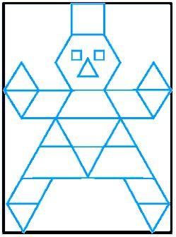

- Find the number of lines of symmetry in the above right sided figure:
(a) 1 (b) 2 (c) 3 (d) 4

- Find the number of lines of symmetry in a circle.
  - 1 (b) 2 (c) 3 (d) none of these

- Which of the followings has no line of symmetry:
  - S (b) A (c) U (d) H

- Which of the followings has both horizontal as well as vertical line of symmetry:
  - Z (b) B (c) P (d) I

- Which letter look the same after reflection when the mirror is placed vertically.
  - S (b) P (c) Q (d) H
- Find the number of lines of symmetry in a scalene triangle.
(a) 0 (b) 1 (c) 2 (d) 3

- Which letter look the same after reflection when the mirror is placed vertically.
  - Z (b) P (c) M (d) N

PRACTICE QUESTIONS

CLASS VI: CHAPTER - 13
SYMMETRY

- Find the number of lines of symmetry of the following figures:
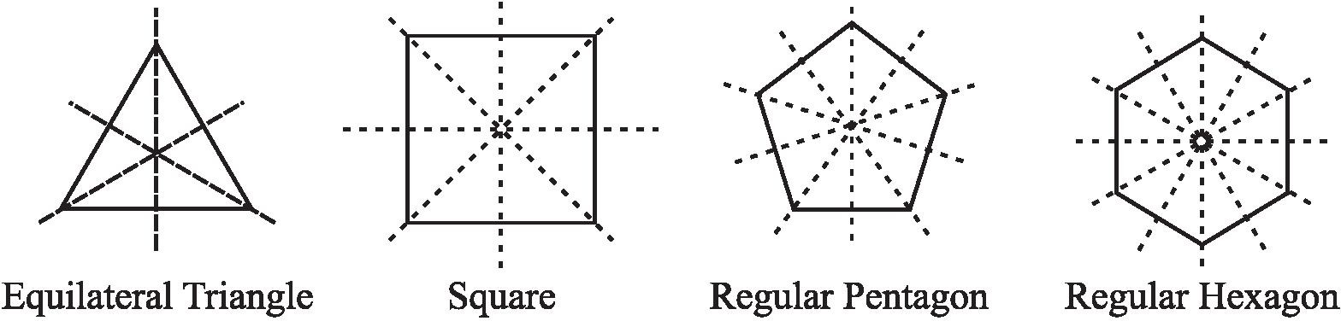
- Given the line(s) of symmetry, find the other hole(s):
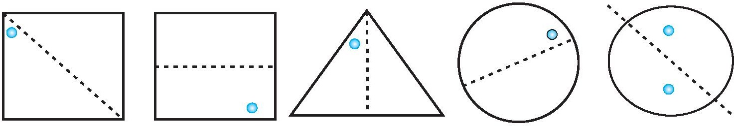
- The following figures have more than one line of symmetry. Such figures are said to have multiple lines of symmetry.
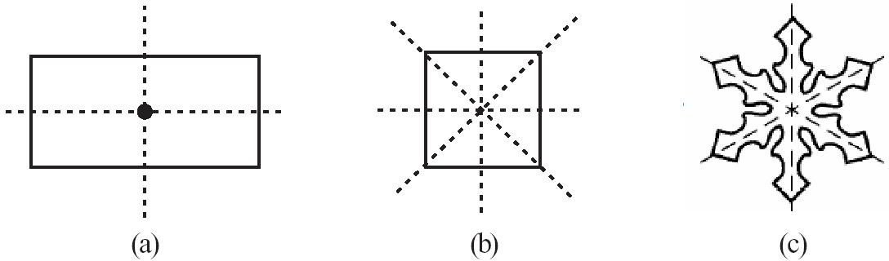
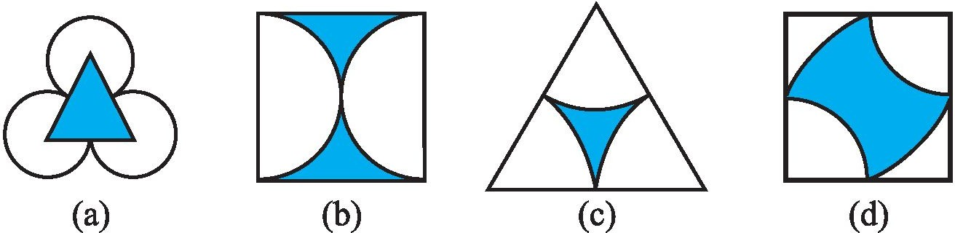
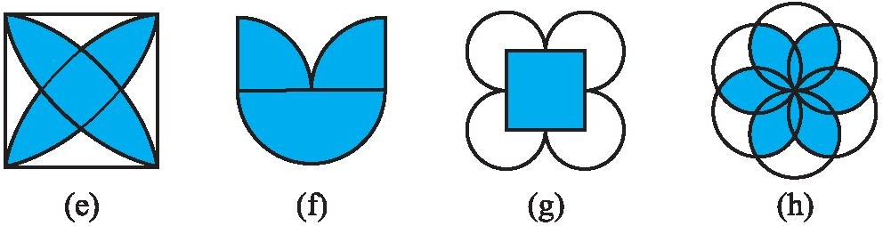
Identify multiple lines of symmetry, if any, in each of the following figures:

- For the given below left figure, which one is the mirror line, l₁ or l₂?
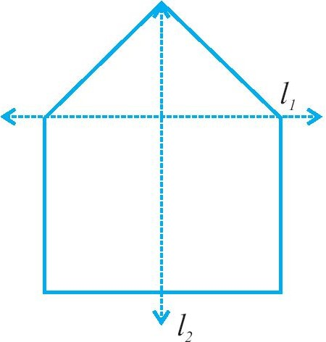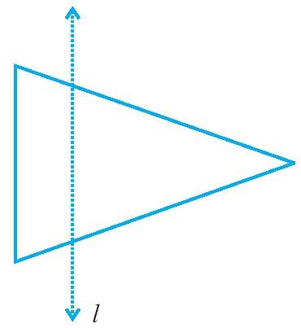
- In the above sided right figure, l is the line of symmetry. Draw the image of the triangle and complete the diagram so that it becomes symmetric.
- Find the number of lines of symmetry for each of the following shapes :
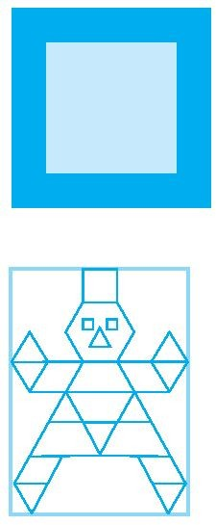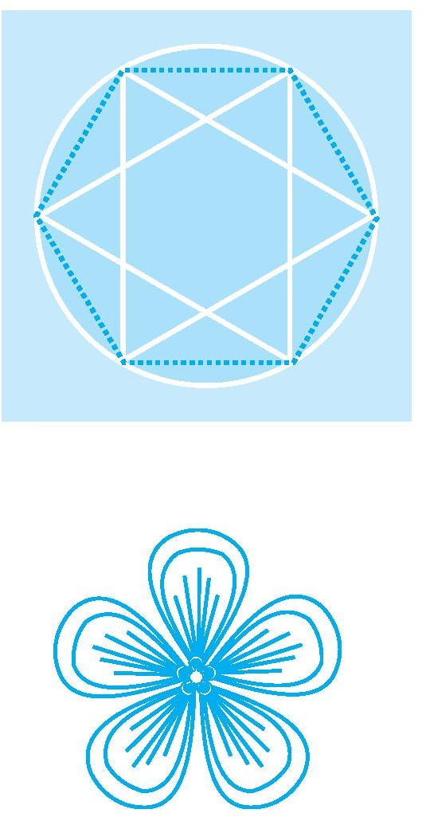
- Copy the triangle in each of the following figures on squared paper. In each case, draw the line(s) of symmetry, if any and identify the type of triangle. (Some of you may like to trace the figures and try paper-folding first!)
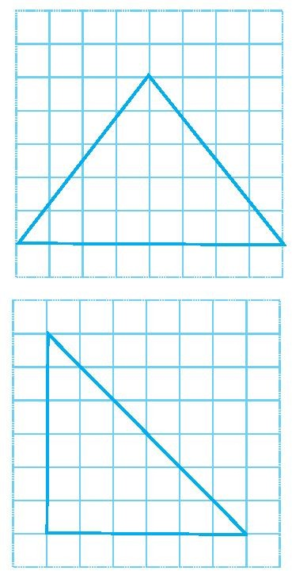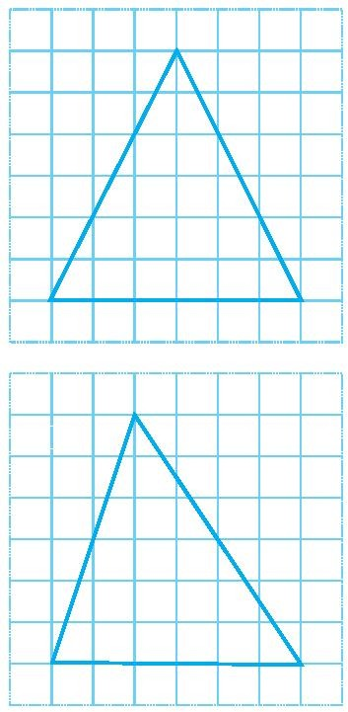
- State the number of lines of symmetry for the following figures:
  - An equilateral triangle (b) An isosceles triangle (c) A scalene triangle (d) A square
(e) A rectangle (f) A rhombus (g) A parallelogram (h) A quadrilateral (i) A regular hexagon
(j) A circle

- What letters of the English alphabet have reflectional symmetry (i.e., symmetry related to mirror reflection) about?
  - a vertical mirror (b) a horizontal mirror (c) both horizontal and vertical mirrors

- Consider the letters of English alphabets, A to Z. List among them the letters which have
  - vertical lines of symmetry (like A)
  - horizontal lines of symmetry (like B)
  - no lines of symmetry (like Q)
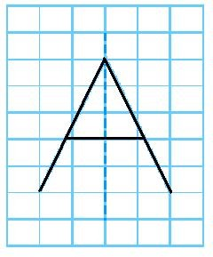
- On a squared paper, sketch the following:
  - A triangle with a horizontal line of symmetry but no vertical line of symmetry.
  - A quadrilateral with both horizontal and vertical lines of symmetry.
  - A quadrilateral with a horizontal line of symmetry but no vertical line of symmetry.
  - A hexagon with exactly two lines of symmetry.
  - A hexagon with six lines of symmetry.

- Complete the following table.
Shape | Rough  figure | Number of lines of symmetry
Equilateral triangle
Square
Rectangle
Isosceles triangle
Rhombus
Circle

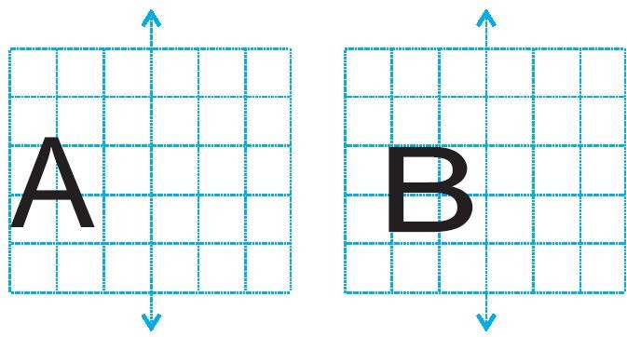
- In each figure alongside, a letter of the alphabet is shown along with a vertical line. Take the mirror image of the letter in the given line. Find which letters look the same after reflection (i.e. which letters look the same in the image) and which do not. Can you guess why?
Try for O E M N P H L T S V X
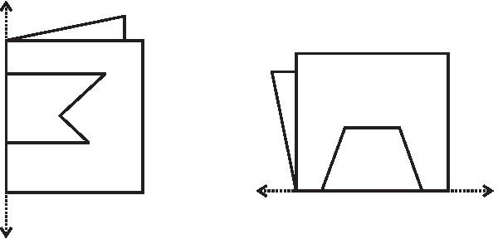
- Given here are figures of a fewfolded sheets and designs drawn about the fold. In each case, draw a rough diagram of the complete figure that would be seen when the design is cut off.

(b) (c)

(d) (e)

(f)

(g) (h) (i)

(j) (k) (l)

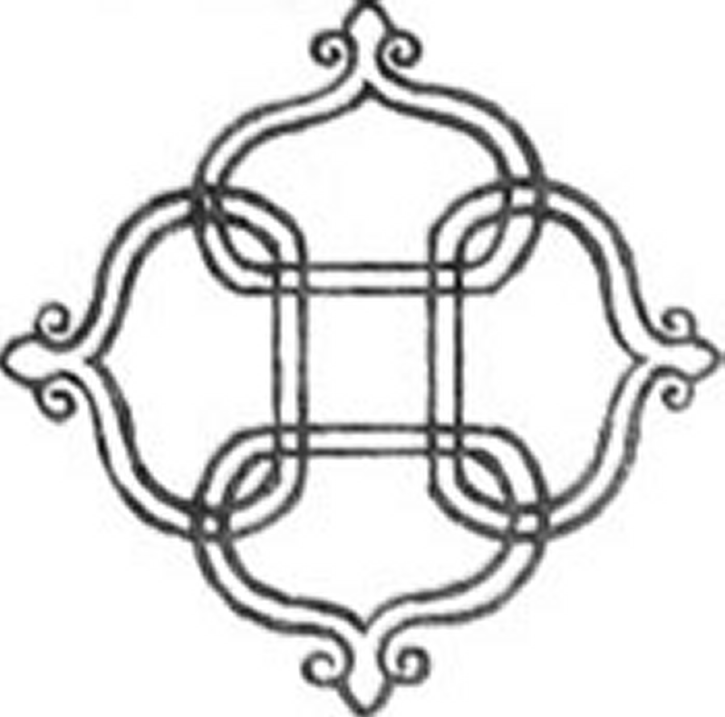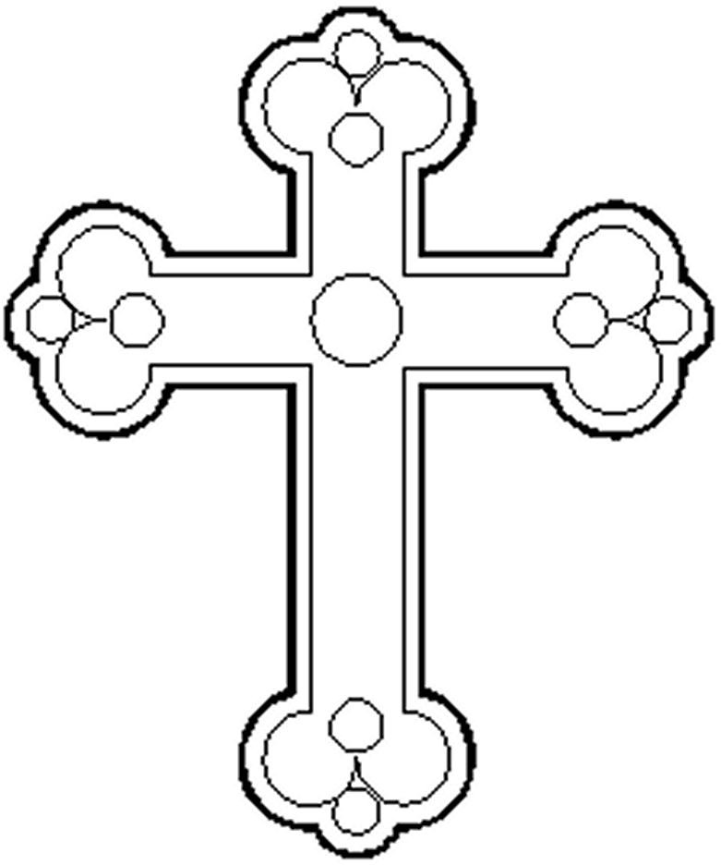

(a) (b) (c)
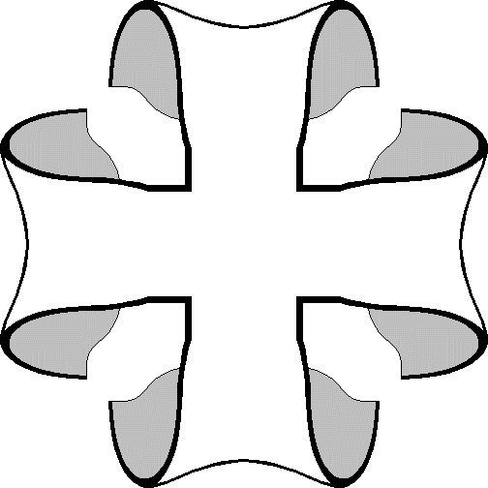
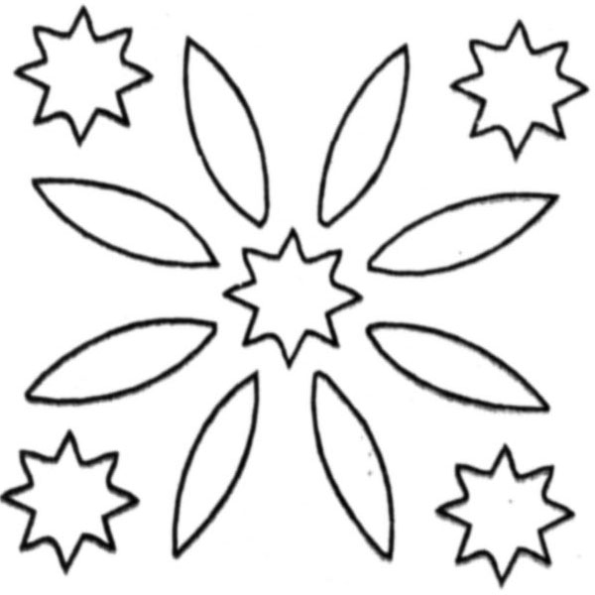
(d) (e) (f)

(g) (h) (i)
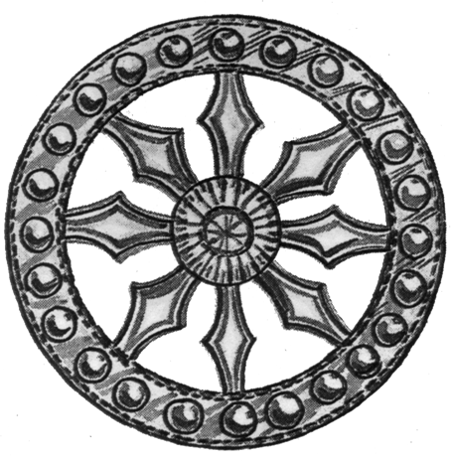
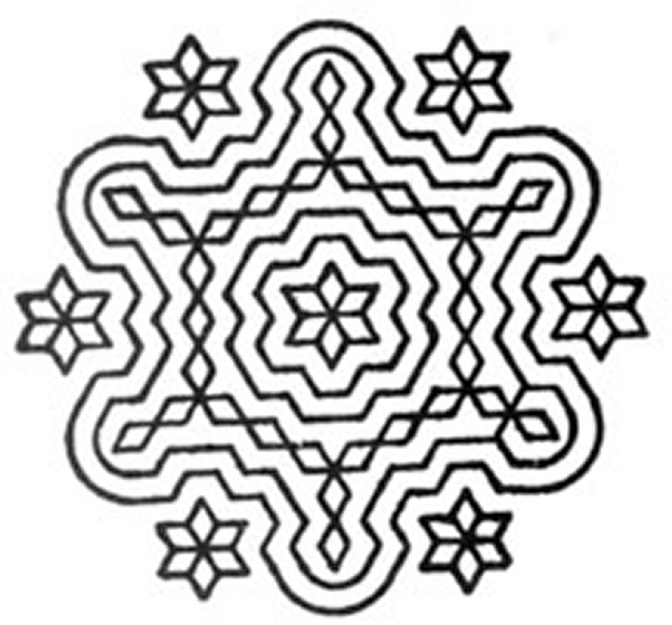
(j) (k) (l)

ASSIGNMENT QUESTIONS

CLASS VI: CHAPTER - 13
SYMMETRY

- Draw and write the number of lines of symmetry of the following shapes :

- Write all the capital letters of the English alphabets which have more than one lines of symmetry.

- Write the letters of the word ‘MATHEMATICS’ which have no line of symmetry.

- Write the letters of the word ‘GEOMETRY’ which have no line of symmetry.

- Write the number of lines of symmetry in each letter of the word ‘SYMMETRY’.

- Fill in the blanks:
  - The digits having only two lines of symmetry are and .
  - The digit having only one line of symmetry is .
  - The number of digits having no line of symmetry is .
  - The number of capital letters of the English alphabets having only vertical line of symmetry is .
  - The number of capital letters of the English alphabets having only horizontal line of symmetry is .
  - The number of capital letters of the English alphabets having both horizontal and vertical lines of symmetry is .
  - The number of capital letters of the English alphabets having no line of symmetry is .
  - The line of symmetry of a line segment is the bisector of the line segment.
  - The number of lines of symmetry in a regular hexagon is .
  - The number of lines of symmetry in a regular polygon of n sides is .
  - A protractor has line/lines of symmetry.
- On a squared paper, sketch the following:
  - A triangle with a horizontal line of symmetry but no vertical line of symmetry.
  - A triangle with a vertical line of symmetry but no horizontal line of symmetry.
  - A triangle with no line of symmetry.
  - A quadrilateral with both vertical and horizontal line of symmetry.
  - A quadrilateral with a horizontal line of symmetry but no vertical line of symmetry.
  - A quadrilateral with a vertical line of symmetry but no horizontal line of symmetry.
  - A hexagon with exactly two lines of symmetry.
  - A hexagon with six lines of symmetry.

- State the number of lines of symmetry for the following figures:
(a) An equilateral triangle (b) An isosceles triangle (c) A scalene triangle (d) A square
(e) A rectangle (f) A rhombus (g) A parallelogram (h) A quadrilateral (i) A regular hexagon
(j) A circle

- Consider the letters of English alphabets, A to Z. List among them the letters which have
- vertical lines of symmetry (like A)
- horizontal lines of symmetry (like B)
- no lines of symmetry (like Q)
- vertical and horizontal lines of symmetry (like H).

- Which geometrical instrument used to draw line segments and to measure their lengths.
  - ruler (b) compasses (c) divider (d) set squares
- Which geometrical instrument used to draw perpendicular and parallel lines.
  - ruler (b) compasses (c) divider (d) set squares
- Which geometrical instrument used to compare lengths.
  - protractor (b) compasses (c) divider (d) set squares
- Which geometrical instrument used to draw and measure angles.
  - protractor (b) compasses (c) divider (d) set squares
- Which geometrical instrument used to mark off equal lengths but not to measure them and draw arcs and circles.
  - protractor (b) compasses (c) divider (d) set squares
- Name the geometrical instrument having a pair – a pointer on one end and a pencil on the other.
  - protractor (b) compasses (c) divider (d) set squares
- Name the geometrical instrument having a pair of pointers
  - protractor (b) compasses (c) divider (d) set squares
- Name the geometrical instrument having two triangular pieces
  - protractor (b) compasses (c) divider (d) set squares
- Name the geometrical instrument having a semi-circular device graduated into 180 degree-parts.
  - protractor (b) compasses (c) divider (d) set squares
- A is a simple closed curve all of whose points are at the same distance from a fixed point.
  - circle (b) diameter (c) radius (d) none of these

- The line segment joining any two points on the circle is called
  - chord (b) diameter (c) radius (d) none of these
- A is the longest chord of a circle.
  - circle (b) diameter (c) radius (d) none of these
- The line segment forming a polygon are called .
  - Vertex (b) sides (c) angle (d) curve
- Number of lines which can be drawn from one point:
  - one (b) infinite (c) two (d) zero
- A line has length.
  - definite (b) indefinite (c) no (d) none of these.
- The edge of a ruler draws .
  - ray (b) line (c) line segment (d) curve

- Draw a circle of radius 3.2 cm.
- With the same centre O, draw two circles of radii 4 cm and 2.5 cm.
- Draw a line segment of length 7.3 cm using a ruler.
- Construct a line segment of length 5.6 cm using ruler and compasses.

- Construct AB of length 7.8 cm. From this, cut off AC of length 4.7 cm. Measure BC .

- Given AB of length 3.9 cm, construct PQ such that the length of PQ is twice that of AB . Verify by measurement.

- Given AB of length 7.3 cm and CD of length 3.4 cm, construct a line segment XY such that the

length of XY is equal to the difference between the lengths of AB and CD . Verify by measurement.

- Draw any line segment AB. Mark any point M on it. Through M, draw a perpendicular to AB . (use ruler and compasses)

- Draw any line segment PQ. Take any point R not on it. Through R, draw a perpendicular to PQ . (use ruler and set-square)
- Draw a line l and a point X on it. Through X, draw a line segment XY perpendicular to l. Now draw a perpendicular to XY at Y. (use ruler and compasses)
- Draw a line segment of length 9.5 cm and construct its perpendicular bisector.
- With PQ of length 6.1 cm as diameter, draw a circle.
- Draw a circle with centre C and radius 3.4 cm. Draw any chord AB. Construct the perpendicular bisector of AB and examine if it passes through C.
- Draw a circle of radius 4 cm. Draw any two of its chords. Construct the perpendicular bisectors of these chords. Where do they meet?
- Draw ∠POQ of measure 75° and find its line of symmetry.
- Draw a right angle and construct its bisector.
- Construct with ruler and compasses, angles of following measures: (a) 60° (b) 30° (c) 90° (d) 120° (e) 45° (f) 135°
- Draw an angle of 70⁰. Make a copy of it using only a straight edge and compasses.

